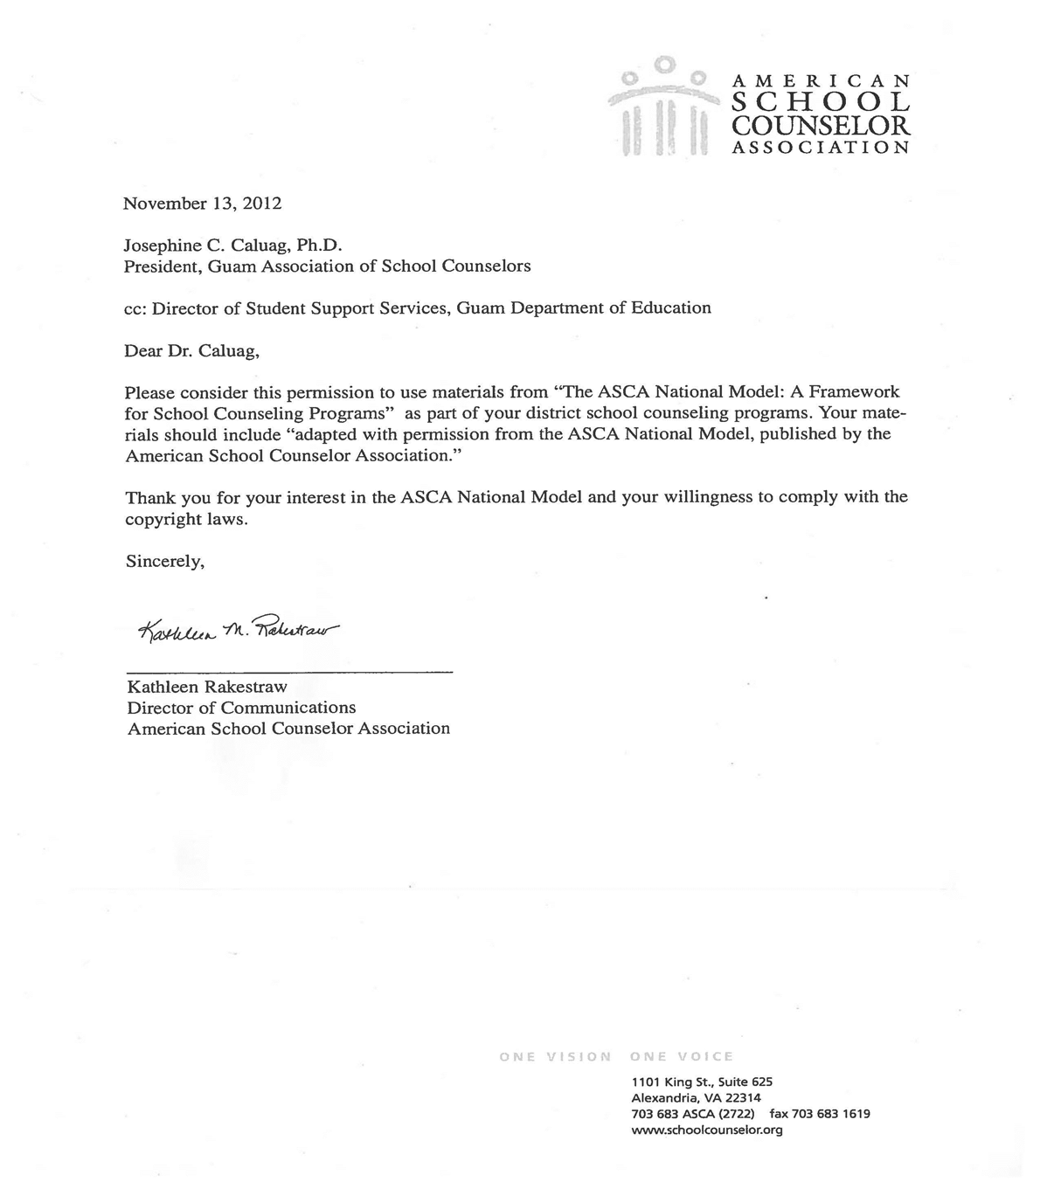

Foreword

Dear Guam School Counselors,

In conjunction with the GASC, the Student Support Services Division, and the Guam Comprehensive School Counseling Team, I am excited to announce the completion of the Guam Comprehensive School Counselor Program K-12 document. I encourage you to continue implementing the critical components of the ASCA National Model based on the district-wide efforts since 2005.

On behalf of all Guam Guidance Counselors, I am deeply grateful to Judy Bowers Ed.D., for conducting multiple years of training and consulting on the National Model. She was instrumental in obtaining permission from Kathleen Rakestraw, Director of Communications, ASCA, “. . . to use materials from the ASCA National Model.”

The program did not happen overnight! It started in 2003 with the combined leadership of the AMERICAN COUNSELING ASSOCIATION (ACA) and the AMERICAN SCHOOL COUNSELING ASSOCIATION (ASCA) as an appeal for local legislators to review the 32-hour work week and its impact on schools. During the time that Judy Bowers, Ed.D. was the President of ASCA, GASC led the counselors to share the same mission and vision of their national counterparts. She focused on the crucial roles of the school counselor as teacher, advocate, leader, guide and friend. To the present day, counseling in schools has become a collaborative and community effort.

Successful program implementation depends on the continued cooperation of the legislators and support of stakeholders, which include the superintendent, administrators, faculty and staff, parents, and community leaders. This type of leadership is essential in developing effective and accountable counseling programs.
On behalf of the team, I am deeply grateful for the completion of the district’s initiative. My sincerest appreciation goes to the previous superintendents of the Guam DOE, Dr. Juan P. Flores and Dr. Nerissa B. Underwood. Dr. Juan P. Flores was the first to support my initiative to form a professional organization (GASC). Dr. Nerissa B. Underwood gave GASC the same support to standardize K-12 counseling programs.

In my tenure as the Acting Student Support Services Administrator, I successfully coordinated professional development with UOG/GCC for the preparation of school counselors. This partnership added an assurance of support through inclusion of school counseling in course offerings.

It is my hope that you will find this resource useful in guiding your respective guidance program. Be confident in what you do as a professional counselor. If you have made your students achieve the results expected, you have given them a legacy and a GIFT OF A LIFETIME! Congratulations!

Josephine Cenzon Caluag Ph.D.
GASC Founding President

Guam Comprehensive School Counseling Team

Francis S. Ballares, M.A  John F. Kennedy School  Management System Team  300-4357 (W)  fsballares@gdoe.net | Billie-Jo P.J. Marzan, Ed.D.  Machananao Elementary School  Foundation Team  635-4389 (W)  bmarzan@gdoe.net
Jovita M. Young, M.S.  Tamuning Elementary School  Accountability System Team  646-8058 (W)  jvyoung@gdoe.net | Estela L. Calata, M.A.  Wettengel Elementary School  Delivery System Team  632-7770 (W)  elcalata@gdoe.net

Proponents:

Christopher Anderson, M.Ed. Josephine C. Caluag, Ph.D.
Administrator, Student Support Services Division Counselor Emeritus
Guam Department of Education GASC Founding President
Guam Department of Education Local Mentor, ASCA National Model

Ross Schlosbon, Ed.S.
Psychologist, Student Support Services Division
Guam Department of Education

Trainers:

Judy Bowers, Ed.D.
Recognized International Educational Consultant, Leader and Advocate of School Counseling Programs; Co-author, ASCA National Model: A Framework for School Counseling Programs (ASCA, 2003), ASCA National Model Workbook (ASCA, 2004), and Revised ASCA National Model (June 2012); Trainer in 2nd, 4th, & 5th SGC Conference

Diana Johnston, M. Ed.
Prevention Specialist; Trainer in 2nd, 4th, 5th SGC Conference; Recognized ASCA Model Program (RAMP) Awardee for Bullying Prevention

James Conkwright, Ed.D. & Candyce Conkwright, Ed.D.
Trainers in 3rd SGC Conference

Rhonda Williams, Ed.D.
Professor, University of Colorado., Trainer in 1st SGC Conference

TABLE OF CONTENTS PAGES

Chapter 1. What is a Comprehensive School Counseling Program? 5

Chapter 2. Components of a School Counseling Program 10

Chapter 3. Foundation Components 14
Chapter 4. Management System 25
Chapter 5. Delivery System Components 31
Chapter 6. Accountability System 40
Chapter 7. Professional School Counselor’s Job Description and Evaluation 45

AppendICES 48

- Lesson Plan Template /Samples/Standards Chart Form 49
- Family Educational Rights and Privacy Act (FERPA) 64
- Program Audit 65
- School Counselor Roles 76
- ASCA Ethical Standards for School Counselors 86
- Certification of School Counselors (Guam Public Law 31-50) 95
- School Counselors Work Teams 98
- Guide for Three Year ASCA Implementation Plan 99
- School Counselor Management Agreement Form 101
- School Counselor Performance Appraisal Form 104
- Glossary: Definition of School Counseling Key Terms 108
- Professional Association, GASC Officers 116

REFERENCES 117

Chapter 1

What is a Comprehensive School Counseling Program?

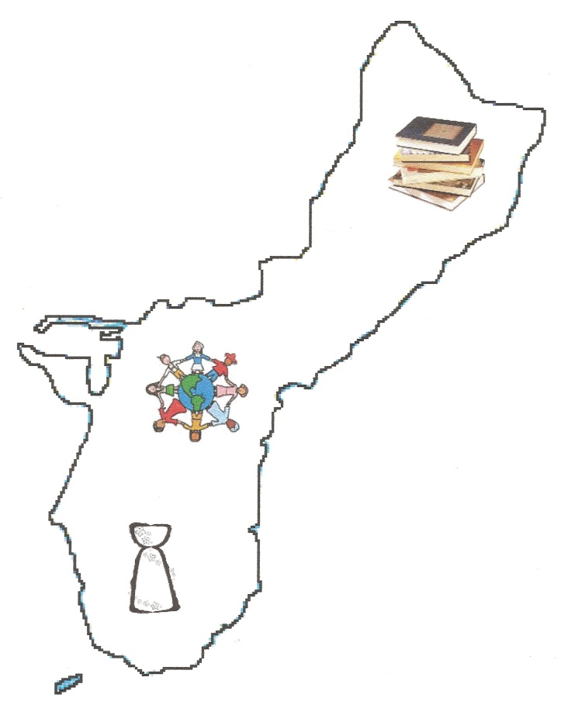

A Comprehensive School Counseling Program

Reaches All Students

Comprehensive in Scope: Based on ASCA National Model

Consists of Three Developmental Domains: Academic, Career, Personal/Social

Preventative in Design

Integral Part of the Total Education Program

Designs a Delivery System

Guidance Curriculum:

Classroom Activities

Interdisciplinary Curriculum Development

Group Activities

Parent Workshops

Individual Student Planning:

Individual or Small Group Appraisal

Individual or Small Group Advisement

Responsive Service:

Consultation

Individual and Small Group Counseling

Career Counseling

Crisis Counseling

Referrals

Peer Facilitation

System Support:

Professional Development

Consultation

Collaboration and Teaming

Program Management and Operation

Implemented by a Certified School Counselor

Conducted in Collaboration with Stakeholders

Monitors Student Progress and Improvement of Program Services

Data Driven

Guam Comprehensive School Counseling Program K-12 Includes the Following Components:

Developmental in Nature

- School Counselors design programs and services to meet the needs of students at various growth and developmental stages. The Guam Comprehensive School Counseling Program (GSCP K-12) based on the American School Counselor Association National Standards, defines what students should know and be able to do as a result of participating in a school counseling program.

- The standards for academic development guide the school counseling program to implement strategies and activities to support and maximize student learning. Academic development includes acquiring attitudes, knowledge and skills that contribute to effective learning in school and across the life span.

- The standards for career development guide the school counseling program to provide the foundation for the acquisition of skills, attitudes and knowledge enabling students to make a successful transition from school to the world of work and from job to job across the life span. Career development includes the employment of strategies to achieve future career success and job satisfaction as well as fostering understanding of the relationship between personal qualities, education and training and the world of work.

- The standards for personal/social development guide the school counseling program to provide the foundation for personal social growth as students’ progress through school and into adulthood. Personal/social development includes the acquisition of skills, attitudes and knowledge that help students understand and respect self and others, acquire effective interpersonal skills, understand safety and survival skills and develop into contributing members of our society.

- School counselors coordinate the objectives, strategies and activities of a developmental school counseling program.

Integral Part of the Total Educational Program

- The Guam Comprehensive School Counseling Program K-12 supports the school’s academic mission by promoting and enhancing the learning process for all students through an integration of academic, career and personal/social development.

- School counselors are specially trained educators in a position to call attention to situations within the schools that defeat, frustrate and hinder students’ academic success.
- School counselors are aware of the data identifying patterns of achievement and behaviors affecting student success. They provide the leadership to assess school needs, to identify issues and to collaborate with others to develop solutions.

Designs a Delivery System

The GSCP K-12 uses four components in the systematic delivery of the program:

- The curriculum component provides opportunities for all students to receive school guidance curriculum in a systematic way.

- The individual student-planning component provides all counselors the opportunity to work closely with students, parents or guardians to plan and monitor student growth and development through action planning.

- The responsive services component responds to the direct, immediate concerns of students and includes individual counseling, crisis counseling, referrals and consultations with parents or guardians, teachers, or others specialists.

- The system support component enables the school counseling process to be effective through: leadership, advocacy, consultation, collaboration, program management and professional development.

- Implemented by a Fully Certified School Counselor

  - School counselors in Guam are fully certified by the Guam Commission for Educators Certification (GCEC). Refer to Appendix V.

- School counselors receive training in human growth and development, student learning styles, classroom behavioral management, curriculum and instruction, student assessment and student achievement.

Conducted in Collaboration and Shared Successes

- Professional school counselors work collaboratively with parents or guardians, community members, school personnel, and other support services professionals as part of the support services team for students.

- This team identifies student needs and makes referrals to appropriate resources both within and outside of the school.

- School counselors share their program successes. Informed stakeholders know and promote the value of school counselors in children’s lives.

- School counselors collaborate and share the results of successful programs.

Monitors Student Progress and Program Services

- Counselors are expected to consistently monitor academic progress and achievement.
- Monitoring is the process of reviewing data to determine if a student or group of students is demonstrating the desired results as delineated in the program goals and related student competencies.

- The purpose of evaluation is to improve programs and services.

- School counselors measure results to determine what is working and what is not working to evaluate the program and make necessary adjustments.

Driven by Data

- School counseling programs are data driven.

- Data create a picture of student needs and provide an accountable way to align the school counseling program.

- Process data tells what services are actually provided, and is accompanied by results data which answers the question, ”so what?”

- It is important to disaggregate data by variables such as gender, ethnicity or socio-economic status to examine various student groups.

Chapter 2

Components of a School Counseling Program

Components of a School Counseling Program
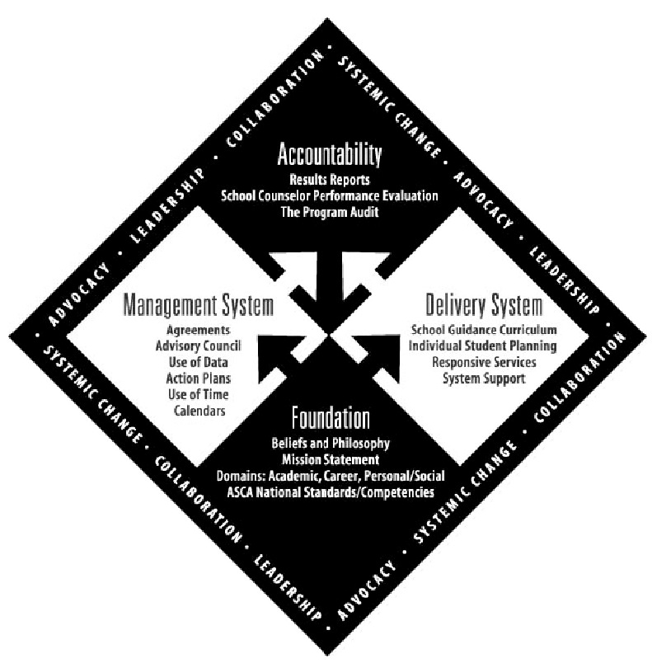

ASCA National Model

Components of the Guam School Counseling Model

- Foundation - The foundation of the program describes what every student will know and be able to do.

- Belief and Philosophy: The philosophy is a set of principles that guides the program development, implementation and evaluation.

- Mission: A mission statement describes the program’s purpose and provides the vision of what is desired for every student.

- Domains: Domains are the extension of the mission and focus on the results students will achieve by the time the student graduates. The GCSCP K-12 academic, career and personal/social domains are aligned with the ASCA Model.

- Standards: The GCSCP K-12 Standards are aligned with the ASCA National Standards and are statements that describe what students should know and be able to do at the highest level of expectation. Standards specify the level or rate of performance that students will achieve a competency or set of indicators.

- Delivery System - The delivery system states how the program will be implemented.

- Guidance Curriculum: This curriculum is a developmental structured lesson approach for all K-12 students to develop knowledge and skills appropriate to their age and grade level.

- Individual Student Planning: Individual planning is designed to help students establish personal goals and develop future plans through ongoing systemic planning.
- Responsive Services: Students’ immediate needs are met through responsive services such as counseling, consultation, referral, peer mediation, information gathering and coordination.

- Systems Support: The purpose of these activities is to establish, maintain and enhance the school counseling program. These activities include: consultation, collaboration and teaming, professional development and program management.

- Management Systems - The Management System tells when, why and on what authority the program will be implemented.

- Use of Time/Calendars: A comprehensive school counseling program requires a counselor’s time to be spent on direct service and eliminates non-school-counseling tasks. Establishing a calendar of activities and curriculum delivery will assist students, parents, staff and administrators in acknowledging the program.

- Management Agreements: Statements of agreement between the counselor and the administrator clearly outline areas of responsibility to which a counselor is responsible within the school year. This is a dynamic document that may change year to year based on data and school needs. The agreements were previously referred to as Results Agreements.

- Advisory Council: The role of an advisory council is to review guidance program results and to make recommendations. This group is made up of students, school personnel, parents, and community members.

- Use of Data: School counselors must show that each activity implemented is based on a careful analysis of students’ needs, achievement, and related data. Data is a force of change necessary to determine the effectiveness of the school counseling program and its future direction.

- Action Plans: Action plans that strategies are in place for programming to meet the needs of every student. Guidance curriculum action plans include: the domain, standard and competency addressed, description of guidance lesson activity, curriculum or materials to be used, time activity takes to complete, the person responsible for program delivery, and the means of evaluating student success.

- Accountability - The accountability system answers the question, “How are students different as a result of the school counseling program”?

- Results Reports: Reports which include process, perception and results data ensure that the work has been done and evaluated for effectiveness and the counseling program has been adjusted as needed.

- School Counselor Performance Standards: The school counselor’s performance evaluation should be based on standards of good practice. These performance standards serve as a basis for self-evaluation and counselor evaluation.

- Program Audit: The primary purpose of a program audit is to collect information to guide future action within the program to improve future results for students.

Chapter 3

Foundation Components

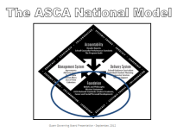

Foundation

School counseling programs are built upon the foundation elements including counselor beliefs, philosophy, mission statement, and ASCA National Standards for student academic, career, and personal/social development (ASCA, 2005). Essentially, the foundation requires collaboration between stakeholders and counselors to determine how the school counseling program will benefit all students. One critical question for counselors to consider is “what will every student know and be able to do?” School counseling programs are integral in the total education program for student success.

Beliefs and Philosophy
Counselor beliefs about students, families, teachers and the educational process are important in supporting overall student success. Examining counselor beliefs help to define the assumptions or guiding principles providing shape to the nature and structure of the program. The philosophy statement is established based on the beliefs and assumption of school counselors.

The program philosophy is an agreed-upon set of guiding principles individuals follow when implementing the school counseling program (Johnson & Johnson, 2001). School counselors achieve a consensus on each belief or guiding principle to develop the philosophy. The following statement was developed for Guam school counselors.

The professional school counselors believe every child can learn and that all students have an equal right to access a certified school counselor. All students have a right to participate in a comprehensive school counseling program designed to ensure student success. The following principles are the foundation for the school counseling program:
- All students’ ethnic, cultural, racial differences are considered in planning and implementing the school wide program.
- There is collaborative effort among school counselors, administration, and teachers to coordinate with parents and the community.
- Classroom lessons and activities incorporate the personal, academic, social, and career domains.
- School counselors adhere to ethical standards and participate in professional development activities.

Mission Statement
The mission statement gives the overall direction and vision of counseling program by describing the programs purpose and what is desired for every student (Johnson & Johnson, 2001; Gysbers & Henderson, 1998). Individual school mission statements should align with the school district’s mission. Ideally, the program mission supports the learning environment for students and contributes to meeting student needs while nurturing their progress. The following is the mission statement developed for Guam school counselors.

The mission of our school counseling program is to provide support through a comprehensive and developmental approach which addresses academic, career, and personal/social skills necessary to achieve quality learning and lifelong success as directed by the Guam Department of Education. In partnership with other educators, parents or guardians, and the community, school counselors are professional advocates who promote activities for students to equally access opportunities and maximize their achievement as they prepare to become successful and responsible citizens.

Domains
Three broad domains-- academic, career, and personal/social help facilitate student development to promote and enhance the learning process. Each domain provides guidance and direction at the state, district, and individual school level. Domains are broad developmental areas including standards and competencies and promote behaviors that enhance learning for all students.

Content Standards
Standards are statements that describe what students should know and be able to do at the highest level of expectation. Standards also specify the level or rate of performance that students will achieve a competency or set of indicators.

Competencies
Student competencies define the specific knowledge, attitudes, and skills student should obtain. Indicators describe demonstration of skill acquisition. Student competencies describe the expectations that students accomplish within the academic, career, and personal/social developmental domains.

Indicators
Indicators describe the specific knowledge, skills, or abilities that individuals demonstrate to meet a competency.

Guam Comprehensive School Counselor Program K-12
Students Standards

Coding Key for Student Competencies
EXAMPLE:

A:A1.1 articulate feelings of competence and confidence as learners

Legend:
A - Academic Domain
A:A – Standard A
A:A1 – Competency A1
A:A1.1 – Indicator 1

ACADEMIC DEVELOPMENT DOMAIN – GRADES K-12

National Standard A: Students will acquire the attitudes, knowledge, and skills that contribute to effective learning in school and across the life span.
Competency A1 Improve Academic Self-concept

A:A1.1 articulate feelings of competence and confidence as learners

A:A1.2 display a positive interest in learning

A:A1.3 take pride in work and achievement

A:A1.4 accept mistakes as essential to the learning process

A:A1.5 identify attitudes and behaviors which lead to successful learning

Competency A2 Acquire Skills for Improving Learning

A:A2.1 apply time management and task management skills
A:A2.2 demonstrate how effort and persistence positively affect learning
A:A2.3 use communications skills to know when and how to ask for help when needed
A:A2.4 apply knowledge and learning styles to positively influence school performance
Competency A3 Achieve School Success

A:A3.1 take responsibility for their actions
A:A3.2 demonstrate the ability to work independently, as well as the ability to work cooperatively with other students
A:A3.3 develop a broad range of interest and abilities
A:A3.4 demonstrate dependability, productivity, and initiative
A:A3.5 share knowledge

National Standard B: Students will complete school with the academic preparation essential to choose from a wide range of substantial postsecondary options, including college.
Competency B1 Improve Learning

A:B1.1 demonstrate the motivation to achieve individual potential
A:B1.2 learn and apply critical thinking skills
A:B1.3 apply the study skills necessary for academic success at each level
A:B1.4 seek information and support from faculty, staff, family and peers
A:B1.5 organize and apply academic information from a variety of sources
A:B1.6 use knowledge of learning styles to positively influence school performance
A:B1.7 become a self-directed and independent learner
Competency B2 Plan to Achieve Goals

A:B2.1 establish challenging academic goals in elementary, middle/junior high, and high school
A:B2.2 use assessment results in educational planning
A:B2.3 develop and implement an annual plan of study to maximize academic ability and achievement
A:B2.4 apply knowledge of aptitudes and interests to goal setting
A:B2.5 use problem-solving and decision-making skills to assess progress toward educational goals
A:B2.6 understand the relationship between classroom performance and success in school
A:B2.7 identify post-secondary options consistent with interests, achievement, aptitude, and abilities

National Standard C: Students will understand the relationship of academics to the world of work, and to life at home and in the community.
Competency C1 Relate School to Life Experience

A:C1.1 demonstrate the ability to balance school, studies, extracurricular activities, leisure time, and family life
A:C1.2 seek co-curricular and community experiences to enhance the school experience
A:C1.3 understand the relationship between learning and work
A:C1.4 demonstrate an understanding of the value of lifelong learning as essential to seeking, obtaining, and maintaining life goals
A:C1.5 understand that school success is the preparation to make the transition from student to community member
A:C1.6 understand how school success and academic achievement enhance future career and vocational opportunities

CAREER DEVELOPMENT DOMAIN
National Standard A: Students will acquire the skills to investigate the world of work in relation to knowledge of self and to make informed career decisions.
Competency A:1 Develop Career Awareness

C:A1.1 develop skills to locate, evaluate, and interpret career information
H:B1 Health Information, Services, and Products – Identify which school and community health helpers are needed in given situations

C:A1.2 learn about the variety of traditional and nontraditional occupations
H:B1 Health Information, Services, and Products – Identify which school and community health helpers are needed in given situations
C:A1.3 develop an awareness of personal abilities, skills, interests, and motivations
C:A1.4 learn how to interact and work cooperatively in teams
C:A1.5 learn to make decisions
C:A1.6 learn how to set goals
C:A1.7 understand the importance of planning
C:A1.8 pursue and develop competency in areas of interest
C:A1.9 develop hobbies and vocational interests
C:A1.10 balance between work and leisure time

Competency A:2 Develop Employment Readiness

C:A2.1 acquire employability skills such as working on a team, problem-solving
and organizational skills

C:A2.2 apply job readiness skills to seek employment opportunities

C:A2.3 demonstrate knowledge about the changing workplace

C:A2.4 learn about the rights and responsibilities of employers and employees

C:A2.5 learn to respect individual uniqueness in the workplace

C:A2.6 learn how to write a resume

C:A2.7 develop a positive attitude toward work and learning

C:A2.8 understand the importance of responsibility, dependability, punctuality, integrity,
and effort in the workplace

C:A2.9 utilize time and task-management skills

National Standard B: Students will employ strategies to achieve future career goals with success and satisfaction.
Competency B:1 Acquire Career Information

C:B1.1 apply decision making skills to career planning, course selection, and career transition

C:B1.2 identify personal skills, interests, and abilities and relate them to current career choice
C:B1.3 demonstrate knowledge of the career planning process

C:B1.4 know the various ways in which occupations can be classified

C:B1.5 use research and information resources to obtain career information

C:B1.6 learn to use the internet to access career planning information

C:B1.7 describe traditional and non-traditional occupations and how these relate to career choice

C:B1.8 understand how changing economic and societal needs influence employment trends and future training
Competency B:2 Identify Career Goals

C:B2.1 demonstrate awareness of the education and training needed to achieve career goals

C:B2.2 assess and modify their educational plan to support career

C:B2.3 use employability and job readiness skills in internship, mentoring, shadowing, and/or other work experience

C:B2.4 select course work that is related to career interests

C:B2.5 maintain a career planning portfolio

CAREER DEVELOPMENT DOMAIN
National Standard C: Students will understand the relationship between personal qualities, education, training, and the world of work.
Competency C:1 Acquire Knowledge to Achieve Career Goals

C:C1.1 understand the relationship between educational achievement and career success

C:C1.2 explain how work can help to achieve personal success and satisfaction

C:C1.3 identify personal preferences and interests which influence career choice and success

C:C1.4 understand that the changing workplace requires lifelong learning and acquiring new skills

C:C1.5 describe the effect of work on lifestyle

C:C1.6 understand the importance of equity and access in career choice

C:C1.7 understand that work is an important and satisfying means of personal expression

Competency C2 Apply Skills to Achieve Career Goals

C:C2.1 demonstrate how interests, abilities and achievement relate to achieving personal, social, educational, and career goals

C:C2.2 learn how to use conflict management skills with peers and adults

C:C2.3 learn to work cooperatively with others as a team member

C:C2.4 apply academic and employment readiness skills in work-based learning situations such as internships, shadowing, and/or mentoring experiences

PERSONAL/SOCIAL DOMAIN
National Standard A: Students will acquire the knowledge, attitudes, and interpersonal skills to help them understand and respect self and others.
Competency A1 Acquire Self-Knowledge

PS:A1.1 develop positive attitudes toward self as a unique and worthy person

PS:A1.2 identify values, attitudes and beliefs

PS:A1.3 learn the goal-setting process

PS:A1.4 understand change is a part of growth

PS:A1.5 identify and express feelings

PS:A1.6 distinguish between appropriate and inappropriate behavior

PS:A1.7 recognize personal boundaries, rights, and privacy needs

PS:A1.8 understand the need for self-control and how to practice it

PS:A1.9 demonstrate cooperative behavior in groups

PS:A1.10 identify personal strengths and assets

PS:A1.11 identify and discuss changing personal and social roles

PS:A1.12 identify and recognize changing family roles

Competency A2 Acquire Interpersonal Skills

PS:A2.1 recognize that everyone has rights and responsibilities

PS:A2.2 respect alternative points of view

PS:A2.3 recognize, accept, respect and appreciate individual differences

PS:A2.4 recognize, accept and appreciate ethnic and cultural diversity

PS:A2.5 recognize and respect differences in various family configurations

PS:A2.6 use effective communications skills

PS:A2.7 know that communication involves speaking, listening, and nonverbal behavior

PS:A2.8 learn how to make and keep friends

National Standard B: Students will make decisions set goals, and take necessary action to achieve goals.
Competency B1 Self-Knowledge Application

PS:B1.1 use a decision-making and problem-solving model

PS:B1.2 understand consequences of decisions and choices
PS:B1.3 identify alternative solutions to a problem

PS:B1.4 develop effective coping skills for dealing with problems

PS:B1.5 demonstrate when, where and how to seek help for solving problems and making decisions

PS:B1.6 know how to apply conflict resolution skills

PS:B1.7 demonstrate a respect and appreciation for individual and cultural differences

PS:B1.8 know when peer pressure is influencing a decision

PS:B1.9 identify long- and short-term goals

PS:B1.10 identify alternative ways of achieving goals
turns, sharing equipment, etc.) while participating in physical activities

PS:B1.11 use persistence and perseverance in acquiring knowledge and skills

PS:B1.12 develop an action plan to set and achieve realistic goals

National Standard C: Students will understand safety and survival skills.
Competency C1 Acquire Personal Safety Skills

PS:C1.1 demonstrate knowledge of personal information (i.e. telephone number, home address, emergency contact)
PS:C1.2 learn about the relationship between rules, laws, safety, and the protection of rights of the individual

PS:C1.3 learn about the differences between appropriate and inappropriate physical contact

PS:C1.4 demonstrate the ability to set boundaries, rights and personal privacy

PS:C1.5 differentiate between situations requiring peer support and situations requiring adult professional help

PS:C1.6 identify resource people in the school and community, and know how to seek their help

PS:C1.7 apply effective problem-solving and decision-making skills to make safe and healthy choices

PS:C1.8 learn about the emotional and physical dangers of substance use and abuse

PS:C1.9 learn how to cope with peer pressure

PS:C1.10 learn techniques for managing stress and conflict

PS:C1.11 learn coping skills for managing life events

Chapter 4

Management System

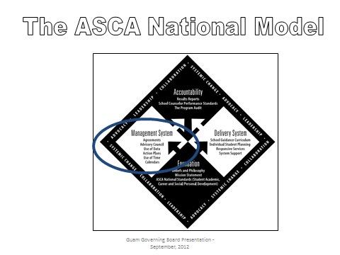

Management Agreements

To implement a comprehensive school counseling program, management system decisions and agreements must be made regarding the organization and assignment of counselors (Johnson & Johnson, 2001). This should be accomplished in consultation with the principal or school counseling administrator prior to the next step in program implementation. It is recommended that:

- The school counseling team members and administrator review and discuss data-driven needs for the student population and school site based on data analysis.
- The school counseling team decides on a plan of action to meet student needs.
- The school counseling team and administrator agree on how students, guidance curriculum and services will be assigned to specific counselors.
- The school counseling team produces and presents yearly a draft of the management agreement.
- The administrator reviews the management agreement and arrives at consensus with the school counseling team.

When school counselors and administrators meet and agree on program priorities, implementation strategies and the organization of the counseling department, the entire program runs more smoothly and is more likely to produce the desired results for students.

Advisory Council

An advisory council is a representative group of persons appointed to both advise and assist the school counseling program within a school district. The advisory council reviews the program goals, competencies and results and participates in making recommendations to the school counseling department, principal and superintendent (Johnson & Johnson, 2001). Ideally, advisory council membership reflects the community’s diversity. It should include representative stakeholders of the school counseling program: students, parents or guardians, teachers, counselors, administrators, school board members, business and community members. The council should meet twice a year at a minimum.

Use of Data

The use of data to effect change within the school system is integral to ensuring that every student receives the benefits of the school counseling program. School counselors must show that each activity implemented as part of the school counseling program was developed from a careful analysis of student needs, achievement and related data.

- Data provides useful information for many purposes

- Concretely demonstrates accountability and progress toward goals
- Monitors student progress
- Creates an urgency for change
- Serves as a catalyst for focused action
- Engages decision-makers, district leaders, and school teams in data driven
- Challenges existing policies, practices, and attitudes
- Exposes evidence of access and equity issues for focused advocacy and intervention
- Focuses resources, programs, interventions and strategies where they are needed most
- Supports grant proposals

B. School counselors monitor student progress through three types of data: student-achievement data, achievement-related data, and standard-and competency-related data

  - Student-achievement data measure student academic progress in several fields
    - Standardized test data
    - Grade point average
    - Graduation rate
    - Dropout rates
  - Achievement-related data measure those fields research has shown to be correlated to academic achievement
    - Course enrollment patterns
    - Discipline referrals
    - Attendance rates

Use of Time

How much time should school counselors spend delivering services in each component area? New counselors are often unsure. Although some experts assert that it doesn’t matter as long as you obtain results for students (Johnson & Johnson, 1997), others maintain that sticking to suggested allocated time distribution does produce the required results. In “Developing and Managing Your School Guidance Program,” by Norm Gysbers and Patricia Henderson (2000), the authors encourage school counselors to work with their departments to protect their time so that 80 percent of it is spent in direct service to students, staff and families and the remainder is spent in program management. The following percentages (See Figure 5.2) serve as a guide to school counselors and administrators when determining the time their program needs to spend in each of the four delivery system components.

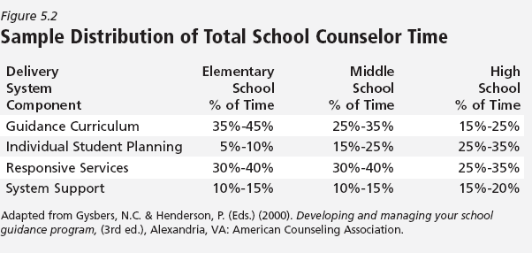

As a first step to understanding your site’s use of time, all the school counselors could keep track of their time and document activities performed throughout their days. This allows school counselors and administrators to determine the amount of time being spent in each of the delivery system components and in non-school-counseling activities. This is especially helpful when first designing the program because it serves to answer the question of “What is” and then provides a forum for the discussion of “What should be?”

In programs with more than one school counselor per site, there is often more flexibility between and among school counselors in determining how much time individual school counselors may spend in the delivery of system components. Keeping in mind that the program percentages are only suggested; the individual time a certain school counselor spends in the delivery of systemic services may vary depending on talents and expertise. School counselors with expertise in group counseling may focus delivering these services, while others may present more school guidance lessons. The time percentages are designed to be programmatic, not counselor specific. Counselors are encouraged to allot times based on program priorities and needs.

A conclusion may also be drawn from use of time information regarding how much time is currently being spent on counseling activities versus non-school counseling activities. For example, in one school, 35 percent of the high school counselors’ time was being spent on non-school-counseling activities, which included master schedule building, clerical tasks and the counting and managing of the standardized tests. Following a presentation to district administrators on the results of a time analysis, the administrators decided, and the governing board supported, elimination of the non-school counseling activities and hired school counseling assistants to help school counselors. Eliminating non-school counseling activities and providing more clerical help freed school counselors to provide more direct services to students. Again, ASCA recommends school counselors spend a majority of their time in direct service to students.

Calendars

School counselors develop and publish a master calendar of school counseling events to ensure students, parents or guardians, teachers and administrators know what and when school counseling activities are scheduled and when and where activities will be held. Calendars also assist with planning, ensuring program participation.

The use of a school counseling program calendar aligned with the school site calendar facilitates staff, parents or guardians, student and community involvement as partners in students’ education. The calendar establishes a site schedule for the school and counseling program activities. As the program grows and multiple activities are developed, a calendar validates the important support the school counselor program provides students, parents or guardians, teachers and administrators. A well-developed calendar that is complete, timely and colorful can be a powerful public relations booster. Time and thought on how the calendar will be formatted, consistency in the timing and distribution methods, attractiveness of the design, color and detail produce a useful tool. An effective calendar invites others to acknowledge and participate in the school counseling program activities (Henderson & Gysbers, 1998; Johnson & Johnson, 2001; Myrick, 2003).

A school counseling program is balanced in two ways:
- In the delivery system (i.e. school guidance curriculum, individual student planning, responsive services and system support)
- In the use of time spent delivering the components

Annual Calendar

The yearly calendar is a way for school counselors to identify the school counseling program priorities and their commitment to them. Ideally, the calendar is located in several prominent places such as the department bulletin board, school or student bulletin boards, classroom bulletin boards, administrative offices, parent or guardian center, career center, student store and other sites used to communicate school events. It may also be submitted to the local newspaper, the student newspaper and the school counseling department’s website to increase the program’s visibility. The student support calendar might include relevant school activities for families, such as back to school night, open house, parents or guardian-teacher meetings, standardized tests dates, parents or guardian, student and teacher conferences, planned school counseling classroom lessons, career or college nights, evening meetings for reviewing study skills or other opportunities provided through the school and the community, as well as the student support program.

Many schools provide a yearly schedule of school activities that can be coordinated with other events with all relevant dates and times noted on the student support calendar. The school counseling program calendar:
- Increases visibility of the student support program and other related educational activities
- Provides focus on events or activities of value for the students, parents or guardians and staff
- Increases communication within the school and home about schedules and program activities
- Encourages the student, family, department and school to plan ahead for important student support functions
- Establishes an organizational pattern of highlighting and valuing student support opportunities
- Reserves the use of the facility hosting the events or activities
- Reinforces the importance of student participation in student support related activities

Monthly Calendar

The monthly calendar is maintained and circulated to highlight the specific activities and events for each month throughout the school year and into the summer. Print the monthly calendar in a distinctive color and distribute it to all teachers for their classroom bulletin boards. Be sure to remind teachers that they are invited to participate and to encourage student participation or observance of upcoming events.

Mail the calendar to parents or guardians as well. Schedule classroom guidance lessons on a monthly basis, such as one grade level per month for four to six lessons.

Chapter 5

Delivery System Components

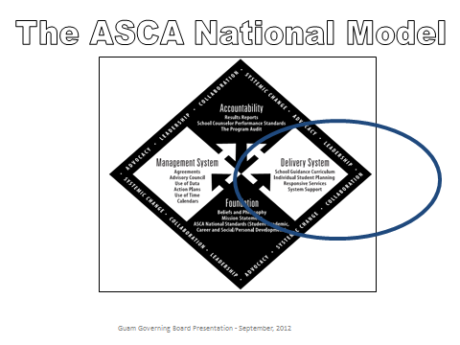

Delivery System

Guidance Curriculum

Curriculum is composed of written instructional program that is comprehensive in scope, preventative and proactive, developmental in design, coordinated and delivered by school counselors and other educators.
    - Classroom Activities
    - Interdisciplinary curriculum development
    - Group Activities
    - Parent Workshops

Individual Student Planning

Planning is composed of school counselors coordinating ongoing systematic activities that help all students plan, monitor and manage their own learning as well as meet competencies in the areas of academic, career, personal/social domains.
    - Individual or small group appraisal
    - Individual or small group advisement

Responsive Service

Service is composed of activities that meet student needs and concerns. These activities are available to all students and delivered through:
    - Consultation
    - Individual and small group counseling
    - Crisis counseling
    - Referrals
    - Peer facilitation

System Support

Support is composed of management activities that establish, maintain, and enhance the total school counseling program. School Counselors use their leadership and advocacy skills to promote systemic change by contributing in the following areas:
    - Professional development
    - Consultation, collaboration & teaming
    - Program management and operation

Sample Topics: Six Units of Study
Elementary (K-5) | Middle School (6-8) | High School (9-12)
Improve Academic Self-Concept | Acquire Skills for Improving Learning | Study Skills  Interpersonal Skills  Tolerance / Accepting
Achieve School Success | Achieve School Success  Improve Learning | Learning styles
Develop Career Awareness | Develop Career Awareness | Learn about a variety of traditional & non-traditional careers
Acquire Self-Knowledge | Acquire Self-Knowledge | Develop and awareness of personal abilities, skills, interests; Personal Strengths & Weaknesses
Acquire Interpersonal Skills | Acquire Interpersonal Skills | Responsibility and Accountability for Student Actions
Acquire Personal Safety Skills | Acquire Personal Safety Skills | Becoming An Adult (responsibility/Being out on your own)
NOTATION ON THE CROSSWALKING TOOL

The cross walking tool provides a baseline of standards, competencies and indicators (S/C/I) to be delivered by grade levels. Through the use of data, school guidance counselors will assess and determine whether additional SCIs are necessary for their respective students.

ASCA NATIONAL STANDARDS:
DEVELOPMENTAL CROSSWALKING TOOL
 | This form is a tool that can be used to assist you in planning your overall guidance curriculum.
 | ACADEMIC DEVELOPMENT DOMAIN |  |  |  |  | K-2 | 3-5 | 6-8 |  | 9-12
 | Standard A: Students will acquire the attitudes, knowledge, and skills that contribute to
 | effective learning in school and across the life span.
 | Competency A1 Improve Academic Self-concept
 | A:A1.1 articulate feelings of competence and confidence as learners |  |  |  |  |  | X
 | A:A1.2 display a positive interest in learning |  |  |  |  | X
 | A:A1.3 take pride in work and achievement |  |  |  |  |  |  | X
 | A:A1.4 accept mistakes as essential to the learning process |  |  |  |  |  |  |  |  | X
 | A:A1.5 identify attitudes and behaviors which lead to successful learning |  |  |  |  |  |  | X |  | X
 | Competency A2 Acquire Skills for Improving Learning
 | A:A2.1 apply time management and task management skills |  |  |  |  |  |  | X
 | A:A2.2 demonstrate how effort and persistence positively affect learning |  |  |  |  |  | X | X
 | A:A2.3 use communications skills to know when and how to ask for help when needed |  |  |  |  | X |  |  |  | X
 | A:A2.4 apply knowledge and learning styles to positively influence school performance |  |  |  |  |  | X
 | Competency A3 Achieve School Success
 | A:A3.1 take responsibility for their actions |  |  |  |  | X
 | A:A3.2 demonstrate the ability to work independently, as well as the ability to work |  |  |  |  | X
 | cooperatively with other students
 | A:A3.3 develop a broad range of interest and abilities |  |  |  |  |  |  | X |  | X
 | A:A3.4 demonstrate dependability, productivity, and initiative
 | A:A3.5 share knowledge |  |  |  |  |  |  | X
 | Standard B: Students will complete school with the academic preparation essential to
 | choose from a wide range of substantial postsecondary options, including
 | college.
 | Competency B1 Improve Learning
 | A:B1.1 demonstrate the motivation to achieve individual potential |  |  |  |  |  |  | X
 | A:B1.2 learn and apply critical thinking skills |  |  |  |  |  |  |  |  | X
 | A:B1.3 apply the study skills necessary for academic success at each level |  |  |  |  |  |  | X
 | A:B1.4 seek information and support from faculty, staff, family and peers |  |  |  |  |  |  |  |  | X
 | A:B1.5 organize and apply academic information from a variety of sources |  |  |  |  |  |  | X |  | X
 | A:B1.6 use knowledge of learning styles to positively influence school performance |  |  |  |  |  |  | X
 | A:B1.7 become a self-directed and independent learner |  |  |  |  |  |  |  |  | X
 | ASCA National Standards: Developmental Crosswalking Tool
 | ACADEMIC DEVELOPMENT DOMAIN |  |  |  |  | K-2 | 3-5 | 6-8 |  | 9-12
 | Competency B2 Plan to Achieve Goals
 | A:B2.1 establish challenging academic goals in elementary, middle/junior high, and |  |  |  |  |  |  | X
 | high school
 | A:B2.2 use assessment results in educational planning |  |  |  |  |  |  |  |  | X
 | A:B2.3 develop and implement an annual plan of study to maximize academic ability |  |  |  |  |  |  | X
 | and achievement
 | A:B2.4 apply knowledge of aptitudes and interests to goal setting |  |  |  |  |  |  | X |  | X
 | A:B2.5 use problem-solving and decision-making skills to assess progress toward |  |  |  |  |  | X
 | educational goals
 | A:B2.6 understand the relationship between classroom performance and success in |  |  |  |  |  |  | X
 | school
 | A:B2.7 identify post-secondary options consistent with interests, achievement, aptitude, |  |  |  |  |  |  |  |  | X
 | and abilities
 | STANDARD C: Students will understand the relationship of academics to the world of
 | work, and to life at home and in the community.
 | Competency C1 Relate School to Life Experience
 | A:C1.1 demonstrate the ability to balance school, studies, extracurricular activities, |  |  |  |  |  |  | X
 | leisure time, and family life
 | A:C1.2 seek co-curricular and community experiences to enhance the school experience |  |  |  |  |  |  |  |  | X
 | A:C1.3 understand the relationship between learning and work |  |  |  |  |  |  | X
 | A:C1.4 demonstrate an understanding of the value of lifelong learning as essential to |  |  |  |  |  |  | X
 | seeking, obtaining, and maintaining life goals
 | A:C1.5 understand that school success is the preparation to make the transition from |  |  |  |  |  | X | X
 | student to community member
 | A:C1.6 understand how school success and academic achievement enhance future |  |  |  |  |  |  | X
 | career and vocational opportunities
 | CAREER DEVELOPMENT DOMAIN |  |  |  |  | K-2 | 3-5 | 6-8 |  | 9-12
 | STANDARD A: Students will acquire the skills to investigate the world of work in relation
 | to knowledge of self and to make informed career decisions.
 | Competency A:1 Develop Career Awareness
 | C:A1.1 develop skills to locate, evaluate, and interpret career information |  |  |  |  |  |  |  |  | X
 | C:A1.2 learn about the variety of traditional and nontraditional occupations |  |  |  |  | X
 | C:A1.3 develop an awareness of personal abilities, skills, interests, and motivations |  |  |  |  |  | X | X |  | X
 | C:A1.4 learn how to interact and work cooperatively in teams
 | C:A1.5 learn to make decisions |  |  |  |  | X | X
 | C:A1.6 learn how to set goals |  |  |  |  |  |  | X
 | C:A1.7 understand the importance of planning |  |  |  |  |  |  |  |  | X
 | C:A1.8 pursue and develop competency in areas of interest |  |  |  |  |  | X
 | C:A1.9 develop hobbies and vocational interests |  |  |  |  |  |  | X
 | C:A1.10 balance between work and leisure time |  |  |  |  |  |  |  |  | X
 | ASCA National Standards: Developmental Crosswalking Tool
 | CAREER DEVELOPMENT DOMAIN |  |  |  |  | K-2 | 3-5 | 6-8 |  | 9-12
 | Competency A:2 Develop Employment Readiness
 | C:A2.1 acquire employability skills such as working on a team, problem-solving and |  |  |  |  |  |  |  |  | X
 | organizational skills
 | C:A2.2 apply job readiness skills to seek employment opportunities |  |  |  |  |  |  |  |  | X
 | C:A2.3 demonstrate knowledge about the changing workplace
 | C:A2.4 learn about the rights and responsibilities of employers and employees
 | C:A2.5 learn to respect individual uniqueness in the workplace
 | C:A2.6 learn how to write a resume |  |  |  |  |  |  |  |  | X
 | C:A2.7 develop a positive attitude toward work and learning |  |  |  |  | X | X |  |  | X
 | C:A2.8 understand the importance of responsibility, dependability, punctuality, integrity, |  |  |  |  |  |  |  |  | X
 | and effort in the workplace
 | C:A2.9 utilize time and task-management skills |  |  |  |  |  |  | X
 | STANDARD B: Students will employ strategies to achieve future career goals with success
 | and satisfaction.
 | Competency B:1 Acquire Career Information
 | C:B1.1 apply decision making skills to career planning, course selection, and career |  |  |  |  |  |  |  |  | X
 | transition
 | C:B1.2 identify personal skills, interests, and abilities and relate them to current career |  |  |  |  |  |  | X |  | X
 | choice
 | C:B1.3 demonstrate knowledge of the career planning process |  |  |  |  |  |  | X
 | C:B1.4 know the various ways in which occupations can be classified |  |  |  |  | X | X
 | C:B1.5 use research and information resources to obtain career information |  |  |  |  |  |  | X |  | X
 | C:B1.6 learn to use the internet to access career planning information |  |  |  |  |  |  |  |  | X
 | C:B1.7 describe traditional and non-traditional occupations and how these relate to |  |  |  |  |  |  | X
 | career choice
 | C:B1.8 understand how changing economic and societal needs influence employment |  |  |  |  |  |  |  |  | X
 | trends and future training.
 | Competency B:2 Identify Career Goals
 | C:B2.1 demonstrate awareness of the education and training needed to achieve career |  |  |  |  |  |  | X
 | goals
 | C:B2.2 assess and modify their educational plan to support career |  |  |  |  |  |  |  |  | X
 | C:B2.3 use employability and job readiness skills in internship, mentoring, shadowing, |  |  |  |  |  |  |  |  | X
 | and/or other work experience.
 | C:B2.4 select course work that is related to career interests |  |  |  |  |  |  |  |  | X
 | C:B2.5 maintain a career planning portfolio |  |  |  |  |  |  |  |  | X
 | CAREER DEVELOPMENT DOMAIN  ASCA National Standards: Developmental Crosswalking Tool |  |  |  |  | K-2 | 3-5 | 6-8 |  | 9-12
 | STANDARD C: Students will understand the relationship between personal qualities,
 | education, training, and the world of work.
 | Competency C:1 Acquire Knowledge to Achieve Career Goals
 | C:C1.1 understand the relationship between educational achievement and career |  |  |  |  |  | X | X
 | success
 | C:C1.2 explain how work can help to achieve personal success and satisfaction |  |  |  |  |  |  |  |  | X
 | C:C1.3 identify personal preferences and interests which influence career choice and |  |  |  |  |  |  | X |  | X
 | success
 | C:C1.4 understand that the changing workplace requires lifelong learning and acquiring |  |  |  |  |  |  |  |  | X
 | new skills
 | C:C1.5 describe the effect of work on lifestyle |  |  |  |  |  |  |  |  | X
 | C:C1.6 understand the importance of equity and access in career choice |  |  |  |  |  |  | X
 | C:C1.7 understand that work is an important and satisfying means of personal
 | expression
 | Competency C2 Apply Skills to Achieve Career Goals |  |  |  |  |  |  | X
 | C:C2.1 demonstrate how interests, abilities and achievement relate to achieving |  |  |  |  |  | X
 | personal, social, educational, and career goals
 | C:C2.2 learn how to use conflict management skills with peers and adults |  |  |  |  | X | X
 | C:C2.3 learn to work cooperatively with others as a team member |  |  |  |  |  |  | X
 | C:C2.4 apply academic and employment readiness skills in work-based learning |  |  |  |  |  |  |  |  | X
 | situations such as internships, shadowing, and/or mentoring experiences
 | PERSONAL/SOCIAL DOMAIN |  |  |  |  | K-2 | 3-5 | 6-8 |  | 9-12
 | STANDARD A: Students will acquire the knowledge, attitudes, and interpersonal skills to
 | help them understand and respect self and others.
 | Competency A1 Acquire Self-Knowledge
 | PS:A1.1 develop positive attitudes toward self as a unique and worthy person |  |  |  |  | X | X
 | PS:A1.2 identify values, attitudes and beliefs |  |  |  |  |  |  | X
 | PS:A1.3 learn the goal-setting process |  |  |  |  |  |  |  |  | X
 | PS:A1.4 understand change is a part of growth |  |  |  |  |  |  | X
 | PS:A1.5 identify and express feelings |  |  |  |  | X | X
 | PS:A1.6 distinguish between appropriate and inappropriate behavior |  |  |  |  | X | X | X
 | PS:A1.7 recognize personal boundaries, rights, and privacy needs |  |  |  |  | X | X |  |  | X
 | PS:A1.8 understand the need for self-control and how to practice it |  |  |  |  |  |  | X
 | PS:A1.9 demonstrate cooperative behavior in groups |  |  |  |  |  | X
 | PS:A1.10 identify personal strengths and assets |  |  |  |  |  |  | X |  | X
 | PS:A1.11 identify and discuss changing personal and social roles |  |  |  |  |  | X
 | PS:A1.12 identify and recognize changing family roles |  |  |  |  |  |  |  |  | X
 | PERSONAL/SOCIAL DOMAIN |  |  |  |  | K-2 | 3-5 | 6-8 |  | 9-12
 | Competency A2 Acquire Interpersonal Skills
 | PS:A2.1 recognize that everyone has rights and responsibilities |  |  |  |  | X | X | X
 | PS:A2.2 respect alternative points of view |  |  |  |  |  |  | X
 | PS:A2.3 recognize, accept, respect and appreciate individual differences |  |  |  |  | X | X | X
 | PS:A2.4 recognize, accept and appreciate ethnic and cultural diversity |  |  |  |  |  |  | X
 | PS:A2.5 recognize and respect differences in various family configurations |  |  |  |  |  |  | X
 | PS:A2.6 use effective communications skills |  |  |  |  |  |  | X |  | X
 | PS:A2.7 know that communication involves speaking, listening, and nonverbal behavior |  |  |  |  |  |  | X
 | PS:A2.8 learn how to make and keep friends |  |  |  |  | X | X | X
 | STANDARD B: Students will make decisions set goals, and take necessary action to
 | achieve goals.
 | Competency B1 Self-Knowledge Application
 | PS:B1.1 use a decision-making and problem-solving model |  |  |  |  |  | X
 | PS:B1.2 understand consequences of decisions and choices |  |  |  |  | X | X |  |  | X
 | PS:B1.3 identify alternative solutions to a problem |  |  |  |  |  |  | X
 | PS:B1.4 develop effective coping skills for dealing with problems |  |  |  |  |  |  | X
 | PS:B1.5 demonstrate when, where and how to seek help for solving problems and |  |  |  |  | X | X | X
 | making decisions
 | PS:B1.6 know how to apply conflict resolution skills |  |  |  |  |  |  | X
 | PS:B1.7 demonstrate a respect and appreciation for individual and cultural differences |  |  |  |  |  |  | X
 | PS:B1.8 know when peer pressure is influencing a decision |  |  |  |  |  | X
 | PS:B1.9 identify long- and short-term goals |  |  |  |  |  |  |  |  | X
 | PS:B1.10 identify alternative ways of achieving goals |  |  |  |  |  |  |  |  | X
 | PS:B1.11 use persistence and perseverance in acquiring knowledge and skills |  |  |  |  |  | X
 | PS:B1.12 develop an action plan to set and achieve realistic goals |  |  |  |  |  |  |  |  | X
 | STANDARD C: Students will understand safety and survival skills.
 | Competency C1 Acquire Personal Safety Skills
 | PS:C1.1 demonstrate knowledge of personal information (i.e. telephone number, home |  |  |  |  | X
 | address, emergency contact)
 | PS:C1.2 learn about the relationship between rules, laws, safety, and the protection of |  |  |  |  | X | X
 | rights of the individual
 | PS:C1.3 learn about the differences between appropriate and inappropriate physical |  |  |  |  | X | X | X
 | contact
 | PS:C1.4 demonstrate the ability to set boundaries, rights and personal privacy |  |  |  |  | X | X | X
 | PS:C1.5 differentiate between situations requiring peer support and situations requiring |  |  |  |  |  |  | X
 | adult professional help
 | PS:C1.6 identify resource people in the school and community, and know how to seek |  |  |  |  | X | X | X |  | X
 | their help
 | PS:C1.7 apply effective problem-solving and decision-making skills to make safe and |  |  |  |  |  | X |  |  | X
 | healthy choices
 | PS:C1.8 learn about the emotional and physical dangers of substance use and abuse |  |  |  |  |  |  |  |  | X
 | PS:C1.9 learn how to cope with peer pressure |  |  |  |  |  |  | X
 | PS:C1.10 learn techniques for managing stress and conflict |  |  |  |  |  |  | X |  | X
 | PS:C1.11 learn coping skills for managing life events |  |  |  |  |  |  | X
Sample: System Support Planning Chart
List your responsibilities in this area that support your program |  | First Quarter | Second Quarter | Third Quarter | Fourth Quarter
Professional Development
In-service training (attending or facilitating |  | SGC Annual School Counselors' Conference | ASCA National Model Implementation Planning |  | Program Audit
Memberships |  | GASC | ASCA | GFT | ACA
Post-grad education |  | UOG/GCC | Accredited Universities
Consultation, Collaboration and Teaming
Consultation |  | Admin., Teachers, School Climate Cardre | Parents/Guardians, School Climate Cadre | School Staff, School Climate Cadre | School Climate Cadre
Partnerships |  | Inafa Maolek, Rainbows for All Children, Judiciary, PIRC,SSSD | DMHSA-Healing Hearts, DYA, Island Power Girls, National Guard | DMHSA,DPHSS,  GPD,VARO | GREAT-Juvenile Court/Dept of Justice,
Advisory council |  | Meeting/Inform/  Awareness | Tasking  Invite/Organize | Monitor/Sustain | Review/Evaluation
Community outreach |  | Parent Family Community Outreach Program | Mayor's office | Businesses | Career Day / Service Learning
Program Management and Operation
Management activities |  | Monthly meeting with Admin | Monthly SGC Meetings | SSSD & CI sponsored conferences | Superintendent Visits
Data analysis |  | RPE-Ready Results-Item Analysis, SWIS, PowerSchool | RPE-SAT 10 analysis, FSAIS-PowerSchool, SWIS | RP & E, SWIS, PowerSchool | SWIS, PowerSchool
Fair-share responsibilities |  | Committees: Rainbows & Peer Mediation, School Climate Cadre | PBSOM-Positive Behavior Student of the Month, Bully Prevention (e.g., Olweus) | SAT 10 Data Analysis | End of Year Clearance

Chapter 6

Accountability System

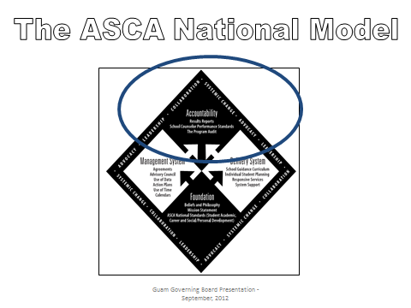

Accountability

- Program Evaluation

It is important that school counselors use data to show program effectiveness. To evaluate the impact of the counseling program process, perception and results data should be collected to show immediate and long term effectiveness.

Process Data

Process data answers the question,” What did you do for whom?”

Examples include:
- Held six five-session counseling groups with eight students each on anger management.
- 1,350 9th grade students attended a substance abuse prevention workshop day.

Perception Data

Perception data answers the question,” What do people think they know, or believe or can do?” These data measure knowledge gained attitudes and beliefs, competencies achieved. This is often collected through pre-post surveys, tests or skill demonstration, presentation, role play, data, evaluation forms.

Examples include:
- Competency- 100 percent of students in grades 9-12 have completed an academic plan.
- Knowledge- 92 percent of students can identify the early warning signs of violence.
- Attitudes or beliefs-29 percent of students report feeling safe at school.

Results Data

Results data answers the “So what”? question. These data show that your program has had a positive effect on students’ ability to utilize their knowledge, attitudes and skills to effect behavior change. Data sources are attendance rates, number of discipline referrals, graduation and dropout rates, grade point averages.

Examples include:
- Graduation rates improved by 14 percent.
- Discipline referrals decreased by 20 percent.

Data Management

Each school district should decide what is important to be monitored. Student database systems enhance a school counselor’s ability to monitor every child’s progress. Tools for this include student education records and career portfolios.

Closing the Gap

Quality teachers know that not all students learn in the same way or at the same speed. Through the analysis of disaggregated data, they discover which groups of students need additional help and design innovations specifically geared towards those students’ needs.

In the same way, school counselors know that not all students come to school with equal academic and person/social resources. Analyzing disaggregated data also uncovers equity and access issues. Once the problem areas are brought to light, it is important to thoughtfully consider those factors which are creating barriers in those areas. School counselors then strategically design programs or activities to help lessen the barriers and begin to close the gap. The results of these interventions can be documented with student-achievement and achievement –related data. These types of program results move school counseling from the periphery of the school’s mission to a position where the educational community views it as critical to student success.

Results Reports

Results reports help answer the question, “How are students different as a result of the program?”

- Data is collected at three different intervals:
  - Short-term data: provide an immediate evaluation of the activity process on student behavior or student learning
  - Intermediate data: data collection occurs over a longer period of time as a benchmark or indication of the progress toward the goal
  - Long-term data: data collection occurs over an extended period of time and measures the activity’s overall results for students

- Results reports serve as a tool for:
      - Ensuring the program was carried out as planned
      - Ensuring every student was served
      - Ensuring developmentally appropriate materials were used
      - Documenting the program’s process, perception and results data
      - Documenting the program’s immediate, intermediate and long-range impact
      - Analyzing the program’s effectiveness
      - Sharing the program’s success
      - Advocating for systematic change in the school system

- Results reports may include the following:
- The grade level served
- Lesson content areas
- Curriculum or materials used
- Process data such as the number of school counseling lessons delivered and in what subject area
- Process data such as the number of students served
- Short-term perception data such as pre-post tests of knowledge gained
- Intermediate and long-term results data such as the impact on behavior, attendance or achievement
- The implications of the results on the counseling program

Impact Of The School Counseling Program Over Time

  - Comparing data over time offers long-term information reflecting trends in student improvement or areas of concern, which become areas for improvement
  - The impact-over-time form serves as a summary sheet listing baseline and change data over time and gives the counseling staff a tool to review overall student progress

  - Documenting baseline data prior to programmatic restructuring provides ready, necessary information for data-based decision making

- School Counselor Performance Standards
School counselor performance standards align with the ASCA National Model and contain basic standards of practice expected from counselors. However, with the adoption of this document, the Guam School Counselors will be annually evaluated on 10 of these standards. (Please refer to the DOE Professional School Counselor Evaluation Tool).

Standard 1: The professional school counselor plans, organizes and delivers the school counseling program.
Standard 2: The professional school counselor implements the school guidance curriculum through the use of effective instructional skills and careful planning of structured group sessions for all students.
Standard 3: The professional school counselor implements the individual planning component by guiding individuals and groups of students and their parents or guardians through the development of educational and career plans.
Standard 4: The professional school counselor provides responsive services through the effective use of individual and small-group counseling, consultation and referral skills.
Standard 5: The professional school counselor provides system support through effective school counseling program management and support for other educational programs.
Standard 6: The professional school counselor discusses the counseling department management system and the program action plans with the school administrator.
Standard 7: The professional school counselor is responsible for establishing and convening an advisory council for the school counseling program.
Standard 8: The professional school counselor collects and analyzes data to guide program direction and emphasis.
Standard 9: The professional school counselor monitors the students on a regular basis as they progress in school.
Standard 10: The professional school counselor uses time and calendars to implement an efficient program.
Standard 11: The professional school counselor develops a results evaluation for the program.
Standard 12: The professional school counselor conducts a yearly program audit.
Standard 13: The professional school counselor is a student advocate, leader, collaborator, and a systems change agent.

- The Program Audit
  - The audit is a tool aiding school counselors in the breakdown and analysis of each program component.

  - Once completed, the annual program audit indicates implementation areas that will be improved or enhanced. School Guidance Counselors will share the results of the program audit with the Advisory Council before the end of each school year. The audit also serves as the basis for establishing the Management Agreement for subsequent school years.

  - The audit provides evidence of the program’s success in comparison with ASCA’s National Model.

  - After completing the annual audit, analyze responses to determine the following:

- Major strengths of program
- Items in greatest need of strengthening
- Short-range goals for improvement
- Long-range goals for improvement

Chapter 7

Professional School Counselor’s
Job Description and Evaluation

PROPOSED SCHOOL COUNSELOR JOB DESCRIPTION

QUALIFICATIONS: (Refer to Guam Public Law 31-50)
- A School Counselor Certificate issued by the Guam Commission of Educators Certification (GCEC)
- Master’s Degree (Accredited college/university) in Guidance or Counseling or related field (provided existing law is amended)
- Moral character and no police record

REPORT TO:
Principal or Designee

PERFORMANCE RESPONSIBILITIES:
- Classroom Guidance/Counseling Curriculum:
- The professional school counselor plans, organizes, teaches, gathers data and information, and delivers the comprehensive school counseling program and services.
- Individual and Group Counseling:
- The professional school counselor (a strong advocacy for his/her clients) implements and provides counseling sessions which addresses the following areas of academic, social, behavioral, vocational or other personal concerns. These sessions are set up to meet the needs of the students as expressed by the students, parents, teachers, administrators, or other school stakeholders.
- Personal and Professional Growth and Development:
- The professional school counselor promotes, provide, and facilitate workshops, consultation services, parent conferences or activities, and community or departmental referrals.
- Other duties as assigned by the Superintendent and his/her designee.

ACCOUNTABILITY OF SCHOOL COUNSELING PROGRAM:
- The professional school counselor meets, communicates, collaborates, and plans the counseling program with a year-round schedule or master calendar.
- The professional school counselor prepares and provides the principal counseling lesson plans throughout the year.
- The professional school counselor gathers, uses, and monitors data and information as a
guide to move in a direction for the success and assessment of the school community.
- The results of these gathered data are shared with the involved school stakeholders for further assessments, improvements, and development for growth as well as yearly program audit to assess the progress of the school counseling program.

SCHOOL COUNSELING PROGRAM DELIVERY SYSTEM:
- The professional school counselor teachers and conducts classroom and small group sessions.
- The professional school counselor provides and conducts individual sessions.
- The professional school counselor addresses, provides, consults, and coordinate responsive services and systems support as well as other appropriate guidance/counseling duties

SCHOOL COUNSELOR EVALUATION

School: __________________________________ Date: _______________________

Counselor’s Name: ____________________________________________________________

Standards | Descriptions | HE  4 | EF  3 | EM  2 | I  1
Program Organization | The professional school counselor plans, organizes and delivers the comprehensive school counseling program.
2.  Guidance Curriculum | The professional school counselor implements the guidance curriculum through the use of effective instructional skills and careful planning of structured group sessions for all students.
3.  Individual Student Planning | The professional school counselor implements the individual planning component by guiding individuals and groups of students and their parents through the development of educational and career plans.
4.  Responsive Services | The professional school counselor implements the responsive services component through the effective use of individual and small-group counseling, consultation and referral skills.
5.  Systems Support | The professional school counselor implements the systems support component through effective guidance program management and support for other educational programs.
6.  Management Agreement | The professional school counselor has discussed the counseling department management system and the program action plans with the school administrator.
7.  Use of Data | The professional school counselor knows how to use data as a guide to program direction and emphasis.
8.  Student Monitoring | The professional school counselor monitors the students on a regular basis as they progress in school.
9.  Master Calendar/Time | The professional school counselor implements the master calendar/time component to have an efficiently run program.
10.  Results Evaluation | The professional school counselor has developed a results evaluation for the program.
11.  Program Audit | The professional school counselor conducts a yearly program audit.
12.  Advisory Council | The professional school counselor is responsible for establishing and convening a school advisory council for the comprehensive school guidance and counseling program.
13.  Infusing Themes | The professional school counselor is a student advocate, leader, collaborator and a systems change agent.

HE – Highly Effective (48-52pts), EF – Effective (39-47pts), EM – Emerging (26-38pts), I – Ineffective (13-25pts)

Counselor: _____________________________ Signature: ______________________

Administrator: ________________________ Signature: ______________________

APPENDICES

APPENDIX A
LESSON PLAN TEMPLATE

Guam School Counselor Lesson Plan

Grade: _______________ Teacher___________ Taught week of __________________
Lesson Topic: _______________________________
Objective: ___________________________________________________________
Materials/Resources: __________________________________________________

ASCA Competencies Addressed. Put an X behind the competency address:
Academic Domain
Standard 1: Students will acquire the attitudes, knowledge, and skills that contribute to effective learning in school and across the life span.
Standard 2: Students will complete school with the academic preparation essential to choose from a wide range of substantial postsecondary options, including college.
Standard 3: Students will understand the relationship of academics to the world of work, and to life at home and in the community.
Career Domain
Standard 4: Students will acquire the skills to investigate the world of work in relation to knowledge of self and to make informed career decisions.
Standard 5: Students will employ strategies to achieve future career goals with success and satisfaction.
Standard 6: Students will understand the relationship between personal qualities, education, training, and the world of work.
Personal Social Domain
Standard 7: Students will acquire the knowledge, attitudes, and interpersonal skills to help them understand and respect self and others.
Standard 8: Students will make decisions, set goals, and take necessary action to achieve goals.
Standard 9: Students will understand safety and survival skills.

Competency/Indicator addressed:

Guam Standard Addressed:

Activity:

Material Needed:

How did Student change as a result of this lesson:
Student will be able to: (Blooms Taxonomy) (Level 1= Knowledge/remembering; Level 2 = Comprehension/Understanding; Level 3 = application/Applying; Level 4 = Analysis/Analyzing; Level 5 = Synthesis/Creating; Level 6 =Evaluation)
SWBAT:
SWBAT:
SWBAT:
Evaluation: Fill out all three areas to show results of lesson.
Process Data:
Perception Data:
Results Data:

LESSON PLAN SAMPLES
Guam School Counselor Lesson Plan

Grade: K-2 Teacher: Mrs C. Taught week of: First Week of September
Lesson Topic: Building a Positive Classroom Climate
Objective: Create positive classroom climate
Materials/Resources: Index Cards (5x7 inches or larger) for each student and adult, current photo (2x3 inch bust) of each student, basket, marker, chart paper

ASCA Standards Addressed. Highlight the standard/competency addressed:
Academic Domain
Standard A: Students will acquire the attitudes, knowledge, and skills that contribute to effective learning in school and across the life span.
Standard B: Students will complete school with the academic preparation essential to choose from a wide range of substantial postsecondary options, including college.
Standard C: Students will understand the relationship of academics to the world of work, and to life at home and in the community.
Career Domain
Standard A: Students will acquire the skills to investigate the world of work in relation to knowledge of self and to make informed career decisions.
Standard B: Students will employ strategies to achieve future career goals with success and satisfaction.
Standard C: Students will understand the relationship between personal qualities, education, training, and the world of work.
Personal Social Domain
Standard A: Students will acquire the knowledge, attitudes, and interpersonal skills to help them understand and respect self and others.
Standard B: Students will make decisions, set goals, and take necessary action to achieve goals.
Standard C: Students will understand safety and survival skills.

Competency/Indicator addressed:
- A:A1.1 Articulate feelings of competence and confidence as learners
- C:A1.4 Learn how to interact and work cooperatively in teams
- PS:A1.1 Develop positive attitudes toward self as a unique and worthy person

Activity:
- Introduction: When we try to learn everyone’s name and say “hi” or “hello” to each other, we help everyone feel like we are happy they are here. Let’s practice this.
- Initial class meeting or kindergarten only: Show students a name card. Ask students to identify whose card it is. Repeat the process for each student, selecting cards from the basket one at a time:
- Who is this? Identify the student by name.
- Give the name card to that student to hold, and model a greeting, such as Good Morning (name). I’m glad you are here today or Hello (name). It’s nice to see you!
- Once everyone has a name card, ask each student to name a favorite activity he or she likes to do before putting the card back in the basket.
- Discussion Questions : processing the activity
- Wrap- Up: everyone is welcome in our class! We’ll be learning more about each other all the time. One way you can help everyone feel welcome is to say hello to each other on the playground, at lunch, or during free time. Let’s try helping everyone feel welcome everyday

Materials Needed:
Index Cards (5x7 inches or larger) for each student and adult, current photo (2x3 inch bust) of each student, basket, marker, chart paper

How did Student change as a result of this lesson:
Student will be able to: (Blooms Taxonomy) (Level 1= Knowledge/remembering; Level 2 = Comprehension/Understanding; Level 3 = application/Applying; Level 4 = Analysis/Analyzing; Level 5 = Synthesis/Creating; Level 6 =Evaluation)

SWBAT: To remember names of classmates and facts about them.
SWBAT: To practice introducing themselves and others.
SWBAT: To give compliments to peers based on observations of their positive traits and talents.

Evaluation: Fill out all three areas to show results of lesson.

Process Data: Lesson conducted to 150 students were from K-2

Perception Data: Pre and post test administered verbally to each class resulting in at least 90 % displaying comprehension in the post test.

Results Data: Results data gathered from Perception data.

Guam School Counselor Lesson Plan

Grade: 3-5 Teacher: Mrs H. Taught week of: September 20-30, 2011
Lesson Topic: Cyber Bullying Time required: 45 minutes to one hour
Objective: Awareness of Cyberbullying behaviors
Materials/Resources: Power point Presentation, Projector, Laptop, Online videos
ASCA Standards Addressed. Highlight the standard/competency address:
Academic Domain
Standard A: Students will acquire the attitudes, knowledge, and skills that contribute to effective learning in school and across the life span.
Standard B: Students will complete school with the academic preparation essential to choose from a wide range of substantial postsecondary options, including college.
Standard C: Students will understand the relationship of academics to the world of work, and to life at home and in the community.
Career Domain
Standard A: Students will acquire the skills to investigate the world of work in relation to knowledge of self and to make informed career decisions.
Standard B: Students will employ strategies to achieve future career goals with success and satisfaction.
Standard C: Students will understand the relationship between personal qualities, education, training, and the world of work.
Personal Social Domain
Standard A: Students will acquire the knowledge, attitudes, and interpersonal skills to help them understand and respect self and others.
Standard B: Students will make decisions, set goals, and take necessary action to achieve goals.
Standard C: Students will understand safety and survival skills.

Competencies/Indicators addressed:
- PS:A1.1 Develop positive attitudes toward self as a unique and worthy person
- PS:A1.6 Distinguish between appropriate and inappropriate behavior
- PS:A1.7 Recognize personal boundaries, rights and privacy needs
- PS:B1.3 Identify alternative solutions to a problem
- PS:B1.4 Develop effective coping skills for dealing with problems
- PS:B1.5 Demonstrate when, where and how to seek help for solving problems and making decisions
- PS:C1.9 Learn to cope with peer pressure
Activity:
Lecture and discussion, video presentations, and pre and post quiz to check for understanding

How did Student change as a result of this lesson:
Student will be able to: (Blooms Taxonomy) (Level 1= Knowledge/remembering; Level 2 = Comprehension/Understanding; Level 3 = application/Applying; Level 4 = Analysis/Analyzing; Level 5 = Synthesis/Creating; Level 6 =Evaluation)
SWBAT: To be aware of the dangers of cyber bullying.
SWBAT: To choose appropriate cyber behaviors.
SWBAT: To make positive decisions involving cyber awareness.
Evaluation: Fill out all three areas to show results of lesson.

Process Data: 495 students were targeted from grades 3-5.

Perception Data: Pre and post test administered verbally to each class resulting in at least 95 % answers correct based on student responses. At least 85% of the students that were presented understood the concept of cyber bullying, its definition and how to get help.

Results Data: Pending discipline referrals. No cyber bullying cases have been reported to the counselor as of presentation date. Students who score 75% or better are deemed proficient with the student competency/indicator

Guam School Counselor Lesson Plan

Grade: 6-8 Teacher: Ms. E. Taught week of: First Week of September
Lesson Topic: Self-Awareness Time required: 20-30 minutes
Objective: To know one self
Materials/Resources: Handout A-23: Self-Awareness Worksheet
ASCA Standards Addressed. Highlight the standard/competency addressed:
Academic Domain
Standard A: Students will acquire the attitudes, knowledge, and skills that contribute to effective learning in school and across the life span.
Standard B: Students will complete school with the academic preparation essential to choose from a wide range of substantial postsecondary options, including college.
Standard C: Students will understand the relationship of academics to the world of work, and to life at home and in the community.
Career Domain
Standard A: Students will acquire the skills to investigate the world of work in relation to knowledge of self and to make informed career decisions.
Standard B: Students will employ strategies to achieve future career goals with success and satisfaction.
Standard C: Students will understand the relationship between personal qualities, education, training, and the world of work.
Personal Social Domain
Standard A: Students will acquire the knowledge, attitudes, and interpersonal skills to help them understand and respect self and others.
Standard B: Students will make decisions, set goals, and take necessary action to achieve goals.
Standard C: Students will understand safety and survival skills.

Competency/Indicator addressed:
- A:A1.5 Identify attitudes and behaviors that lead to successful learning.
- C:A1.3 Develop an awareness of personal abilities, skills, interests and motivations
- PS:A1.2 Identify values, attitudes and beliefs.
Activity:
Distribute a copy of Handout A-23 to each of the students and ask them to complete it in order to help them gain self-awareness. Afterwards, ask the students to consider that understanding themselves is important to friendship, school success, and eventually their career plans.
Materials Needed:
Handout A-23: Self-Awareness Worksheet

How did Student change as a result of this lesson:
Student will be able to: (Blooms Taxonomy) (Level 1= Knowledge/remembering; Level 2 = Comprehension/Understanding; Level 3 = application/Applying; Level 4 = Analysis/Analyzing; Level 5 = Synthesis/Creating; Level 6 =Evaluation)

SWBAT: To be aware of one’s attitudes, behavior, and abilities.
SWBAT: To know one’s values, skills and interests.
SWBAT: To reflect on skills needed in making choices about careers.
Evaluation: Fill out all three areas to show results of lesson.

Process Data: varies

Perception Data: Pre and post Self-Awareness worksheet administered to each class resulting in at least 90 % displaying completion during administering of the post worksheet.

Results Data: Results data gathered from Perception data.

Guam School Counselor Lesson Plan

Grade: 9-12 Teacher: Mr. P. Taught week of: September 20-30, 2012
Lesson Topic: Bullying Time required: 60 minutes
Objective: Awareness of Bullying behaviors
Materials/Resources: Power point Presentation, Projector, Laptop, Online videos
ASCA Standards Addressed. Highlight the standard/competency address:
Academic Domain
Standard A: Students will acquire the attitudes, knowledge, and skills that contribute to effective learning in school and across the life span.
Standard B: Students will complete school with the academic preparation essential to choose from a wide range of substantial postsecondary options, including college.
Standard C: Students will understand the relationship of academics to the world of work, and to life at home and in the community.
Career Domain
Standard A: Students will acquire the skills to investigate the world of work in relation to knowledge of self and to make informed career decisions.
Standard B: Students will employ strategies to achieve future career goals with success and satisfaction.
Standard C: Students will understand the relationship between personal qualities, education, training, and the world of work.
Personal Social Domain
Standard A: Students will acquire the knowledge, attitudes, and interpersonal skills to help them understand and respect self and others.
Standard B: Students will make decisions, set goals, and take necessary action to achieve goals.
Standard C: Students will understand safety and survival skills.

Competencies/Indicators addressed:
- PS:A1.1 Develop positive attitudes toward self as a unique and worthy person
- PS:A1.6 Distinguish between appropriate and inappropriate behavior
- PS:A1.7 Recognize personal boundaries, rights and privacy needs
- PS:B1.3 Identify alternative solutions to a problem
- PS:B1.4 Develop effective coping skills for dealing with problems
- PS:B1.5 Demonstrate when, where and how to seek help for solving problems and making decisions
- PS:C1.9 Learn to cope with peer pressure
Activity:
Lecture and discussion, video presentations, and pre and post quiz to check for understanding

How did Student change as a result of this lesson:
Student will be able to: (Blooms Taxonomy) (Level 1= Knowledge/remembering; Level 2 = Comprehension/Understanding; Level 3 = application/Applying; Level 4 = Analysis/Analyzing; Level 5 = Synthesis/Creating; Level 6 =Evaluation)
SWBAT: To be aware of the dangers of Bullying.
SWBAT: To choose appropriate behaviors in and out of the classroom.
SWBAT: To make positive decisions involving Bullying awareness.
Evaluation: Fill out all three areas to show results of lesson.

Process Data: 2,500 students were targeted for grades 9-12.

Perception Data: 5 question Pre and post test administered to each class resulting in at least 90 % answers correct based on student responses. At least 85% of the students that were presented understood the concept of Bullying, its definition and how to get help.

Results Data: Pending discipline referrals. No Bullying cases have been reported to the counselor as of presentation date. Students who score 75% or better are deemed proficient with the student competency/indicator

CHART FORM: ASCA STANDARDS
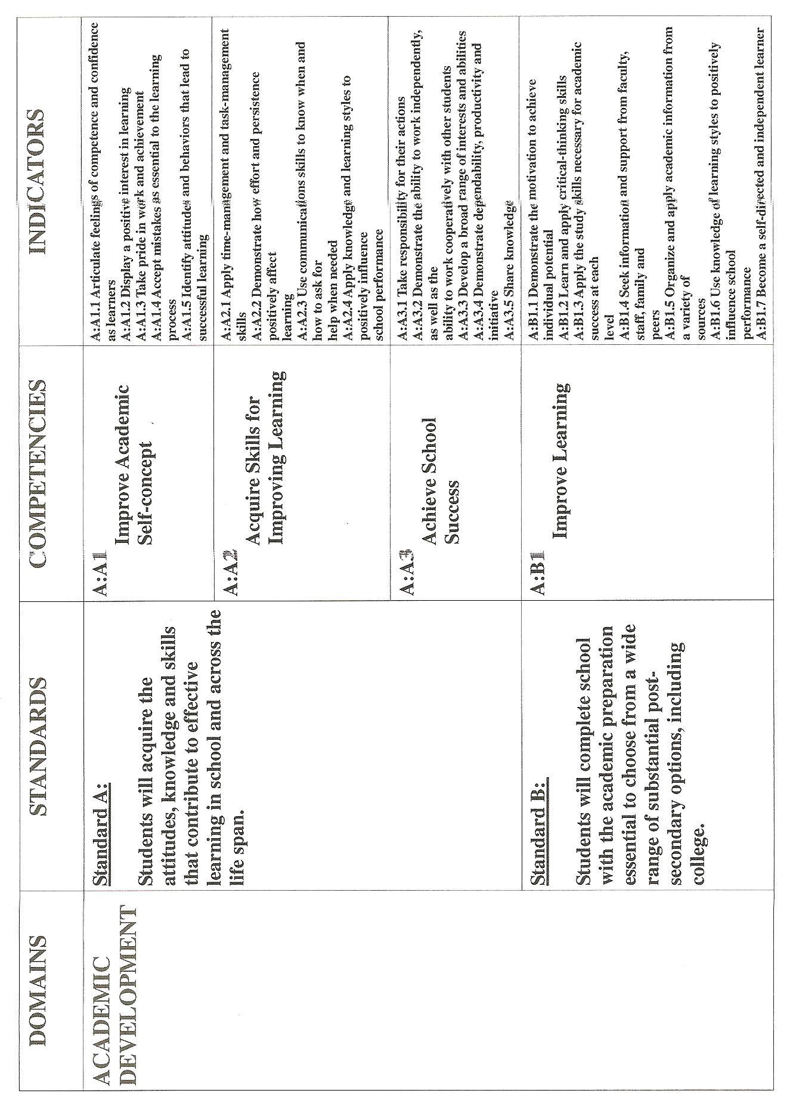
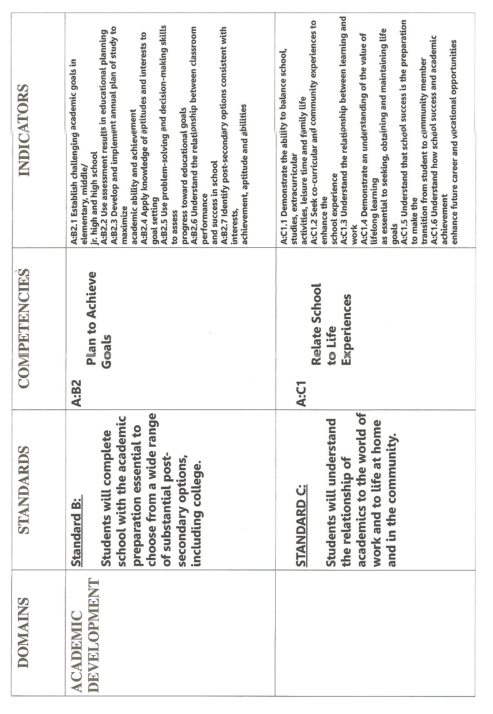
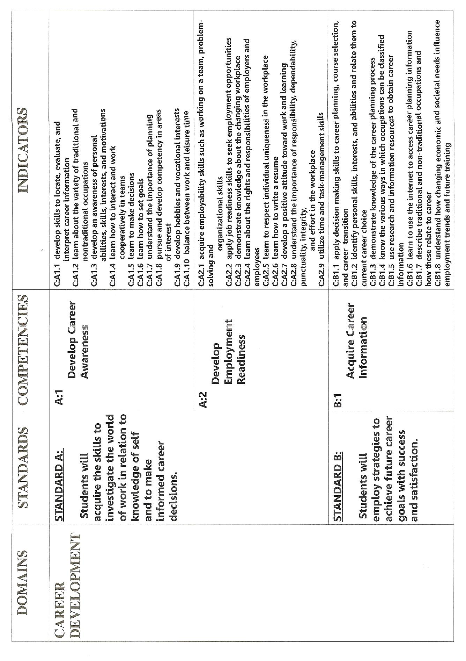
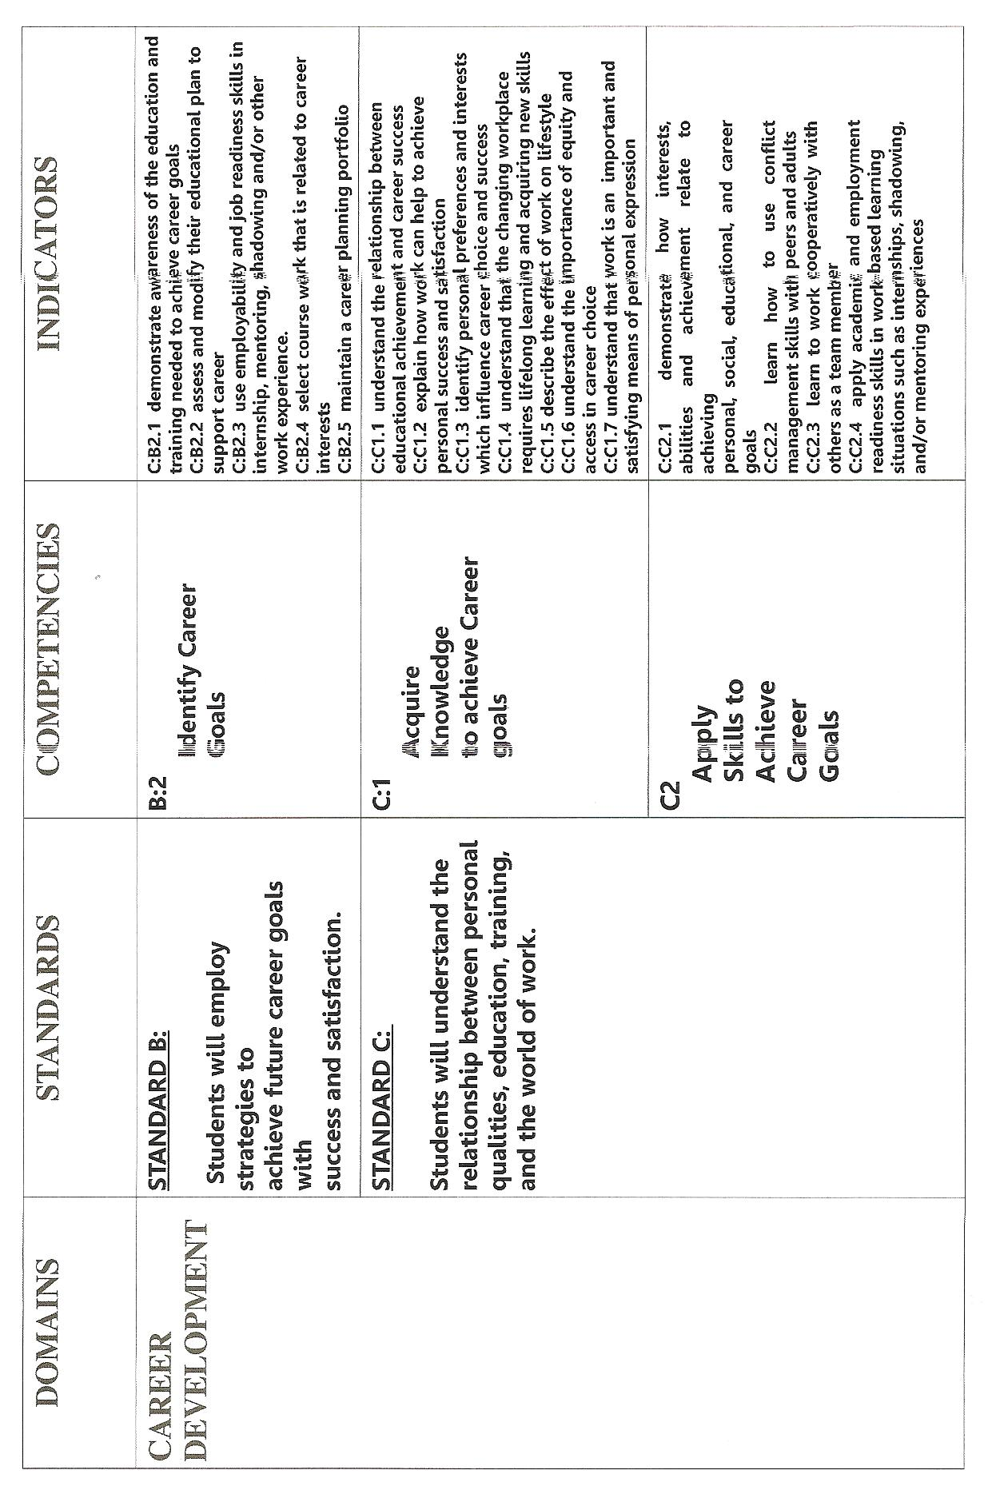
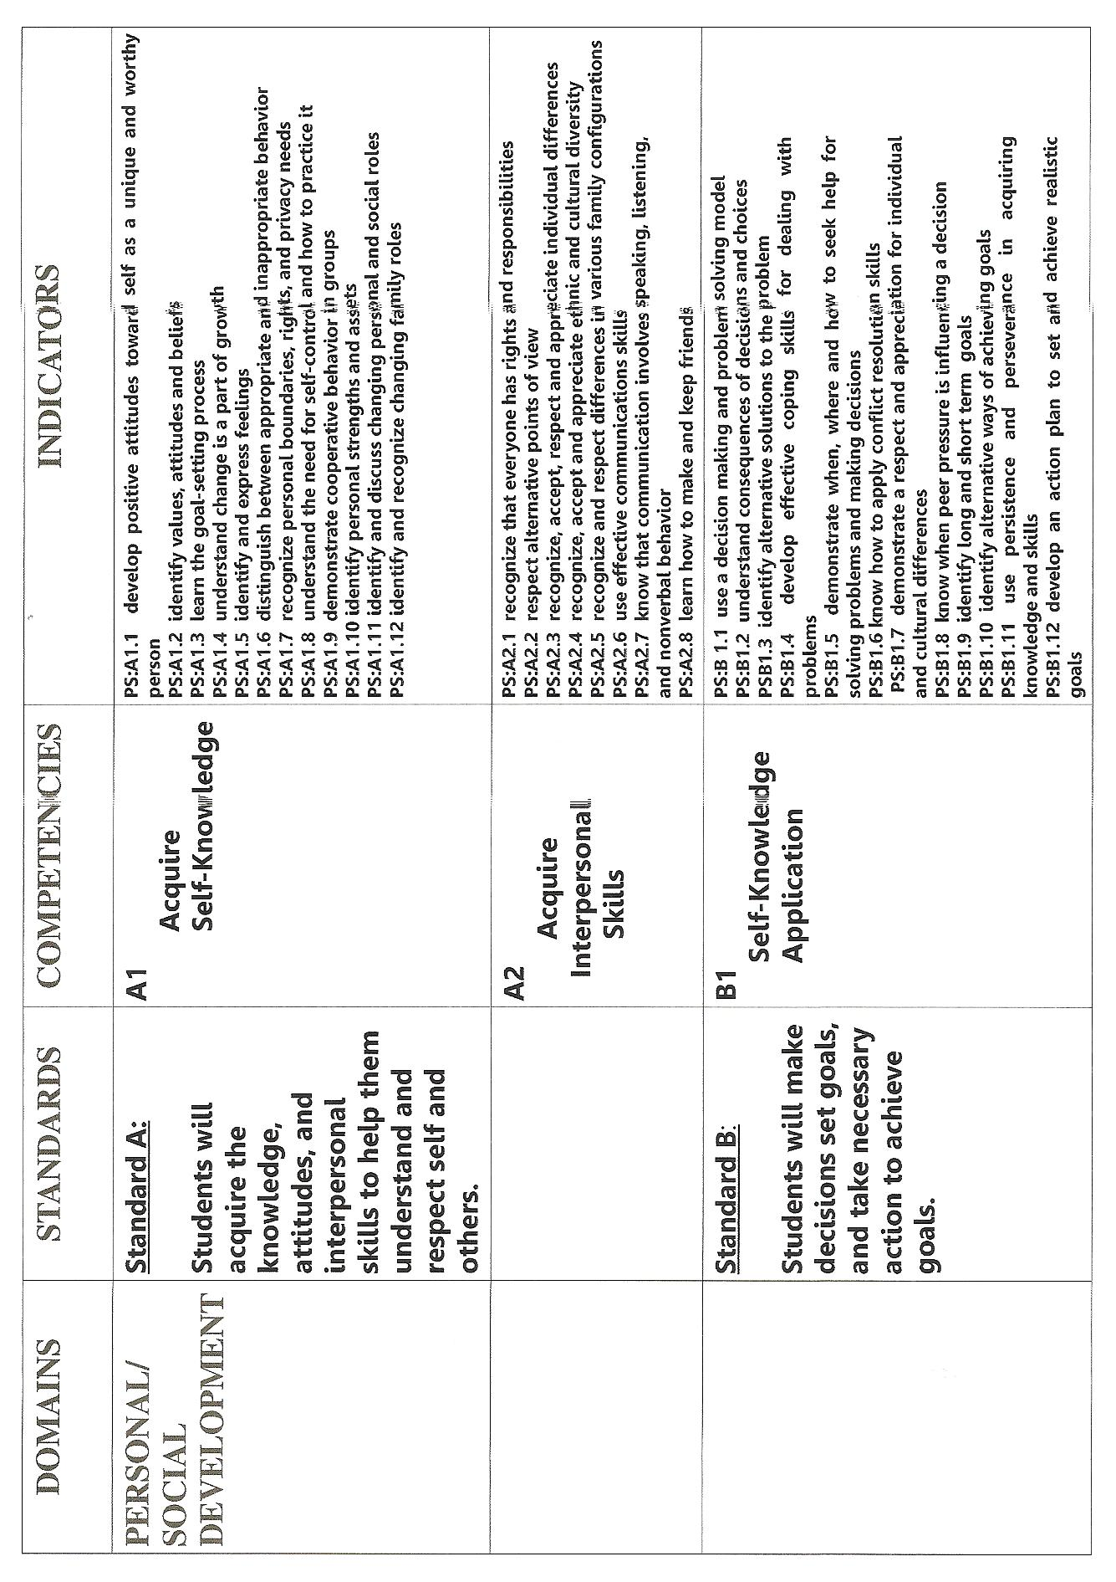
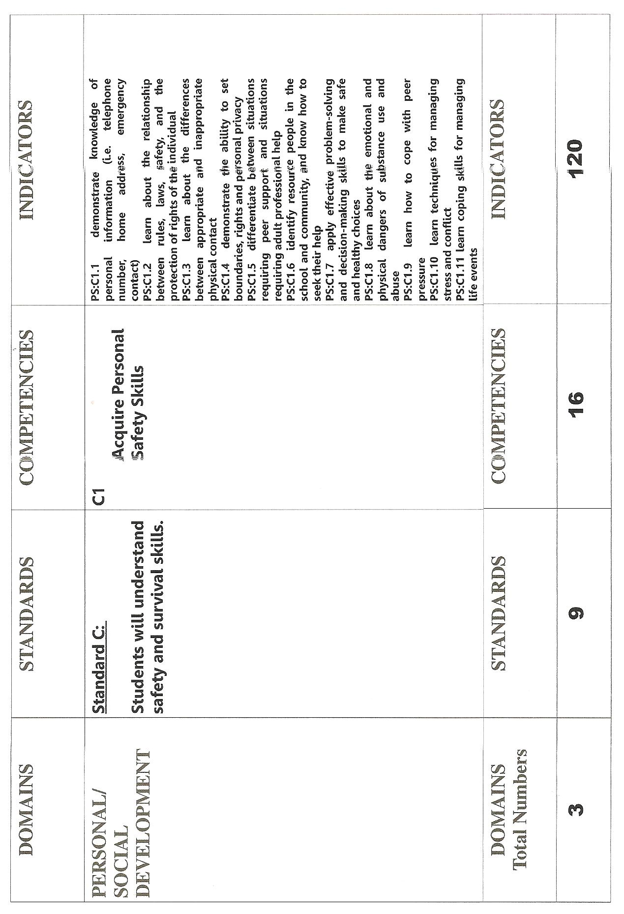
APPENDIX B
Family Educational Rights and Privacy Act (FERPA)

The Family Educational Rights and Privacy Act (FERPA) (20 U.S.C. § 1232g; 34 CFR Part 99) is a Federal law that protects the privacy of student education records. The law applies to all schools that receive funds under an applicable program of the U.S. Department of Education.
FERPA gives parents certain rights with respect to their children's education records. These rights transfer to the student when he or she reaches the age of 18 or attends a school beyond the high school level. Students to whom the rights have transferred are "eligible students."
- Parents or eligible students have the right to inspect and review the student's education records maintained by the school. Schools are not required to provide copies of records unless, for reasons such as great distance, it is impossible for parents or eligible students to review the records. Schools may charge a fee for copies.
- Parents or eligible students have the right to request that a school correct records which they believe to be inaccurate or misleading. If the school decides not to amend the record, the parent or eligible student then has the right to a formal hearing. After the hearing, if the school still decides not to amend the record, the parent or eligible student has the right to place a statement with the record setting forth his or her view about the contested information.
- Generally, schools must have written permission from the parent or eligible student in order to release any information from a student's education record. However, FERPA allows schools to disclose those records, without consent, to the following parties or under the following conditions (34 CFR § 99.31):

  - School officials with legitimate educational interest;
  - Other schools to which a student is transferring;
  - Specified officials for audit or evaluation purposes;
  - Appropriate parties in connection with financial aid to a student;
  - Organizations conducting certain studies for or on behalf of the school;
  - Accrediting organizations;
  - To comply with a judicial order or lawfully issued subpoena;
  - Appropriate officials in cases of health and safety emergencies; and
  - State and local authorities, within a juvenile justice system, pursuant to specific State law.
Schools may disclose, without consent, "directory" information such as a student's name, address, telephone number, date and place of birth, honors and awards, and dates of attendance. However, schools must tell parents and eligible students about directory information and allow parents and eligible students a reasonable amount of time to request that the school not disclose directory information about them. Schools must notify parents and eligible students annually of their rights under FERPA. The actual means of notification (special letter, inclusion in a PTA bulletin, student handbook, or newspaper article) is left to the discretion of each school.
For additional information or technical assistance, you may call (202) 260-3887 (voice). Individuals who use TDD may call the Federal Information Relay Service at 1-800-877-8339.
Or you may contact us at the following address:
Family Policy Compliance Office
U.S. Department of Education
400 Maryland Avenue, SW
Washington, D.C. 20202-5901
APPENDIX C
PROGRAM AUDIT
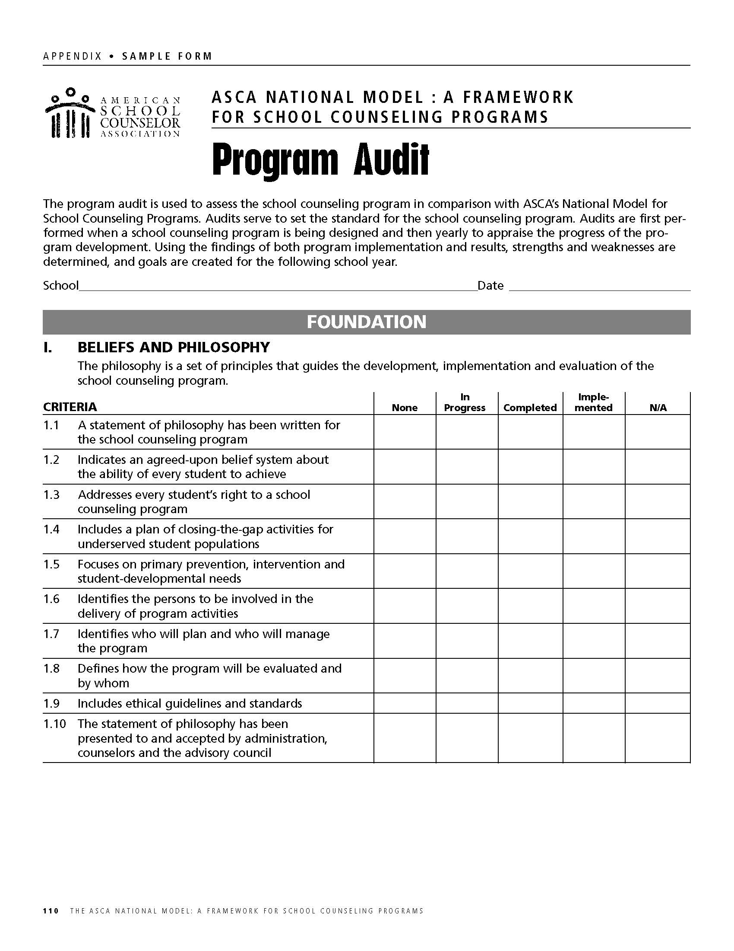
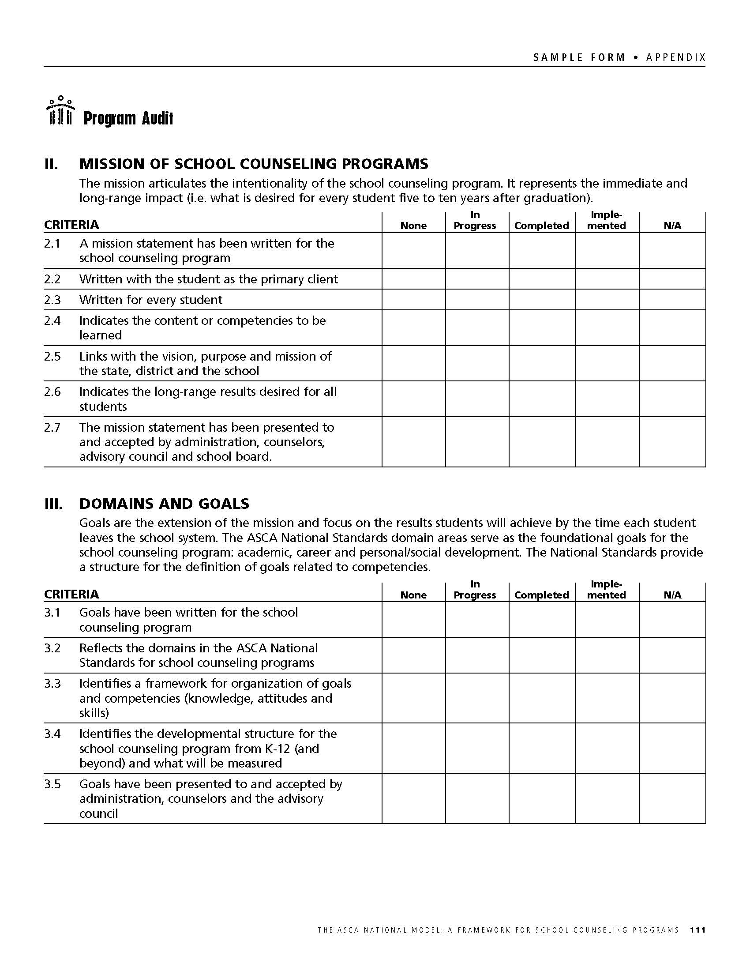

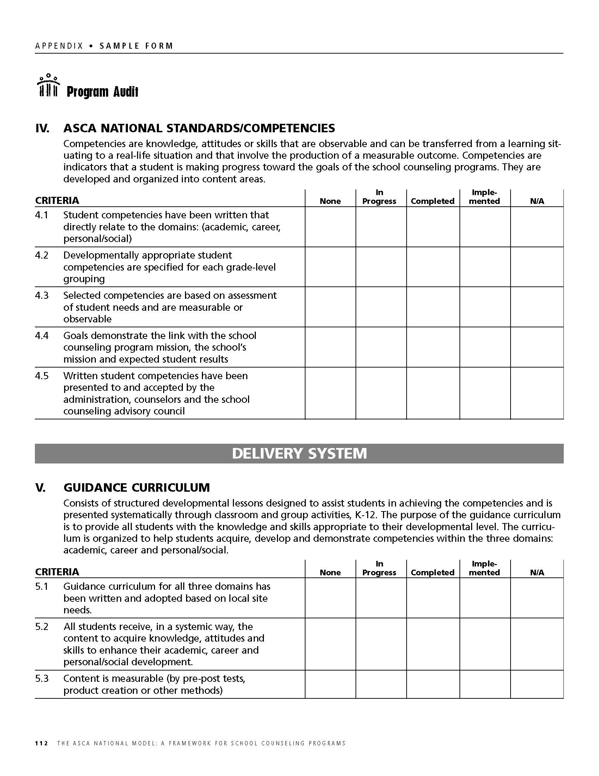

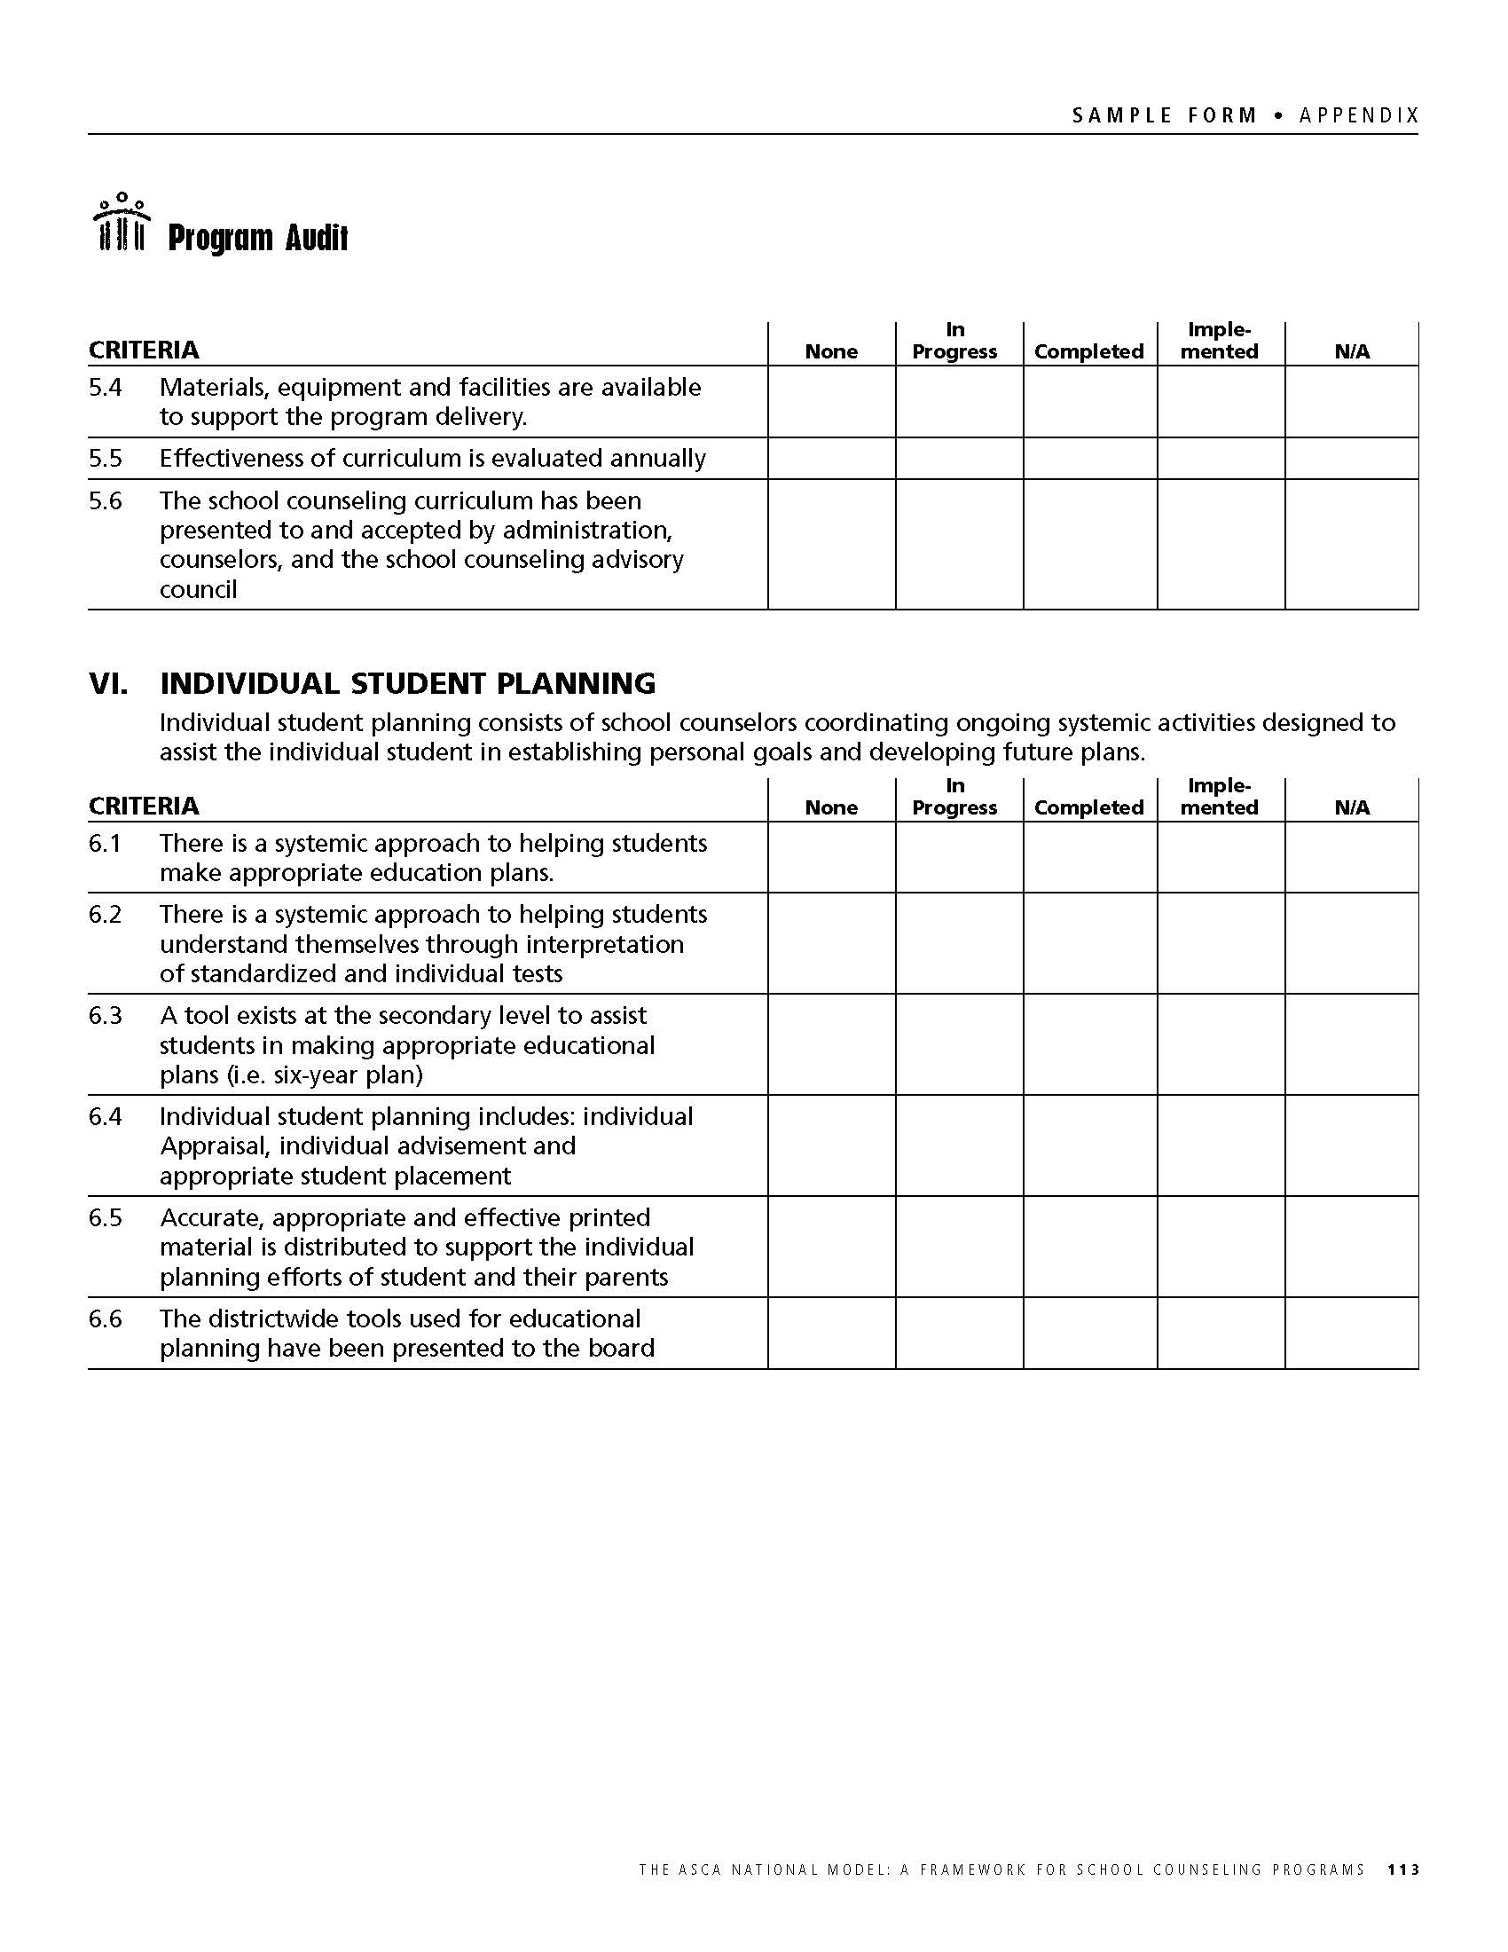

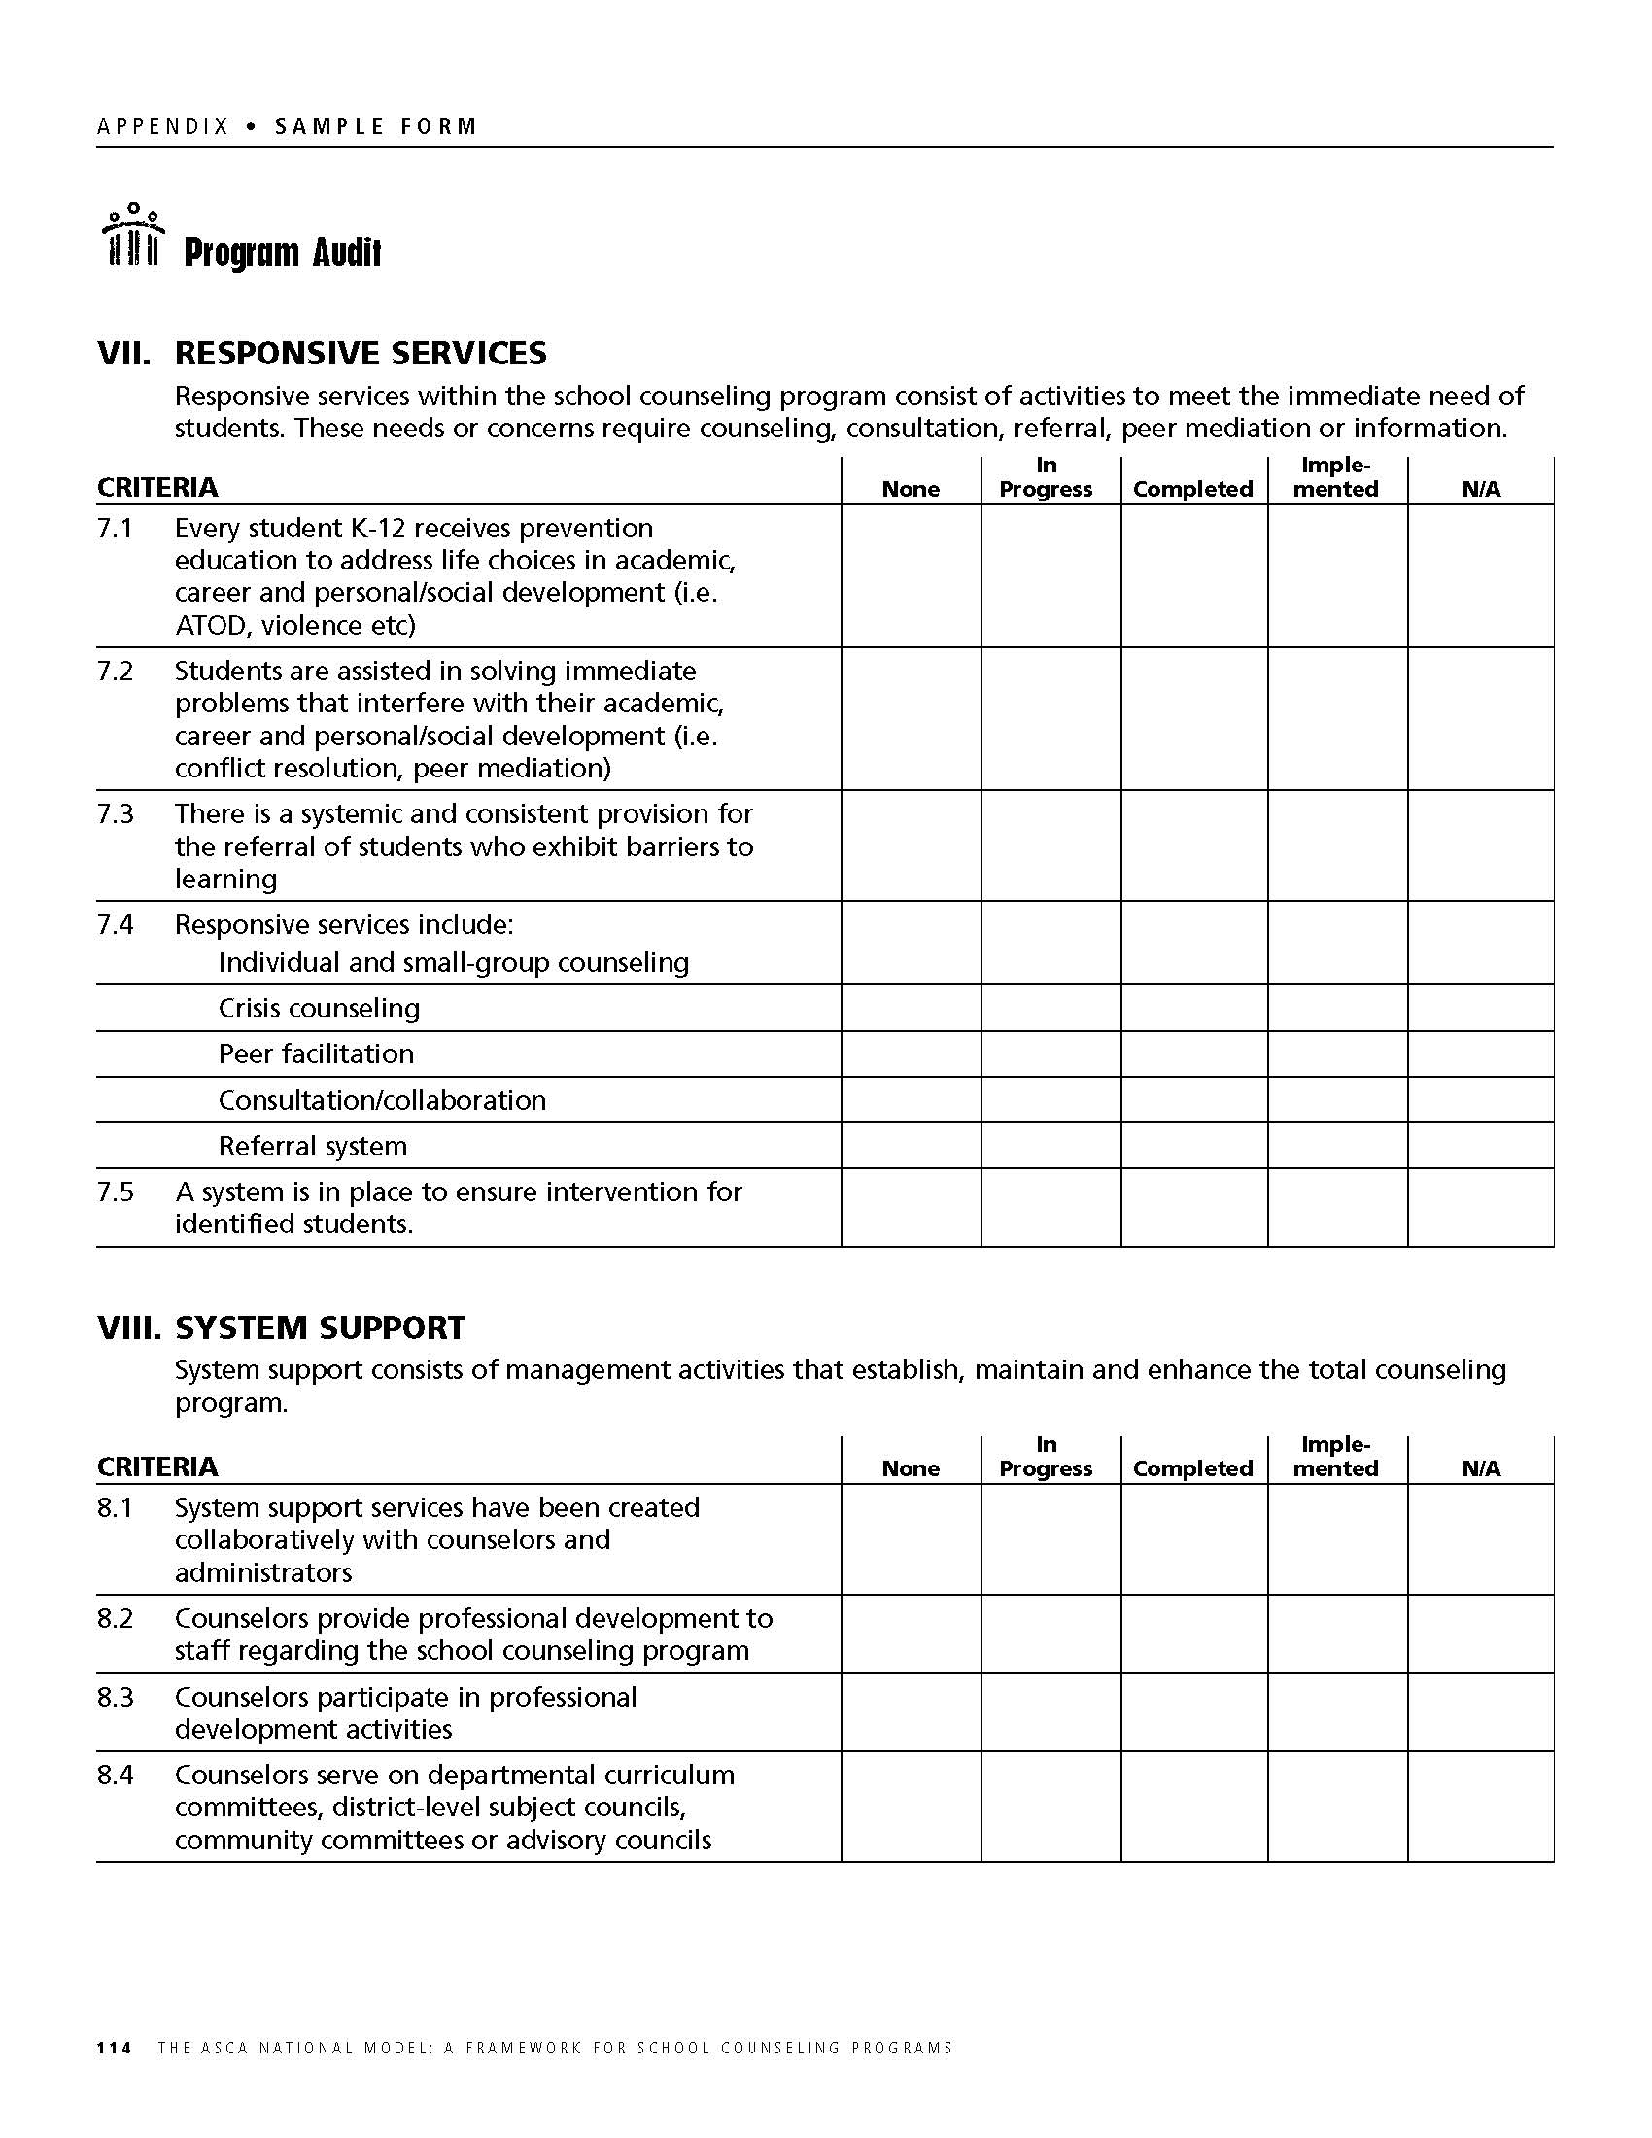

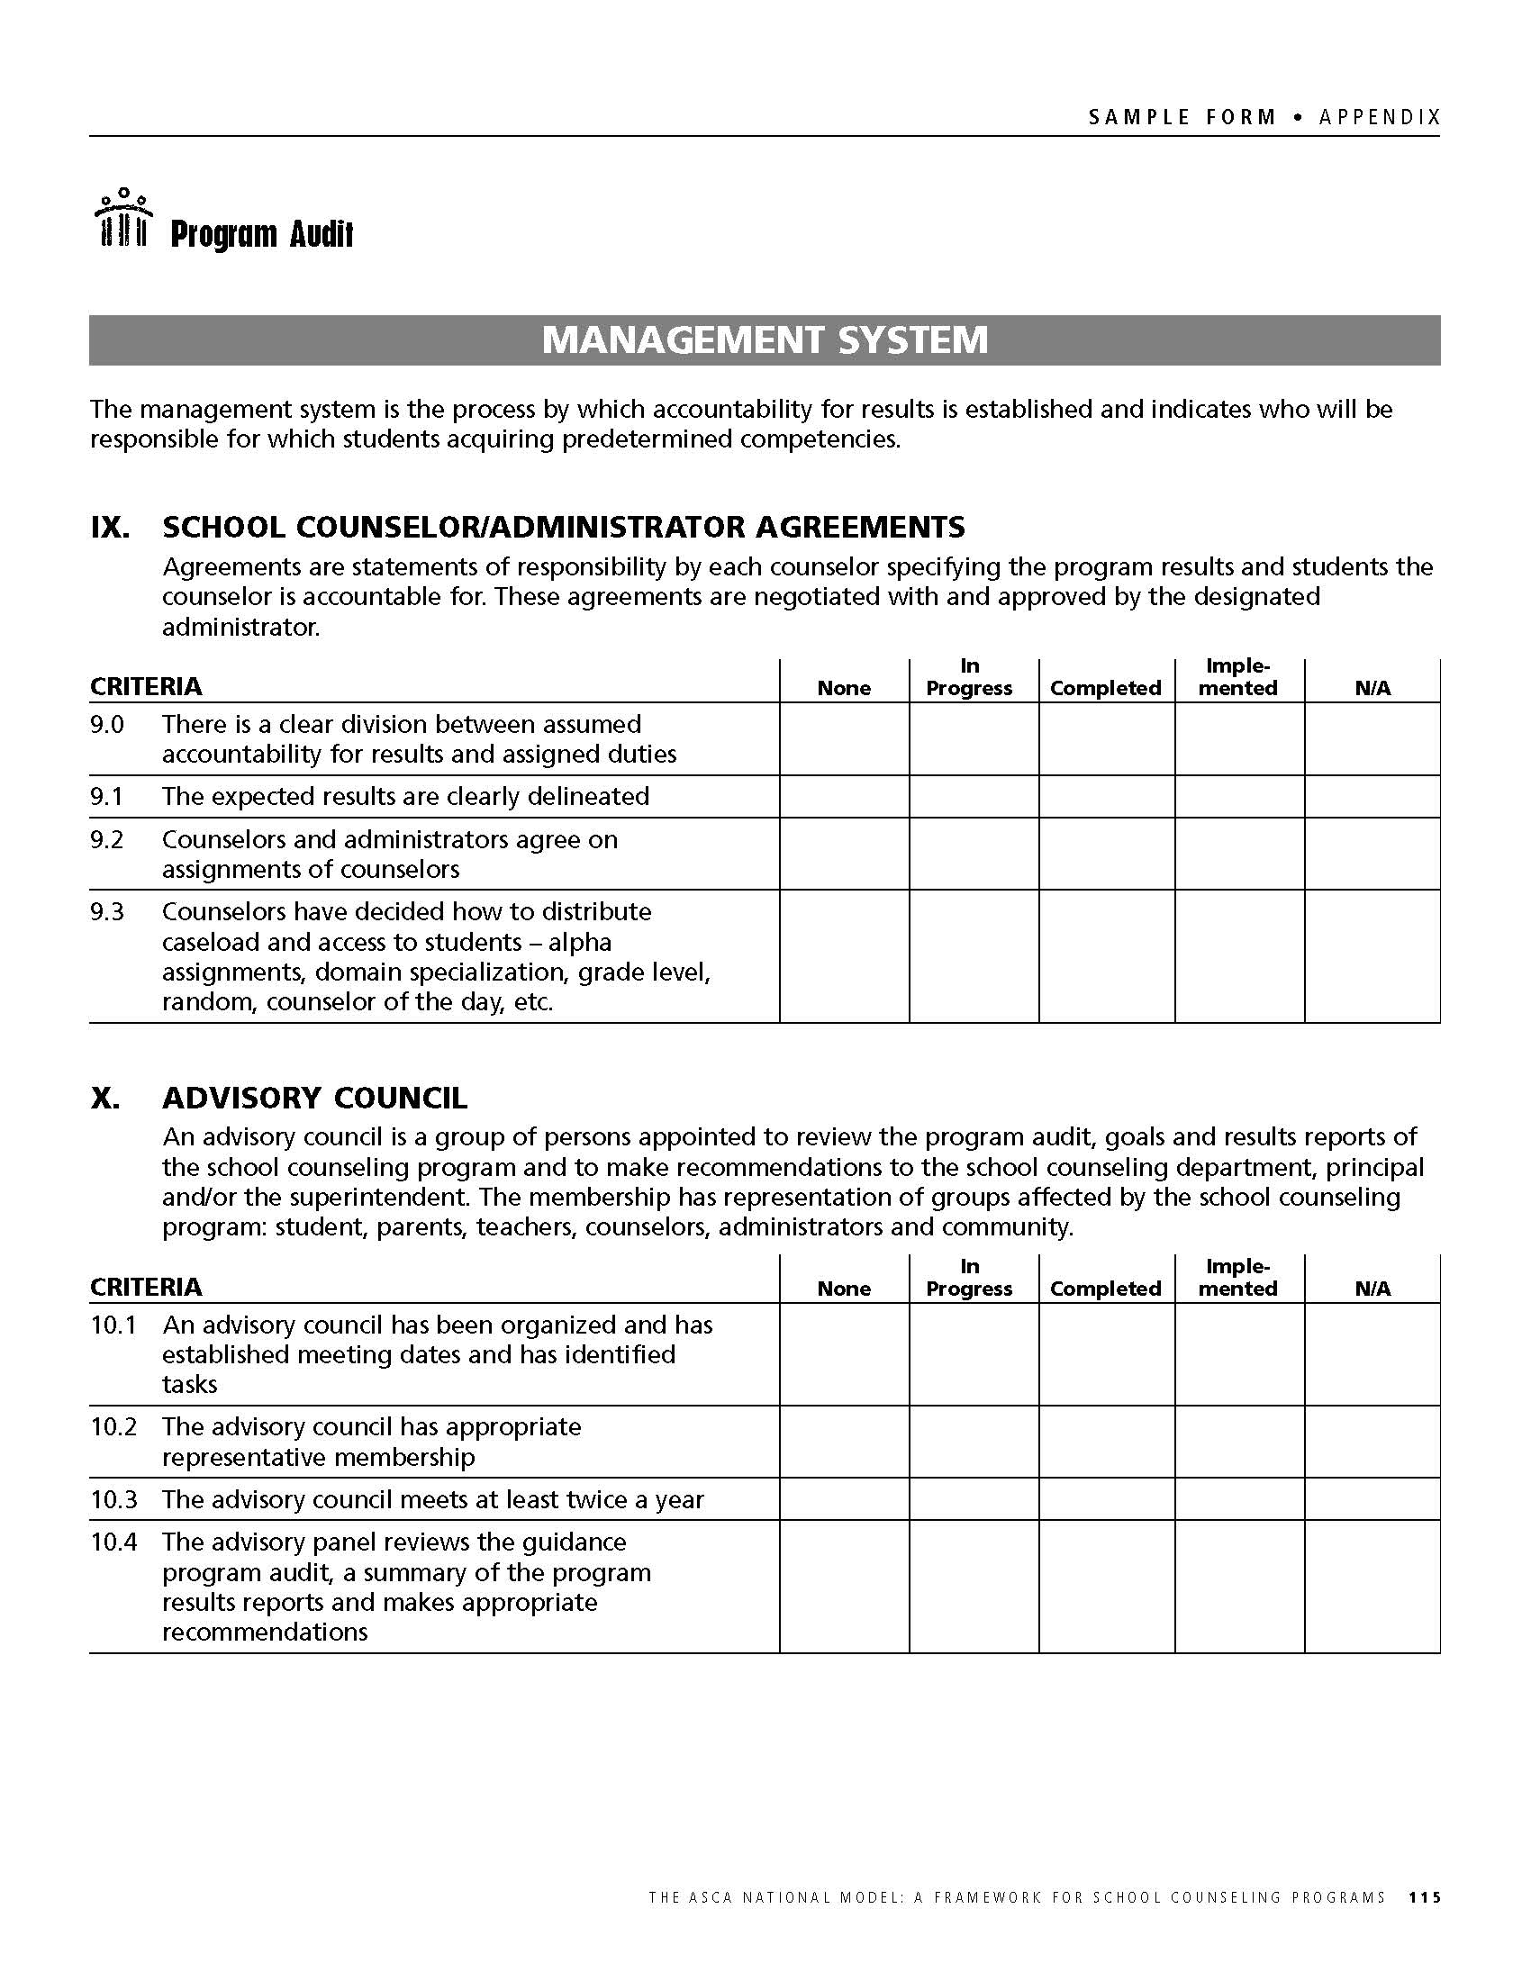

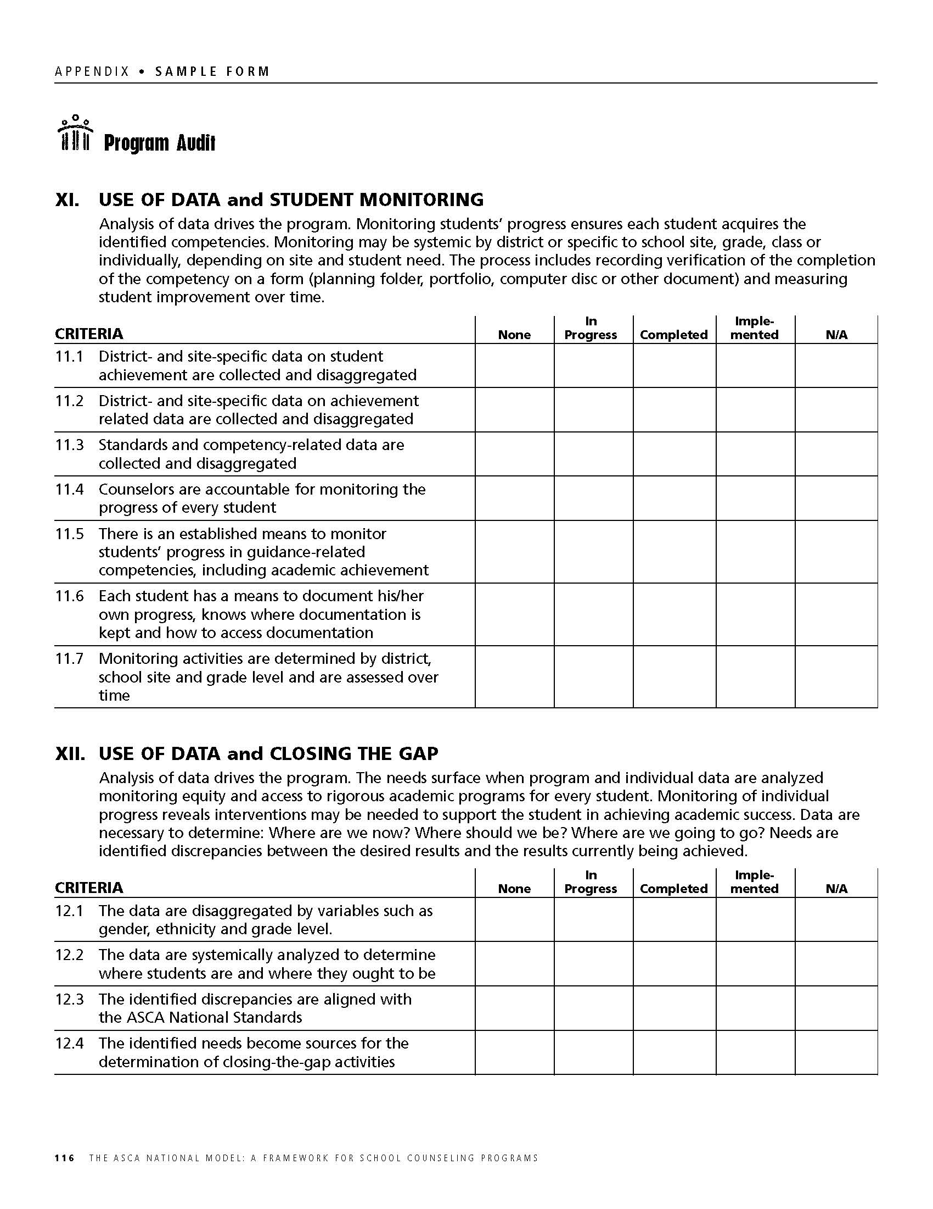

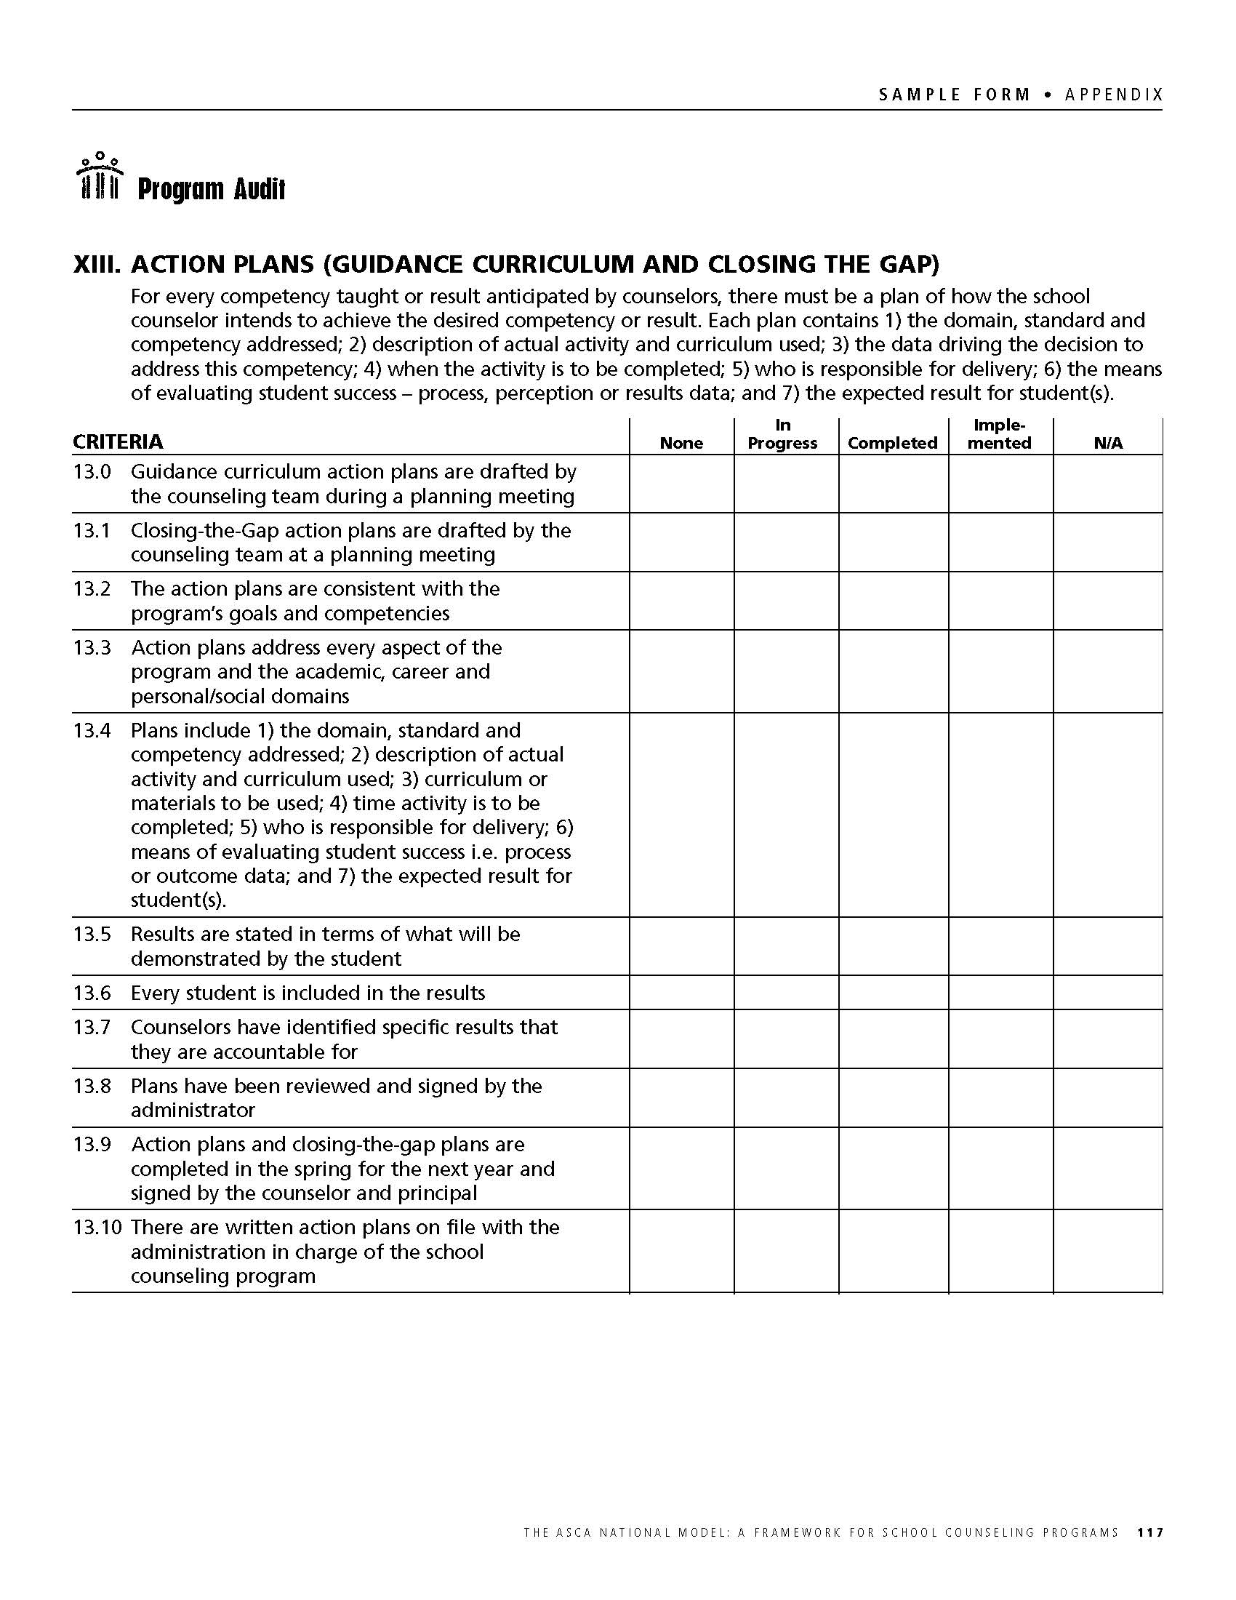

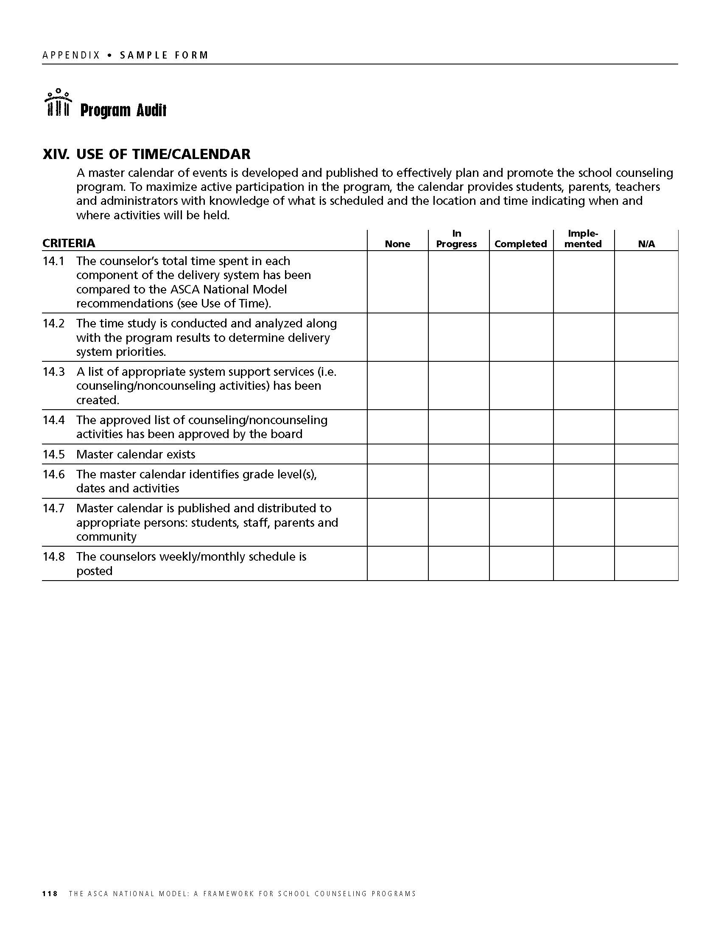

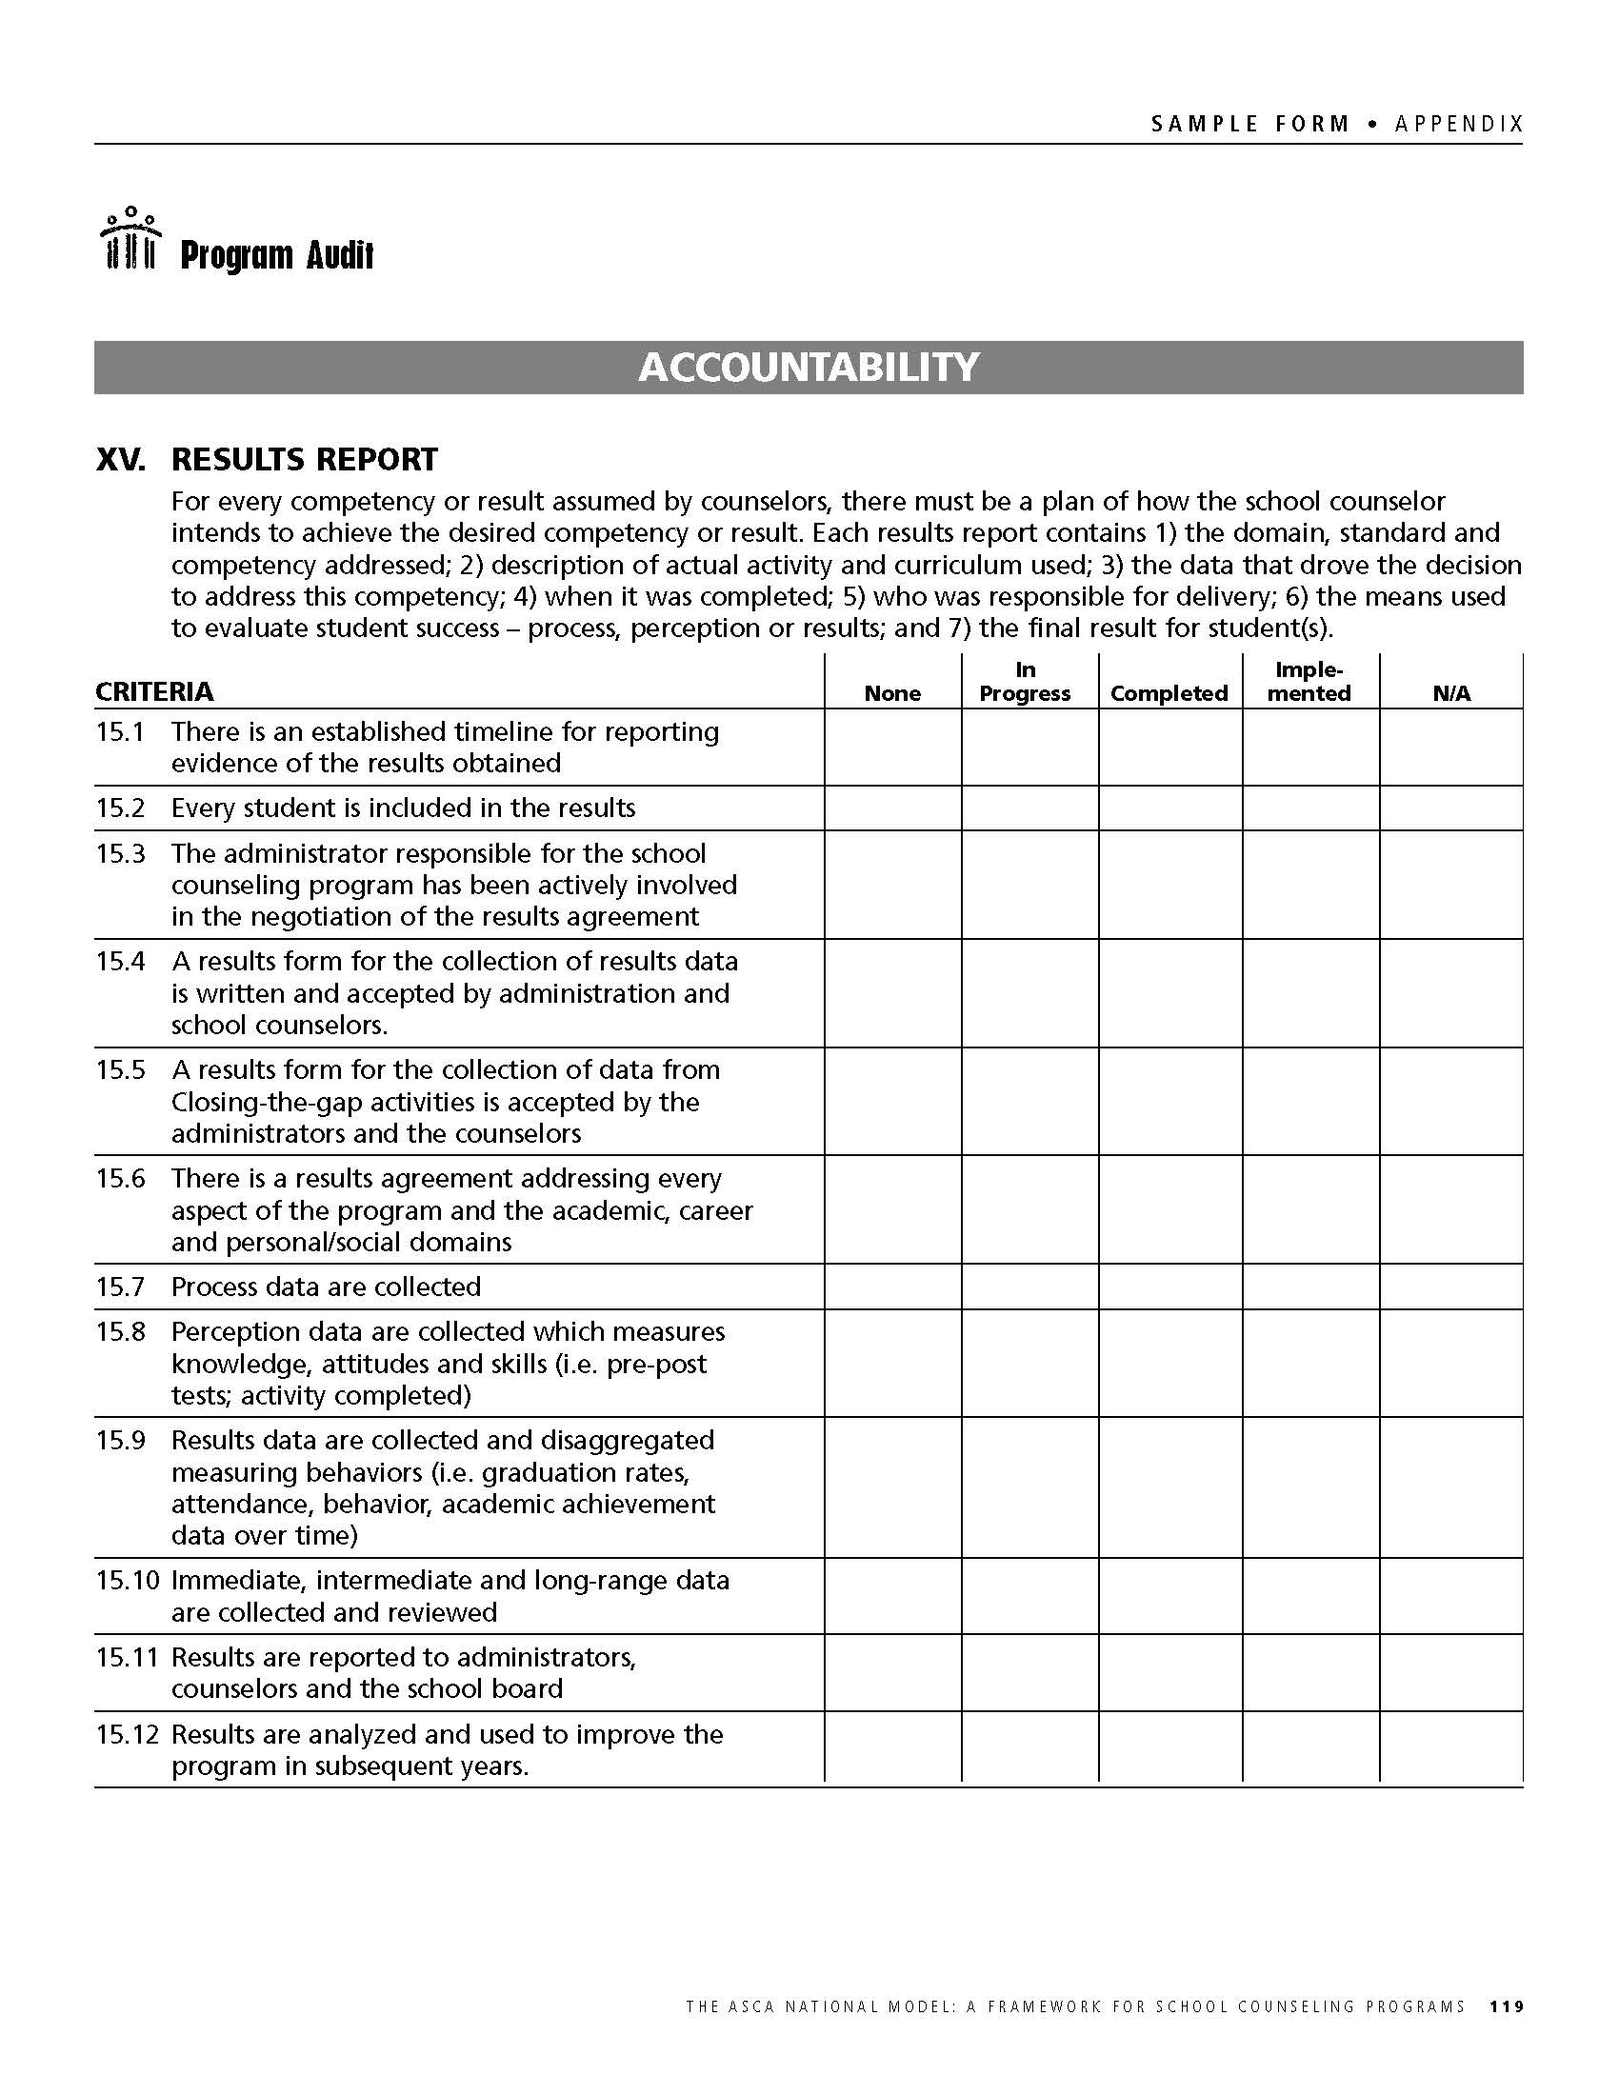

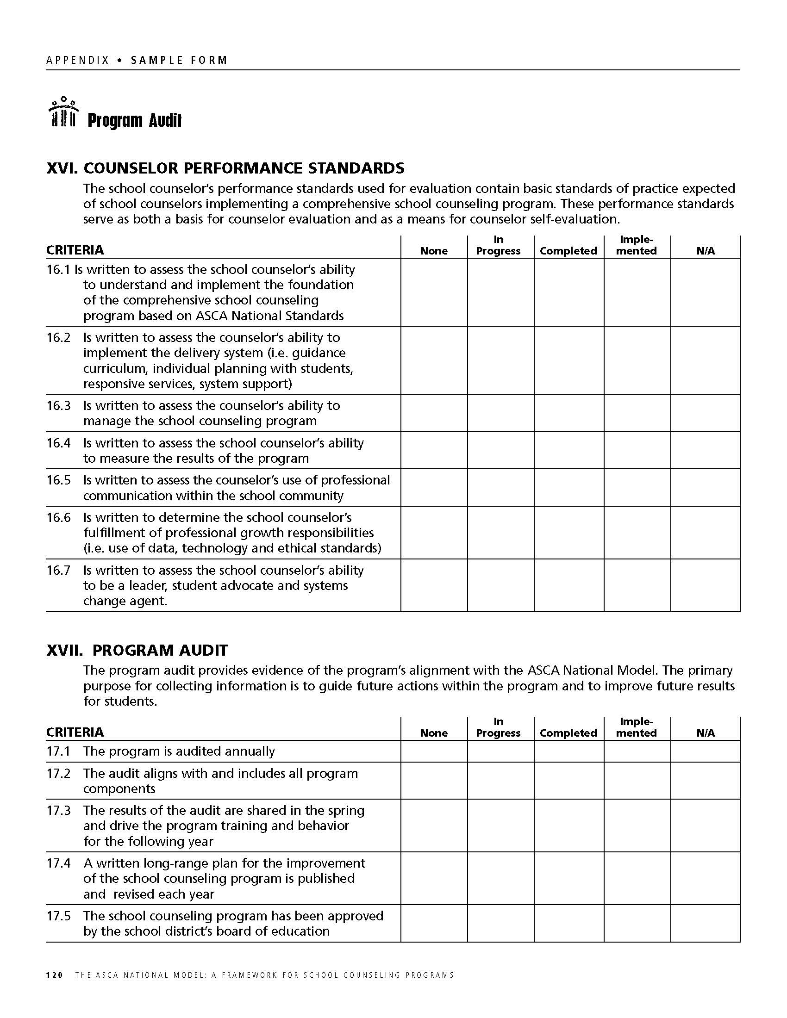

APPENDIX D
SCHOOL COUNSELOR ROLES

Why Elementary School Counselors
Today’s young people are living in an exciting time, with an increasingly diverse society, new technologies and expanding opportunities. To help ensure that they are prepared to become the next generation of parents, workers, leaders and citizens, every student needs support, guidance and opportunities during childhood, a time of rapid growth and change. Children face unique and diverse challenges, both personally and developmentally, that have an impact on academic achievement. “Toward a Blueprint for Youth: Making Positive Youth Development a National Priority”, U.S. Department of Health and Human Services

Elementary School Students’ Developmental Needs
The elementary years are a time when students begin to develop their academic self-concept and their feelings of competence and confidence as learners. They are beginning to develop decision-making, communication and life skills, as well as and character values. It is also a time when students develop and acquire attitudes toward school self, peers, social groups and family. Comprehensive developmental school counseling programs provide education, prevention and intervention services, which are integrated into all aspects of children’s lives. Early identification and intervention of children’s academic and personal/social needs is essential in removing barriers to learning and in promoting academic achievement. The knowledge, attitudes and skills that students acquire in the areas of academic, career and personal/social development during these elementary years serve as the foundation for future success.

Meeting the Challenge
Elementary school counselors are professional educators with a mental health perspective who understand and respond to the challenges presented by today’s diverse student population. Elementary school counselors don’t work in isolation; rather they are integral to the total educational program. They provide proactive leadership that engages all stakeholders in the delivery of programs and services to help students achieve school success. Professional school counselors align with the school’s mission to support the academic achievement of all students as they prepare for the ever-changing world of the 21st century. This mission is accomplished through the design, development, implementation and evaluation of a comprehensive, developmental and systematic school counseling program. ASCA’s National Standards in the academic, career, and personal/social domains are the foundation for this work. The ASCA National Model: A Framework For School Counseling Programs (ASCA, 2002), with its data-driven and results-based focus, serves as a guide for today’s school counselor who is uniquely trained to implement this program.

Elementary School Counselors Implement the Counseling Program by Providing:

School Guidance Curriculum
- Academic support, including organizational, study and test-taking skills
- Goal setting and decision-making
- Career awareness, exploration and planning
- Education on understanding self and others
Peer relationships, coping strategies and effective social skills
- Communication, problem-solving and conflict resolution
- Substance abuse education
- Multicultural/diversity awareness

Individual Student Planning
- Academic planning
- Goal setting/decision- making
- Education on understanding of self, including strengths and weaknesses
- Transition plans

Responsive Services
- Individual and small-group counseling
- Individual/family/school crisis intervention
- Conflict resolution
- Consultation/collaboration
- Referrals
System Support
- Professional development
- Consultation, collaboration and teaming
- Program management and operation

Elementary School Counselors Collaborate with:

Parents
Parent education
Communication/networking
Academic planning
College/career awareness programs
One-on-one parent conferencing
Interpretation of assessment results

Teachers
Classroom guidance activities
Academic support, including learning style assessment and education to help students succeed academically
Classroom speakers
At-risk student identification and implementation of interventions to enhance success

Administrators
School climate
Behavioral management plans
School-wide needs assessments
Student data and results
Student assistance team building

Students
Peer education
Peer support
Academic support
School climate
Leadership development
Community
Job shadowing, service learning
Crisis interventions
Referrals
Parenting classes
Support groups
Career education

**These examples are not intended to be all-inclusive

Why Elementary School Counselors?

Elementary school years set the tone for developing the knowledge, attitudes and skill necessary for children to become healthy, competent and confident learners. Through a comprehensive developmental school counseling program, counselors work as a team with the school staff, parents and the community to create a caring climate and atmosphere. By providing education, prevention, early identification and intervention, school counselors can help all children can achieve academic success. The professional elementary school counselor holds a master’s degree and required state certification in school counseling. Maintaining certification includes on-going professional development to stay current with education reform and challenges facing today’s students. Professional association membership enhances the school counselor’s knowledge and effectiveness. (Information Provided by ASCA)

Why Middle School Counselors
Today’s young people are living in an exciting time, with an increasingly diverse society, new technologies, and expanding opportunities. To help ensure that they are prepared to become the next generation of parents, workers, leaders, and citizens”, every student needs support, guidance, and opportunities during adolescence, a time of rapid growth and change. Early adolescents face unique and diverse challenges, both personally and developmentally, that have an impact on academic achievement.
Middle School Students’ Developmental Needs
Middle school is an exciting, yet challenging time for students, their parents and teachers. During this passage from childhood to adolescence, middle school students are characterized by a need to explore a variety of interests, connecting their learning in the classroom to its practical application in life and work; high levels of activity coupled with frequent fatigue due to rapid growth; a search for their own unique identity as they begin turning more frequently to peers rather than parents for ideas and affirmation; extreme sensitivity to the comments from others; and heavy reliance on friends to provide comfort, understanding and approval.
Meeting the Challenge
Middle school counselors are professional educators with a mental health perspective who understand and respond to the challenges presented by today’s diverse student population. Middle school counselors do not work in isolation; rather they are integral to the total educational program. They provide proactive leadership that engages all stakeholders in the delivery of programs and services to help students achieve success in school. Professional school counselors align with the school’s mission to support the academic achievement of all students as they prepare for the ever-changing world of the 21st century. This mission is accomplished through the design, development, implementation and evaluation of a comprehensive, developmental and systematic school counseling program. The ASCA National Standards in the academic, National Model: A Framework For School Counseling Programs, with its data driven and results-based focus serves as a guide for today’s school counselor who is uniquely trained to implement this program.
Middle School Counselors Implement the Counseling Program by Providing:
School Guidance Curriculum
- Academic skills support
- Organizational, study and test-taking skills
- Education in understanding self and others
- Coping strategies
- Peer relationships and effective social skills
- Communication, problem-solving, decision-making and conflict resolution
- Career awareness, exploration and planning
- Substance abuse education
- Multicultural/diversity awareness
Individual Student Planning
- Goal-setting/decision- making
- Academic planning
- Career planning
- Education in understanding of self, including strengths and weaknesses
- Transition planning
Responsive Services
- Individual and small group counseling
- Individual/family/school crisis intervention
- Peer facilitation
- Consultation/collaboration
- Referrals
System Support
- Professional development
- Consultation, collaboration and teaming
- Program management and operation
Middle School Counselors Collaborate With:
Parents
Parent information night
Communication/networking
Academic planning programs
Parent and family education
One-on-one parent conferencing
Assessment results interpretation
Resource referrals
College/career exploration
Teachers
Career portfolio development
Assistance with students’ academic plans
Classroom guidance activities on study skills, career development, etc.
Academic support, learning style assessment and education to help students succeed academically
Classroom career speakers
At-risk student identification and implementation of interventions to enhance success
Parent communication/education
Administrators
School climate
Behavioral management plans
School-wide needs assessment
Student data and results
Student assistance team building
Leadership
Students
Peer education
Peer support
Academic support
School climate
Leadership development
Community
Job shadowing, service learning
Crisis interventions
Referrals
Parenting classes
Support groups
Career education
Why Middle School Counselors?
Middle school students are characterized by rapid physical growth, curiosity about their world and an emerging self-identity. Through a comprehensive developmental school counseling program, counselors work as a team member with school staff, parents and the community to create a caring, supportive climate and atmosphere whereby young adolescents can achieve academic success. Middle school counselors enhance the learning process and promote academic achievement. School counseling programs are essential for students to achieve optimal personal growth, acquire positive social skills and values, set appropriate career goals and realize full academic potential to become productive, contributing members of the world community. The professional middle school counselor holds a master’s degree and required state certification in school counseling. Maintaining certification includes on-going professional development to stay current with education reform and challenges facing today’s students. Professional association membership is encouraged as it enhances the school counselor’s knowledge and effectiveness. (Information Provided by ASCA)

Why High School Counselors?

Today’s young people are living in an exciting time, with an increasingly diverse and mobile society, new technologies, and expanding opportunities. To help ensure that they are prepared to become the next generation of parents, workers, leaders, and citizen”, every student needs support, guidance, and opportunities during adolescence, a time of rapid growth and change. Adolescents face unique and diverse challenges, both personally and developmentally, that impact academic achievement.

Secondary School Students' Developmental Needs
High school is the final transition into adulthood and the world of work as students begin separating from parents and exploring and defining their independence. Students are deciding who they are, what they do well, and what they will do when they graduate. During these adolescent years, students are evaluating their strengths, skills and abilities. The biggest influence is their peer group. They are searching for a place to belong and rely on peer acceptance and feedback. They face increased pressures regarding risk behaviors involving sex, alcohol and drugs while exploring the boundaries of more acceptable behavior and mature, meaningful relationships. They need guidance in making concrete and compounded decisions. They must deal with academic pressures as they face high-stakes testing, the challenges of college admissions, the scholarship and financial aid application process and entrance into a competitive job market.

Meeting the Challenge
Secondary school counselors are professional educators with a mental health perspective who understand and respond to the challenges presented by today’s diverse student population. Secondary school counselors do not work in isolation; rather they are integral to the total educational program. They provide proactive leadership that engages all stakeholders in the delivery of programs and services to help the student achieve success in school. Professional school counselors align and work with the school’s mission to support the academic achievement of all students as they prepare for the ever-changing world of the 21st century. This mission is accomplished through the design, development, implementation and evaluation of a comprehensive, developmental and systematic school-counseling program. The ASCA National Standards in the academic, career, and personal/social domains are the foundation for this work. The ASCA National Model: A Framework For School Counseling Programs (2), with its data-driven and results-based focus serves as a guide for today’s school counselor who is uniquely trained to implement this program.

High School Counselors Implement the Counseling Program by Providing:

Classroom Guidance

Academic skills support
Organizational, study and test-taking skills
Post-secondary planning and application process
Career planning
Education in understanding self and others
Coping strategies
Peer relationships and effective social skills
Communication, problem-solving, decision-making, conflict resolution and study skills
Career awareness and the world of work
Substance abuse education
Multicultural/diversity awareness

Individual Student Planning

Goal setting
Academic plans
Career plans
Problem solving
Education in understanding of self, including strengths and weaknesses
Transition plans

Responsive Services

Individual and small-group counseling
Individual/family/school crisis intervention
Peer facilitation
Consultation/collaboration
Referrals

System Support

Professional development
Consultation, collaboration and teaming
Program management and operation

These examples are not intended to be all-inclusive

High School Counselors Collaborate with:

Parents
Academic planning/support
Post-secondary planning
Scholarship/financial search process
School-to-parent communications
School-to-work transition programs
One-on-one parent conferencing
Referral process:
Students
Academic support services
Program planning
Peer education program
Peer mediation program
Crisis management
Transition programs

Teachers
Portfolio development, providing recommendations and assisting students with the post-secondary application process
Classroom guidance lessons on post-secondary planning, study skills, career development, etc.
School-to-work transition programs
Academic support, learning style assessment and education to help students succeed academically
Classroom speakers
At-risk student identification and implementation of interventions to enhance success

Administrators
School climate/Academic support interventions
Behavioral management plans/School-wide needs assessments
Data sharing/Student assistance team development

Community
Job shadowing, worked-based learning, part-time jobs, etc.
Crisis interventions
Referrals
Career education

Why High School Counselors?
High school years are full of growth, promise, excitement, frustration, disappointment and hope. It is the time when students begin to discover what the future holds for them. Secondary school counselors enhance the learning process and promote academic achievement. School counseling programs are essential for students to achieve optimal personal growth, acquire positive social skills and values, set appropriate career goals and realize full academic potential to become productive, contributing members of the world community. The professional high school counselor holds a master’s degree and required state certification in school counseling. Maintaining certification includes on-going professional development to stay current with educational reform and challenges facing today’s students. Professional association membership is encouraged as it enhances the school counselor’s knowledge and effectiveness. (Information Provided by ASCA)

APPENDIX E
ASCA Ethical Standards for School Counselors

ASCA’s Ethical Standards for School Counselors were adopted by the ASCA Delegate Assembly, March 19, 1984, revised March 27, 1992, June 25, 1998 and June 26, 2004.

Preamble

The American School Counselor Association (ASCA) is a professional organization whose members are certified/licensed in school counseling with unique qualifications and skills to address the academic, personal/social and career development needs of all students. Professional school counselors are advocates, leaders, collaborators and consultants who create opportunities for equity in access and success in educational opportunities by connecting their programs to the mission of schools and subscribing to the following tenets of professional responsibility:

- Each person has the right to be respected, be treated with dignity and have access to a comprehensive school counseling program that advocates for and affirms all students from diverse populations regardless of ethnic/racial status, age, economic status, special needs, English as a second language or other language group, immigration status, sexual orientation, gender, gender identity/expression, family type, religious/spiritual identity and appearance.

- Each person has the right to receive the information and support needed to move toward self-direction and self-development and affirmation within one’s group identities, with special care being given to students who have historically not received adequate educational services: students of color, low socio-economic students, students with disabilities and students with non-dominant language backgrounds.

- Each person has the right to understand the full magnitude and meaning of his/her educational choices and how those choices will affect future opportunities.

- Each person has the right to privacy and thereby the right to expect the counselor-student relationship to comply with all laws, policies and ethical standards pertaining to confidentiality in the school setting.

In this document, ASCA specifies the principles of ethical behavior necessary to maintain the high standards of integrity, leadership and professionalism among its members. The Ethical Standards for School Counselors were developed to clarify the nature of ethical responsibilities held in common by school counseling professionals. The purposes of this document are to:

- Serve as a guide for the ethical practices of all professional school counselors regardless of level, area, population served or membership in this professional association;

- Provide self-appraisal and peer evaluations regarding counselor responsibilities to students, parents/guardians, colleagues and professional associates, schools, communities and the counseling profession; and

- Inform those served by the school counselor of acceptable counselor practices and expected professional behavior.

A.1. Responsibilities to Students

The professional school counselor:

- Has a primary obligation to the student, who is to be treated with respect as a unique individual.

- Is concerned with the educational, academic, career, personal and social needs and encourages the maximum development of every student.

- Respects the student’s values and beliefs and does not impose the counselor’s personal values.

- Is knowledgeable of laws, regulations and policies relating to students and strives to protect and inform students regarding their rights.

A.2. Confidentiality

The professional school counselor:

- Informs students of the purposes, goals, techniques and rules of procedure under which they may receive counseling at or before the time when the counseling relationship is entered. Disclosure notice includes the limits of confidentiality such as the possible necessity for consulting with other professionals, privileged communication, and legal or authoritative restraints. The meaning and limits of confidentiality are defined in developmentally appropriate terms to students.

- Keeps information confidential unless disclosure is required to prevent clear and imminent danger to the student or others or when legal requirements demand that confidential information be revealed. Counselors will consult with appropriate professionals when in doubt as to the validity of an exception.
- In absence of state legislation expressly forbidding disclosure, considers the ethical responsibility to provide information to an identified third party who, by his/her relationship with the student, is at a high risk of contracting a disease that is commonly known to be communicable and fatal. Disclosure requires satisfaction of all of the following conditions:

- Student identifies partner or the partner is highly identifiable
- Counselor recommends the student notify partner and refrain from further high-risk behavior
- Student refuses
- Counselor informs the student of the intent to notify the partner
- Counselor seeks legal consultation as to the legalities of informing the partner

- Requests of the court that disclosure not be required when the release of confidential information may potentially harm a student or the counseling relationship.

- Protects the confidentiality of students’ records and releases personal data in accordance with prescribed laws and school policies. Student information stored and transmitted electronically is treated with the same care as traditional student records.

- Protects the confidentiality of information received in the counseling relationship as specified by federal and state laws, written policies and applicable ethical standards. Such information is only to be revealed to others with the informed consent of the student, consistent with the counselor’s ethical obligation.

- Recognizes his/her primary obligation for confidentiality is to the student but balances that obligation with an understanding of the legal and inherent rights of parents/guardians to be the guiding voice in their children’s lives.

A.3. Counseling Plans

The professional school counselor:

- Provides students with a comprehensive school counseling program that includes a strong emphasis on working jointly with all students to develop academic and career goals.

- Advocates for counseling plans supporting students right to choose from the wide array of options when they leave secondary education. Such plans will be regularly reviewed to update students regarding critical information they need to make informed decisions.

A.4. Dual Relationships

The professional school counselor:

- Avoids dual relationships that might impair his/her objectivity and increase the risk of harm to the student (e.g., counseling one’s family members, close friends or associates). If a dual relationship is unavoidable, the counselor is responsible for taking action to eliminate or reduce the potential for harm. Such safeguards might include informed consent, consultation, supervision and documentation.
- Avoids dual relationships with school personnel that might infringe on the integrity of the counselor/student relationship

A.5. Appropriate Referrals
The professional school counselor:

  - Makes referrals when necessary or appropriate to outside resources. Appropriate referrals may necessitate informing both parents/guardians and students of applicable resources and making proper plans for transitions with minimal interruption of services. Students retain the right to discontinue the counseling relationship at any time.

A.6. Group Work
The professional school counselor:

- Screens prospective group members and maintains an awareness of participants’ needs and goals in relation to the goals of the group. The counselor takes reasonable precautions to protect members from physical and psychological harm resulting from interaction within the group.

- Notifies parents/guardians and staff of group participation if the counselor deems it appropriate and if consistent with school board policy or practice.

- Establishes clear expectations in the group setting and clearly states that confidentiality in group counseling cannot be guaranteed. Given the developmental and chronological ages of minors in schools, the counselor recognizes the tenuous nature of confidentiality for minors renders some topics inappropriate for group work in a school setting.
- Follows up with group members and documents proceedings as appropriate.
A.7. Danger to Self or Others

The professional school counselor:

- Informs parents/guardians or appropriate authorities when the student’s condition indicates a clear and imminent danger to the student or others. This is to be done after careful deliberation and, where possible, after consultation with other counseling professionals.

- Will attempt to minimize threat to a student and may choose to 1) inform the student of actions to be taken, 2) involve the student in a three-way communication with parents/guardians when breaching confidentiality or 3) allow the student to have input as to how and to whom the breach will be made.

A.8. Student Records
The professional school counselor:

- Maintains and secures records necessary for rendering professional services to the student as required by laws, regulations, institutional procedures and confidentiality guidelines.

- Keeps sole-possession records separate from students’ educational records in keeping with state laws.

- Recognizes the limits of sole-possession records and understands these records are a memory aid for the creator and in absence of privilege communication may be subpoenaed and may become educational records when they 1) are shared with others in verbal or written form, 2) include information other than professional opinion or personal observations and/or 3) are made accessible to others.

- Establishes a reasonable timeline for purging sole-possession records or case notes. Suggested guidelines include shredding sole possession records when the student transitions to the next level, transfers to another school or graduates. Careful discretion and deliberation should be applied before destroying sole-possession records that may be needed by a court of law such as notes on child abuse, suicide, sexual harassment or violence.

A.9. Evaluation, Assessment and Interpretation
The professional school counselor:

- Adheres to all professional standards regarding selecting, administering and interpreting assessment measures and only utilizes assessment measures that are within the scope of practice for school counselors.
- Seeks specialized training regarding the use of electronically based testing programs in administering, scoring and interpreting that may differ from that required in more traditional assessments.
- Considers confidentiality issues when utilizing evaluative or assessment instruments and electronically based programs.

- Provides interpretation of the nature, purposes, results and potential impact of assessment/evaluation measures in language the student(s) can understand.

- Monitors the use of assessment results and interpretations, and takes reasonable steps to prevent others from misusing the information.

- Uses caution when utilizing assessment techniques, making evaluations and interpreting the performance of populations not represented in the norm group on which an instrument is standardized.

- Assesses the effectiveness of his/her program in having an impact on students’ academic, career and personal/social development through accountability measures especially examining efforts to close achievement, opportunity and attainment gaps.

A.10. Technology
The professional school counselor:
- Promotes the benefits of and clarifies the limitations of various appropriate technological applications. The counselor promotes technological applications (1) that are appropriate for the student’s individual needs, (2) that the student understands how to use and (3) for which follow-up counseling assistance is provided.

- Advocates for equal access to technology for all students, especially those historically underserved.
- Takes appropriate and reasonable measures for maintaining confidentiality of student information and educational records stored or transmitted over electronic media including although not limited to fax, electronic mail and instant messaging.

- While working with students on a computer or similar technology, takes reasonable and appropriate measures to protect students from objectionable and/or harmful online material.

- Who is engaged in the delivery of services involving technologies such as the telephone, videoconferencing and the Internet takes responsible steps to protect students and others from harm.
A.11. Student Peer Support Program

The professional school counselor:

Has unique responsibilities when working with student-assistance programs. The school counselor is responsible for the welfare of students participating in peer-to-peer programs under his/her direction.

B. Responsibilities to Parents/Guardians
B.1. Parent Rights and Responsibilities
The professional school counselor:

- Respects the rights and responsibilities of parents/guardians for their children and endeavors to establish, as appropriate, a collaborative relationship with parents/guardians to facilitate the student’s maximum development.

- Adheres to laws, local guidelines and ethical standards of practice when assisting parents/guardians experiencing family difficulties that interfere with the student’s effectiveness and welfare.

- Respects the confidentiality of parents/guardians.

- Is sensitive to diversity among families and recognizes that all parents/guardians, custodial and noncustodial, are vested with certain rights and responsibilities for the welfare of their children by virtue of their role and according to law.

B.2. Parents/Guardians and Confidentiality
The professional school counselor:
- Informs parents/guardians of the counselor’s role with emphasis on the confidential nature of the counseling relationship between the counselor and student.

- Recognizes that working with minors in a school setting may require counselors to collaborate with students’ parents/guardians.

- Provides parents/guardians with accurate, comprehensive and relevant information in an objective and caring manner, as is appropriate and consistent with ethical responsibilities to the student.

- Makes reasonable efforts to honor the wishes of parents/guardians concerning information regarding the student and in cases of divorce or separation exercises a good-faith effort to keep both parents informed with regard to critical information with the exception of a court order.

C. Responsibilities to Colleagues and Professional Associates
C.1. Professional Relationships
The professional school counselor:

- Establishes and maintains professional relationships with faculty, staff and administration to facilitate an optimum counseling program.

- Treats colleagues with professional respect, courtesy and fairness. The qualifications, views and findings of colleagues are represented to accurately reflect the image of competent professionals.

- Is aware of and utilizes related professionals, organizations and other resources to whom the student may be referred.

C.2. Sharing Information with Other Professionals

The professional school counselor:
- Promotes awareness and adherence to appropriate guidelines regarding confidentiality, the distinction between public and private information and staff consultation.

- Provides professional personnel with accurate, objective, concise and meaningful data necessary to adequately evaluate, counsel and assist the student.

- If a student is receiving services from another counselor or other mental health professional, the counselor, with student and/or parent/guardian consent, will inform the other professional and develop clear agreements to avoid confusion and conflict for the student.

- Is knowledgeable about release of information and parental rights in sharing information.
D. Responsibilities to the School and Community
D.1. Responsibilities to the School

The professional school counselor:

- Supports and protects the educational program against any infringement not in students’ best interest.
- Informs appropriate officials in accordance with school policy of conditions that may be potentially disruptive or damaging to the school’s mission, personnel and property while honoring the confidentiality between the student and counselor.

- Is knowledgeable and supportive of the school’s mission and connects his/her program to the school’s mission.

- Delineates and promotes the counselor’s role and function in meeting the needs of those served. Counselors will notify appropriate officials of conditions that may limit or curtail their effectiveness in providing programs and services.

- Accepts employment only for positions, for which he/she is qualified by education, training, supervised experience, state and national professional credentials and appropriate professional experience.
- Advocates that administrators hire only qualified and competent individuals for professional counseling positions.

- Assists in developing: (1) curricular and environmental conditions appropriate for the school and community, (2) educational procedures and programs to meet students’ developmental needs and (3) a systematic evaluation process for comprehensive, developmental, standards-based school counseling programs, services and personnel. The counselor is guided by the findings of the evaluation data in planning programs and services.

D.2. Responsibility to the Community
The professional school counselor:

- Collaborates with agencies, organizations and individuals in the community in the best interest of students and without regard to personal reward or remuneration.

- Extends his/her influence and opportunity to deliver a comprehensive school counseling program to all students by collaborating with community resources for student success.

E. Responsibilities to Self
E.1. Professional Competence

The professional school counselor:

- Functions within the boundaries of individual professional competence and accepts responsibility for the consequences of his/her actions.

- Monitors personal well-being and effectiveness and does not participate in any activity that may lead to inadequate professional services or harm to a student.

- Strives through personal initiative to maintain professional competence including technological literacy and to keep abreast of professional information. Professional and personal growth is ongoing throughout the counselor’s career.

E.2. Diversity
The professional school counselor:

- Affirms the diversity of students, staff and families.

- Expands and develops awareness of his/her own attitudes and beliefs affecting cultural values and biases and strives to attain cultural competence.

- Possesses knowledge and understanding about how oppression, racism, discrimination and stereotyping affect her/him personally and professionally.

- Acquires educational, consultation and training experiences to improve awareness, knowledge, skills and effectiveness in working with diverse populations: ethnic/racial status, age, economic status, special needs, ESL or ELL, immigration status, sexual orientation, gender, gender identity/expression, family type, religious/spiritual identity and appearance.

F. Responsibilities to the Profession
F.1. Professionalism

The professional school counselor:
- Accepts the policies and procedures for handling ethical violations as a result of maintaining membership in the American School Counselor Association.

- Conducts herself/himself in such a manner as to advance individual ethical practice and the profession.
- Conducts appropriate research and report findings in a manner consistent with acceptable educational and psychological research practices. The counselor advocates for the protection of the individual student’s identity when using data for research or program planning.

- Adheres to ethical standards of the profession, other official policy statements, such as ASCA’s position statements, role statement and the ASCA National Model, and relevant statutes established by federal, state and local governments, and when these are in conflict works responsibly for change.
- Clearly distinguishes between statements and actions made as a private individual and those made as a representative of the school counseling profession.

- Does not use his/her professional position to recruit or gain clients, consultees for his/her private practice or to seek and receive unjustified personal gains, unfair advantage, inappropriate relationships or unearned goods or services.

F.2. Contribution to the Profession
The professional school counselor:
- Actively participates in local, state and national associations fostering the development and improvement of school counseling.

- Contributes to the development of the profession through the sharing of skills, ideas and expertise with colleagues.

- Provides support and mentoring to novice professionals.

G. Maintenance of Standards

Ethical behavior among professional school counselors, association members and nonmembers, is expected at all times. When there exists serious doubt as to the ethical behavior of colleagues or if counselors are forced to work in situations or abide by policies that do not reflect the standards as outlined in these Ethical Standards for School Counselors, the counselor is obligated to take appropriate action to rectify the condition. The following procedure may serve as a guide:

- The counselor should consult confidentially with a professional colleague to discuss the nature of a complaint to see if the professional colleague views the situation as an ethical violation.

- When feasible, the counselor should directly approach the colleague whose behavior is in question to discuss the complaint and seek resolution.

- If resolution is not forthcoming at the personal level, the counselor shall utilize the channels established within the school, school district, the state school counseling association and ASCA’s Ethics Committee.

- If the matter still remains unresolved, referral for review and appropriate action should be made to the Ethics Committees in the following sequence:
- State School Counselor Association
- American School Counselor Association

- The ASCA Ethics Committee is responsible for:

- educating and consulting with the membership regarding ethical standards
- periodically reviewing and recommending changes in code
- receiving and processing questions to clarify the application of such standards; Questions must be submitted in writing to the ASCA Ethics chair.
- handling complaints of alleged violations of the ethical standards. At the national level, complaints should be submitted in writing to the ASCA Ethics Committee, c/o the Executive Director, American School Counselor Association, 1101 King St., Suite 625, Alexandria, VA 2231

APPENDIX F
CERTIFICATION OF SCHOOL COUNSELORS
(Excerpt from Guam Public Law 31-50)

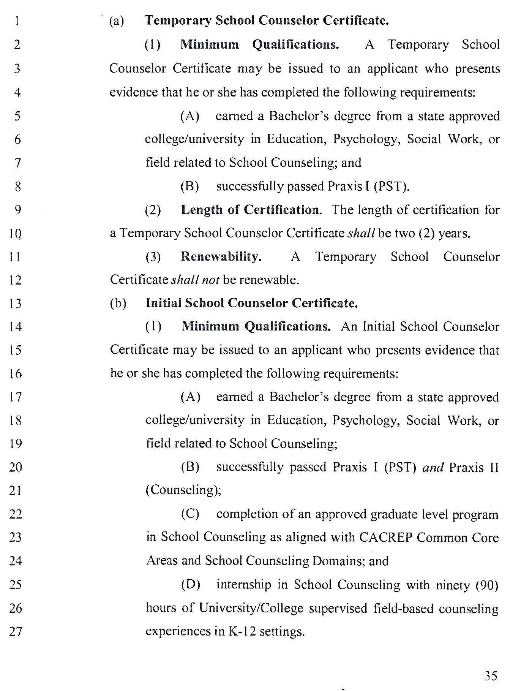
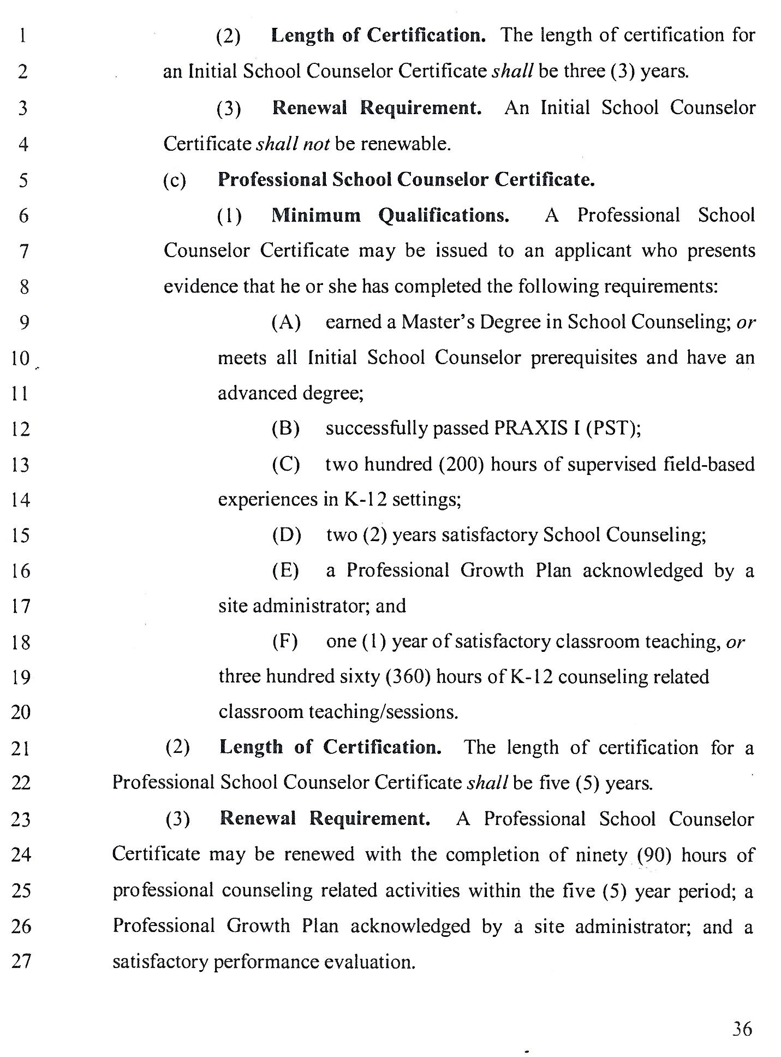
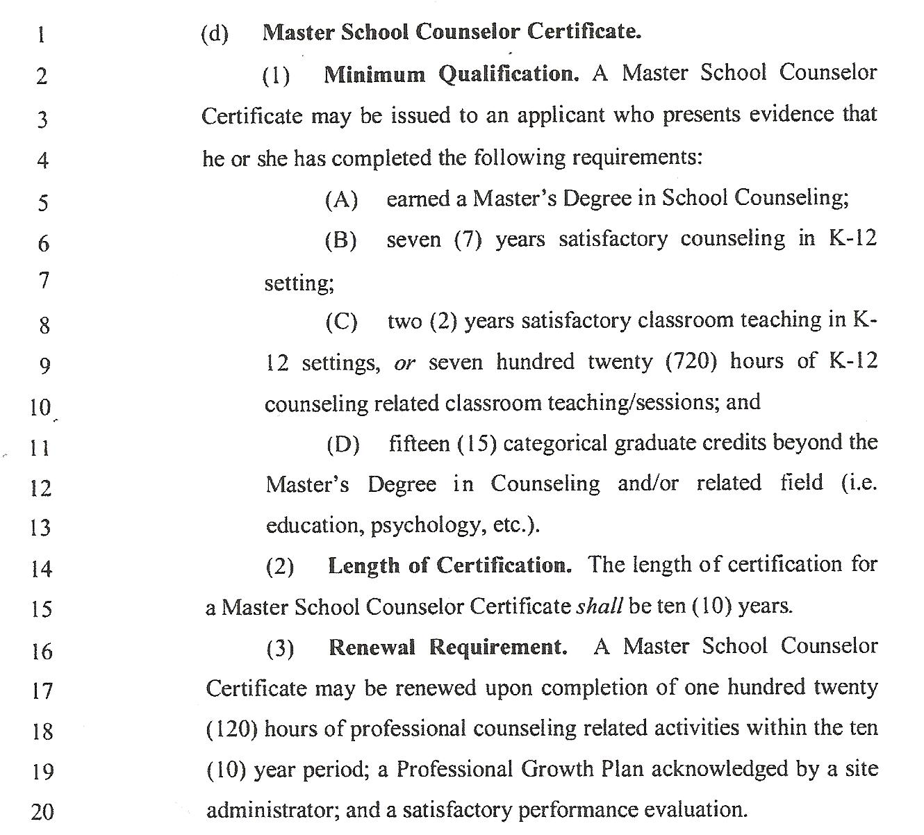

APPENDIX G
School Counselors Work Teams

GDOE SCHOOL COUNSELORS WORK TEAMS SY 2013-14
FOUNDATION (Beliefs & Philosophy, Mission Statement, Domains: Academic, Career, Personal/Social,ASCA National Standards/Competencies)
Team Leader: Billie-Jo Marzan, Ed.D.
Elementary | Valorie Alig, Marie Babauta, Nadine Cruz, Craig Tsuda
Middle | Debra Mariano, Carol Nguyen, Tony Chargualaf, Jamie Zapanta, Flora dela Rosa
High School | Carmen Garrido, Ed.D., Beatrice Camacho,Jovita Alcantara, Terence Emerson, Catherine Drilon,, Jennifer San Nicolas, Marleen Legaspi, Monica Lujan,Rosemarie Guilliot

MANAGEMENT SYSTEM (Agreements, Advisory Councils, Use of Data, Action Plans, Use of time, Calendars)
Team Leader: Francis Ballares
Elementary | Maude Van Ausdall, Agnes Indalecio, Ph.D., Jason Cruz, Roy Cruz, Melanie Olchondra, Leah Tamondong, Lulene Concepcion
Middle | Paul Tibudan, Mary Bais, Marissa Quitugua, Kristle Rosario, Vicky Cruz, Yolanda Pilarca, Cheryl Orland
High School | Jack Van Ausdall, Annie Song, Kelly Sukola, Ed.D., Lois Taitano, Elizabeth Ichihara-Rosario, Jonathan Pilarca, Michelle Santos,Yvonne Pereda,Gina Santos, Lisa Santiago, Norma Chargualaf

DELIVERY SYSTEM (School Guidance Curriculum, Individual Student Planning, Responsive Services, System Support)
Team Leader: Estela Calata
Elementary | Bryce O’Connor, Connie Herrera, Robyn Aguon, Vera Elliott, Jackie Paulino, , Lou Dizon, Lindsey Rousan
Middle | Marcella Takai, JeanetteTabobo, Jerena Camacho, Dhyana Edwards, Rochelle Diego, Tricia San Nicolas, Christine Cruz
High School | Annette Galvez, Leah Duenas, Maribeth Camacho, Ma. Blessa Ramos, Sahlee Felisan, Esther Rios, Rosemarie Nanpei, Hernalin Analista, Brian Muna, Patty Terlaje, Karen Sablan, Gary Hartz, Mary Lee Palomares

ACCOUNTABILITY SYSTEM (Results Reports, School Counselor Performance Evaluation, Program Audit, Job Description, Job Evaluation, Performance Standards)
Team Leader: Jovy Young
Elementary | Lynnette Quitugua, Gloria Guerrero, Tess Borja, Velma Cruz, Fina Leon Guerrero,Wenonah Abrenica, Chris Cabrera
Middle | Leonie Sagun, Brian Butler, Felix Santos, Joseph Lujan, Geolyn Egurrola, Naiomi Uncangco, Wendy Medina
High School | Margie LG Artero, Doreen Pereda, John Mesa, Annie Palomares, Abigail Dimalanta, Joe Wise, Evangeline Perez
APPENDIX H

Guide for Three Year ASCA Implementation Plan

ASCA Model Elements | Year 1 | Year 2 | Year 3
Develop mission philosophy & beliefs, and vision | X | X | X
Selection of student standards, competencies and indicators |  | X | X
Develop delivery system | X | X | X
Counselor/principal agreement | X | X | X
Advisory Committee |  | X | X
Year long calendar | X | X | X
Monthly calendar |  | X | X
Curriculum action plan | X (1 per semester) | X (2 per semester) | X (4 per semester)
Curriculum results reports for action plans | X (1 per semester) | X (2 per semester) | X (4 per semester)
Closing the gap action plan | X (1 per yr) | X (2 per year) | X(3 per year)
Closing the gap results report | X (1 per yr) | X (2 per year) | X (3 per year)
Results over time |  | X | X
Use of time |  | X | X
Student achievement & related data | X | X | X
Disaggregated data |  | X | X
Standards & competency related data |  | X | X
Program Evaluation data: Process, perception & results |  | X | X
Data over time: Immediate, Intermediate, Longitudinal data |  | X | X
Give one pre-post test on guidance curriculum lessons | X | X | X
Program Audit | X | X | X
School counselor performance standards/evaluation |  |  | X
School Counselor Skills | Year 1 | Year 2 | Year 3
Leadership |  | X | X
Advocacy |  | X | X
Collaboration |  | X | X
Systemic Change |  |  | X
Present Completed program to district governing board for approval. |  |  | X (end of year)
Apply for the ASCA RAMP award |  |  | X (end of year)
Support for School Counseling Programs –It is recommended that the following tasks/relationships be started or planned for at the beginning of program implementation. These tasks or relationships must be an ongoing part of an ASCA Model School Counseling program to insure the program will become institutionalized in the school and district. (1)
Task or Relationship Necessary | What needs to be done? | Who are the contacts? | Date to start
Collaboration with faculty members
Commitment of top administrators
Long range implementation plan
Incorporate school mission with school counseling program
Community support
Program of accountability
Public relations plan

(1) ASCA National Model Workbook, DeJong and Moeykens (1995)

Handout Provided by: Judy Bowers, Ed.D.

APPENDIX I

School Counselor Management Agreement

The School Counselor Management Agreement ensures the effective implementation of the delivery system to meet student’s needs. School administrators must be involved in the important process of making management decisions based on school needs and data analysis.

Agreements are statements of responsibility by counselors specifying the program results and students in which the counselor is accountable. These agreements are negotiated with and approved by the designated administrator.

The Management agreement dictates when (action plan and calendar), the why (use of data), the who will implement (management agreement) and on what authority (management agreement) the school counseling program is delivered.

Every year, school administrators shall meet with school counselors to review and establish the Management Agreement within the first quarter. Afterwards, the counselor will share the agreement to an advisory council established by the counselor and approved by the school administrator.

The Management Agreement is the basis for the school counselor evaluation. Administrators and counselors are encouraged to meet once per quarter to review the progress of the Management Agreement.

Administrators and counselors shall meet before the end of the school year to complete the evaluation of the program audit and counselor’s performance.

The Management Agreement must be included as an attachment to the counselor evaluation form. One copy is to be filed in the counselor’s official personnel file, one copy is provided to the administrator, and one copy is provided to the counselor.

School Counselor Management Agreement Form

Programmatic Delivery

The school counseling teams will spend approximately the following time in each component area to ensure the delivery of the school counseling program.

Local School Time Plan

Actual Use Recommended Time
_____% | of time delivering guidance curriculum | Provides developmental comprehensive guidance program content in a systematic way to all students K-12 | Elementary: 35%–45% | Middle/Jr High: 25%–35% | High School 15%–25%
_____% | of time with individual student planning | Assists students and parents in development of academic and career plans | Elementary:  5%–10% | Middle/Jr High: 15%–25% | High School 25%–35%
_____% | of time with  responsive services | Addresses the immediate concerns of students | Elementary:  30%–40% | Middle/Jr High: 30%–40% | High School 25%–35%
_____% | of time with  system support | Includes program, staff and school support activities and services | Elementary: 10%–15% | Middle/Jr High: 10%–15% | High School 15%–20%

School Improvement/Closing-the-Gap Goals
 | Goal Description | Implementation Plan
1
2
3

Programs, Information, Assistance and Outreach

Teachers | Parents | Community

Professional Development for School Counseling Staff
The school counseling team will participate in the following professional development: _______________________________________________________________________________________________________________________________________________________________________________________

Professional Collaboration
The school counseling department will meet weekly/monthly: circle all that apply

A. As a counseling department team | B. With the school staff (faculty) | C. With the advisory council
D. With administration | E. With subject area departments | F. Other:________________

Budget Materials and Supplies
Yearly Budget
$__________
Needed materials, supplies and expenses: _______________________________________________________________________________________________________________________________________________________________________________________________________________________________________________________________________________________________________________________________________________________________________________________________________________________________________

Counselor Availability/Office Organization
The school counseling department will be open for students/parents/teachers from __________to__________
The department will manage the division of hours by _____________________________________________
The career center will be open from ___________to__________

Role and Responsibilities of Other Staff and Volunteers
______________________________________________________________________________________________________________________________________________________________________________________________________________________________________________________________________________________________________________________________________________________________________________________________________

School counselor will be compensated for extra work hours by: Circle all that apply

A. Extra duty pay | C. Flex Schedule | E. Comp Time
B. Principal/Counselor Negotiation | D. No Option for this | F. Other

APPENDIX J

School Counselor Performance Appraisal Form

The school counselor performance appraisal form contains basic standards of practice expected from school counselors. These performance standards not only function as the basis of counselor evaluation but also serve as guides for self-evaluation. This form is optional and can be used by the school counselor as a self-evaluation or by the principal.

The standards to be evaluated are:
- Standard 1 Program Organization
- Standard 2 Guidance Curriculum Delivered to All Students
- Standard 3 Individual Planning with Students
- Standard 4 Response Services
- Standard 5 Systems Support
- Standard 6 School Counselor/Administrator Agreement
- Standard 7 Use of Data
- Standard 8 Student Monitoring
- Standard 9 Master Calendar/Time
- Standard 10 Results Evaluation
- Standard 11 Program Audit
- Standard 12 Advisory Council
- Standard 13 Infusing Themes

The performance standards are to be assessed by indicating “Yes” or “No” to each of the standards. Comments under each section could indicate strengths in that standard or recommendations.

Standard 1: The professional school counselor plans, organizes and delivers the comprehensive school counseling program. | YES | NO
1.1 A program has been written to meet the needs of the school.
1.2 The professional school counselor demonstrates interpersonal relationships with students.
1.3 The professional school counselor demonstrates positive interpersonal relationships with educational staff.
1.4 The professional school counselor demonstrates positive interpersonal relationships with parents/guardians.
Comments: | Date:

Standard 2: The professional school counselor implements the guidance curriculum through the use of effective instructional skills and careful planning of structured group sessions for all students. | YES | NO
2.1 The professional school counselor teaches guidance units effectively.
2.2 The professional school counselor develops materials and instructional strategies to meet student needs and school goals.
2.3 The professional school counselor encourages staff involvement to ensure the effective implementation of the guidance curriculum.
Comments: | Date:
Standard 3: The professional school counselor implements the individual planning component by guiding individuals and groups of students and their parents through the development of educational and career plans. | YES | NO
3.1 The professional school counselor, in collaboration with parents, helps students establish goals and develop and use planning skills.
3.2 The professional school counselor demonstrates accurate and appropriate interpretation of assessment data and the presentation of relevant, unbiased information.
Comments: | Date:
Standard 4: The professional school counselor implements the responsive services component through the effective use of individual and small-group counseling, consultation and referral skills. | YES | NO
4.1 The professional school counselor counsels individual students and groups of students with identified needs/concerns.
4.2 The professional school counselor consults effectively with parents, teachers, administrators and other relevant individuals.
4.3 The professional school counselor implements an effective referral process with administrators, teachers and other school personnel.
Comments: | Date:
Standard 5: The professional school counselor implements the systems support component through effective guidance program management and support for other educational programs. | YES | NO
5.1 The professional school counselor provides a comprehensive and balanced guidance program in collaboration with school staff.
5.2 The professional school counselor provides support for other school programs.
Comments: | Date:
Standard 6: The professional school counselor has discussed the counseling department management system and the program action plans with the school administrator. | YES | NO
6.1 The professional school counselor has discussed the qualities of the counselor management system with the other members of the counseling staff and has agreement.
6.2 The professional school counselor has discussed the program results that will be obtained on the action plans for the school year.
Comments: | Date:
Standard 7: The professional school counselor knows how to use data as a guide to program direction and emphasis. | YES | NO
7.1 The professional school counselor uses school data to make decisions regarding student choice of classes and special programs.
7.2 The professional school counselor uses data from the counseling program to make decisions regarding revisions to the school counseling program.
Comments: | Date:
Standard 8: The professional school counselor monitors the students on a regular basis as they progress in school. | YES | NO
8.1 The professional school counselor is accountable for monitoring the progress of every student.
8.2 The professional school counselor implements monitoring activities appropriate to his/her own school.
8.3 The professional school counselor develops appropriate interventions for students as needed and monitors their progress.
Comments: | Date:
Standard 9: The professional school counselor implements the master calendar/time component to have an efficiently run program. | YES | NO
9.1 The professional school counselor uses a master calendar to plan activities through the year.
9.2 The professional school counselor distributes the master calendar to parents, staff and students.
9.3 The professional school counselor posts a weekly/monthly calendar.
9.4 The professional school counselor analyzes his/her time spent in each of the four areas of the management system to achieve a healthy balance.
Comments: | Date:
Standard 10: The professional school counselor has developed a results evaluation for the program. | YES | NO
10.1 The professional school counselor includes every student in the results.
10.2 The professional school counselor works with members of the school counseling team and with the principal to formulate the desired results.
10.3 The professional school counselor knows how to collect and process data.
Comments: | Date:
Standard 11: The professional school counselor conducts a yearly program audit. | YES | NO
11.1 The professional school counselor provides a yearly program audit that includes the results of all the program components.
11.2 The professional school counselor shares the results of the program audit with the advisory council.
11.3 The professional school counselor uses the yearly audit to make changes in the school counseling program for the following year.
Comments: | Date:
Standard 12: The professional school counselor is responsible for establishing and convening a school advisory council for the comprehensive school guidance and counseling program. | YES | NO
12.1 The professional school counselor has met with the advisory council.
12.2 The professional school counselor has reviewed the school counseling program audit with the council.
12.3 The professional school counselor keeps a record of meeting information.
Comments: | Date:
Standard 13: The professional school counselor is a student advocate, leader, collaborator and a systems change agent. | YES | NO
13.1 The professional school counselor promotes academic success of every student.
13.2 The professional school counselor promotes equity and access for every student.
13.3 The professional school counselor takes a leadership role within the counseling department, the school setting and the community.
13.4 The professional school counselor understands reform issues and works to close the achievement gap.
13.5 The professional school counselor collaborates with teachers, parents and the community to promote academic success of students.
13.6 The professional school counselor builds effective teams by encouraging collaboration among all school staff.
13.7 The professional school counselor uses data to recommend systemic change in policies and procedures that limit or inhibit academic achievement.
Comments: | Date:

APPENDIX K
Glossary: Definition of School Counseling Key Terms

21st Century School Counseling Program: A school counseling program that is aligned with the ASCA National model, that is data-driven, is standards-based, uses current technologies and engaging instructional and communication practices, is highly ethical, creates equity and access for all students, and consistently imparts 21st Century knowledge and skills preparing all students for maximum success in a 21st Century Global world.

Accountability. Responsibility for one’s actions, particularly for objectives, procedures, and results of one’s work and program; involves an explanation of what has been done. Responsibility for counselor performance, program implementation, and results.

Accountability system. A system that measures the effectiveness of school counselor practices and activities and the completeness of the program to include: the school counselor performance standards, evaluation system including a self-appraisal and goals to drive continuous improvement, results reports, and the program audit.

Action plan. How the counselor, or others, intend to achieve the desired result or competency; items in an action plan include domain, standard and competency, actual activity and curriculum, time of completion of activity, data used, means of evaluation, and the expected result for the student(s).

Advisory council. An advisory council is a representation group of the school and community appointed to audit the school counseling program goals and to make recommendations to appropriate regarding program priorities; may be an existing team that spends two meetings per year focusing on evaluating and making recommendations for the school counseling program.

Advocacy. Advocacy refers to the active support of causes, ideas or policies that promote and assist student academic, career, personal/social needs. One form of advocacy is the process of actively identifying under-represented students and supporting them in their efforts to perform at their highest level of academic achievement.

Articulation. A process of coordinating the linking of two or more educational systems within a community.

At-risk students: describes children who are potentially in a harmful or less than optimal situation where school, family or personal barriers may contribute to poor school performance or dropping out.

Career development. A structured, ongoing process to assist students develop knowledge about careers and a plan to acquire necessary skills and attitudes for successful transition from school to work or post-secondary training or education

Closing the gap. Refers to the difference in achievement levels generally between privileged students and students of color or low socioeconomic status.

Collaboration: A partnership where two or more individual or organizations actively work together on a project or problem.

Competencies. Statements that define the specific knowledge, attitudes, and skills
students should obtain.

Comprehensive school guidance and counseling curriculum. Consists of structured developmental lessons designed to assist students in achieving the competencies and is presented systematically through classroom and group activities in grades Pre-K-12.

Comprehensive school guidance and counseling program. Consists of a structured program that is an integral part of the total educational program that helps every student acquire the skills, knowledge and attitudes in the areas of academic, career and personal/social development that promotes academic achievement and meet developmental needs.

Consultation. Consultation refers to a process in which counselors consult with parents or guardians, teachers, other educators and community agencies regarding strategies to help students and families. School counselors serve as student advocates.

Counseling. Counseling refers to a special type of helping process implemented by a professionally trained and certified person, involving a variety of techniques and strategies that help students explore academic, career and personal/social issues impeding healthy development or academic progress.

Counseling-related administrative activities. These activities include: developing and implementing counseling-related events such as orientation and transition programs, financial aid workshops, career and college planning processes, developmental guidance activities, preventive-focused programs and other student-centered activities; writing letters of recommendation; and coordinating with appropriate school officials to assure the maintenance of student records. Counseling activities of a clerical nature such as data entry, the filing of student records and forms, and the duplication of documents and materials for distribution when combined with counseling-related administrative activities, should not exceed more than 25% of the counselor’s time.

Course rigor: indicates the level of intensity of a course and may include higher level courses such as AP, IB, or Honors to prepare students for higher success levels.
Crisis counseling. Crisis counseling provides prevention, intervention and follow-up. Counseling and support are provided to students and families facing emergency situations. Such counseling is normally short term and temporary in nature, and usually results in a referral made to appropriate community resources. School counselors may provide a leadership role in the school district’s crisis intervention team process.

Crosswalk (ASCA National Standards). A matrix used in standards and curriculum alignment. The matrix lists all standards, competencies, and indicators; it makes the alignment visible by showing specifically where each competency is taught developmentally by grade or within a guidance lesson.

Data-driven. Decisions concerning future action that are based on information, survey reports, assessments, statistics, or other forms of data.

Delivery system. The means around which the counseling program is organized and delivered; includes four components: guidance curriculum, individual student planning, responsive services, and system support.

Developmental counseling program. School counseling curriculum based on the developmental age of the student and conducted on a regular and planned basis to assist students in achieving specified competencies.

Direct services. Involves direct contact with students and include: individual counseling, small group counseling, classroom guidance, school-wide activities, and school team meetings in which the student is present.

Disaggregated data. Data separated into component parts by specific variables such as ethnicity, gender, grade level, and socioeconomic status.

Domains. Broad areas of knowledge and skills base that have been divided into three broad standard areas: academic, career, and personal/social that promote and enhance the learning process through a school-wide guidance and counseling program.

Early identification: a systemic, structured process in which schools identify struggling students early and refer for screening or support services.

Equity and Access: a process to ensure that all student have equal access to relevant programs, courses, resources, and activities regardless of ethnicity, social class, family background, ability, or gender.

Evidence and Measures: documentation that counselors gather as proof of performance level they identify during a self appraisal to share with evaluators to substantiate their level of performance.

Foundation. Includes the beliefs, philosophies, mission, domains, and ASCA National Standards and competencies.

Goals. The extension of the mission statement; they provide the desired student results to be achieved by the time the student leaves the school system.

Group counseling. Counseling is provided in a small group for students experiencing similar difficulties with issues that interfere with school and life success and may include: relationships, grief, anger management, study skills, personal concerns or normal developmental tasks. Small group counseling provides structured opportunities for students to learn from each other and the group leader to identify problems, causes, examine choices and possible consequences.

Guam School Counseling Program Model. The GSCPM model describes the expectations for school counselors, program components, describes best practices, and outlines a process for tailoring the model to meet the needs of Guam schools.

Guidance curriculum. Consists of structured developmental lessons designed to assist students in achieving the academic, career, and personal/social competencies and is presented systematically through school-wide, classroom, and group activities in grades Pre-K-12. The purpose of the guidance curriculum is to provide all students the knowledge and skills appropriate for their developmental levels And usually delivered using a collaborative model involving the school counselor, classroom teachers and other appropriate education professionals..

Inappropriate school counseling activities. Any activity or duty not related to the development, implementation, or evaluation of the counseling program.

Indicator. Measurable evidence that individuals have abilities, knowledge, or skills for a specific competency.

Indirect services. Are directly related to planning, designing and implementing the school counseling program and include the management of resources, consultation, collaboration and teaming, advocacy and the coordination of services

Individual counseling. Counseling is provided on an individual basis for students expressing difficulties that are interfering with school success and may include: school concerns, family issues, relationships, academic, personal or behavioral concerns or normal developmental issues. Individual counseling helps students identify problems, causes, alternative and possible consequences in order for appropriate action to be taken and is normally short term in nature. When necessary, referrals are made to appropriate community resources.

Individual planning with students. The individual planning component consists of school counselors coordinating ongoing systemic activities designed to assist the individual student in establishing personal goals and developing future plans. Counselor activities with students include: goal setting, career planning, and individual student academic program planning, including course selection and the interpretation and application of assessment information in a meaningful way to guide academic program
planning. Individual planning with students assumes parental and other school staff involvement, and personalizes the educational experience by helping students set goals and develop pathways to realize academic, career and personal/social aspirations.

Leadership. Capacity or ability to guide others; counselors use their leadership skills in their department and in their advocacy role.

Management agreement: A statement of responsibility negotiated between the principal and counselor that includes office organization, how a program is carried out, and accountability criteria and specific results.

Management system: The management system addresses the allocation of resources to best address the goals and needs of the program. Individual staff responsibilities, accountability, and the cooperation among resource persons responsible for program results are outlined.

Master calendar: A master calendar of guidance events is maintained by the school counseling staff and is distributed to teachers, students, and parents on a regular basis. Planning, visibility, and credibility are enhanced by effective use of a master calendar.

Mission statement: A statement which outlines the purpose or vision of the school counseling program. It is the long-range desired outcome for students. This statement must be compatible with the stated purpose or mission of the school system within which the program operates.

Non-counseling activities. These are described as any activity or duty not related to the development, implementation, or evaluation of the counseling program.

Parent: Anyone who has a legal right to be the custodial caretaker of the student.
Peer facilitation. A technique in which counselors train students as peer mediators, conflict managers, tutors and mentors.

Perception data: These data measure what students and others observe or perceive, knowledge gained, attitudes and beliefs held, or competencies achieved.

Performance appraisal. Assessment of agreed-upon goals, contributions to the school counseling program, and personal and professional characteristics. Specifies contract status recommendations and indicates summative evaluation of school counselor effectiveness.
Performance evaluation. Assessment of school counselor practices and the level of guidance and counseling program implementation to determine strengths and weaknesses and drive a process of continuous improvement.

Personal/social development: Maximizing each student’s individual growth and social maturity in the areas of personal management and social interaction.

Philosophy: A set of principles guiding the development, implementation, and evaluation of the program.

Post secondary options: opportunities for students after high school: the workforce, military, vocational technical school, Two-year College, Four-Year College, Apprenticeship, etc.

Prevention-based programs: programs that are designed to teach students the knowledge they need and provide the skills they need in order to address issues known to interfere with the learning process including – bullying, harassment, substance abuse, mental health issues, depression, suicide, school violence, etc.

Process data: Method of evaluation using figures such as numbers of students served, groups, and classroom visits to show the activities rather than the results from the activities.

Program: A coherent sequence of instruction based upon a validated set of competencies.

Program audit. A program audit refers to the assessment of the school
counseling program on the components of the American School Counselor Association
National Model; the primary purpose for collecting information is to guide future action
within the program and to improve future results for students.

Program Components. Refers to school counseling program components and consists of the following systems: Foundation, Management, Delivery and Accountability.

Program Evaluation. A process used by an individual or group to determine progress, completeness, or quality of the program aimed at ensuring a process of continuous improvement.

Program management. Activities that develop, monitor, and evaluate the implementation of the comprehensive school counseling program.
Protocols: A set of best practices and recommended procedures designed to create uniformity in School Counseling Programs aimed at producing outstanding student outcomes

Research-based: indicates that substantial studies have been conducted to substantiate the effectiveness of these practices.

Responsive services. Consists of activities to meet students’ immediate needs and may be provided in a direct format through individual and group counseling, including crisis counseling, or indirectly through consultation, peer facilitation or outside referral. Frequently dominated by presenting student issues or school building, community and parental concerns, responsive services may address peer pressure, conflict resolution, family relationships, personal identity issues, grief and loss, suicide, child abuse, substance abuse, school dropout prevention and motivation and achievement concerns. Responsive for students with a severe crisis are usually short term and temporary in nature. Longer term crisis would involve referral to an appropriate school or community resources/agencies.

Results. Demonstration of learning performance or behavioral change (grades, attendance, promotions, discipline, etc.) after guidance and counseling program participation.

Results data. Outcome data; how students are measurably different as a result of the program.

Results report: Written presentation of the outcomes of counseling program activities; contains process, perception, and outcome data.

School counselors. Hold a school counseling certificate valid on Guam, are highly-qualified with a [minimum] master’s-level degree. Professional school counselors addresses developmental needs of all students in the areas of academic, career, personal/social while at the same time, working collaboratively with educators, families, and the community.

Sequential. Happens in a chronological order and the order of one item or activity may impact the outcome or level of success of another.

Stakeholder. Any person who assists with or benefits from the school counseling program and may include: students, school staff and leadership, parents, and community members and leaders.

Standards. A broad set of statements that provide clear expectations for knowledge that define expectations for knowledge, skills, attitudes, and behaviors. Related to school counseling there are student standards, content standards, program standards, performance standards, and ethical
standards.

Standards Based Program. A school counseling program that is based on core foundational standards including the student standards and the school counselor performance standards.

Student standards for school counseling. Student standards are aligned with the nine National Standards for School Counseling that are organized in three categories of student development: academic, career and personal/social. Each of the nine standards includes competencies that enumerate the desired student learning outcomes and define the specific knowledge, attitudes and skills that students should obtain or demonstrate as a result of participating in a school counseling program.

Student supports: describes a set of behaviors and efforts the school counselor undertakes to support student success. Supports may involve: acquiring new knowledge and skills through professional development, consultation, collaboration and teaming, and program management, and operation activities that establish, maintain, and enhance relevant school-wide efforts and the total school counseling program

Student support system. a structured school-wide system that is designed to involve school staff, families, and the community to personalize services based on student needs and provide a systemic approach to academic, career, and personal/social supports.

Student support components. academic and behavioral supports, career development, school and community prevention programs, collaborative support teams, community collaborations.

Systemic change. Change affecting the entire system; transformational change; change affecting more than an individual or series of individuals; focus of the change is upon the dynamic of the environment, not the individual.

Use of data. An essential element to ensure that all students receive the benefits of a school counseling program. School counselors know how to evaluate data from their school site.

Definitions Adopted from ASCA 2005

APPENDIX L
Professional Association: Guam Association of School Counselors (GASC) Officers

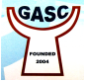
JOSEPHINE CALUAG, Ph.D.
President
Maria Ulloa Elementary School (Retired)

JOVY YOUNG
Executive Vice President
Tamuning Elementary School

LYNNETTE QUITUGUA
Vice President – Elementary
L.B.J. Elementary School

JOHN VAN AUSDALL
Vice President – Secondary
G.W. High School (Retired)

ESTELA CALATA
Secretary
Wettengel Elementary School

LEONY BERNARDO
Treasurer
FBLG (Retired)

Directors:
MAUDE VAN AUSDALL, Chief Brodie Elementary School (Retired)
BILLIE-JO MARZAN, Ed.D., Machananao Elementary School
LEAH DUENAS, Ocean View Middle School
DOREEN PEREDA, George Washington High School

REFERENCES

American School Counselors Association (2005). The ASCA National Model: A Framework for School Counseling Program, Second Edition. Alexandria, VA. Author.

American School Counselors Association (2004). The ASCA National Model Workbook. Alexandria, VA: Author.

5A G.A.R. § 8112(a)(1); Guam Public Law 31-50. Guam Commission for Educator
Certification

